Welcome Back!
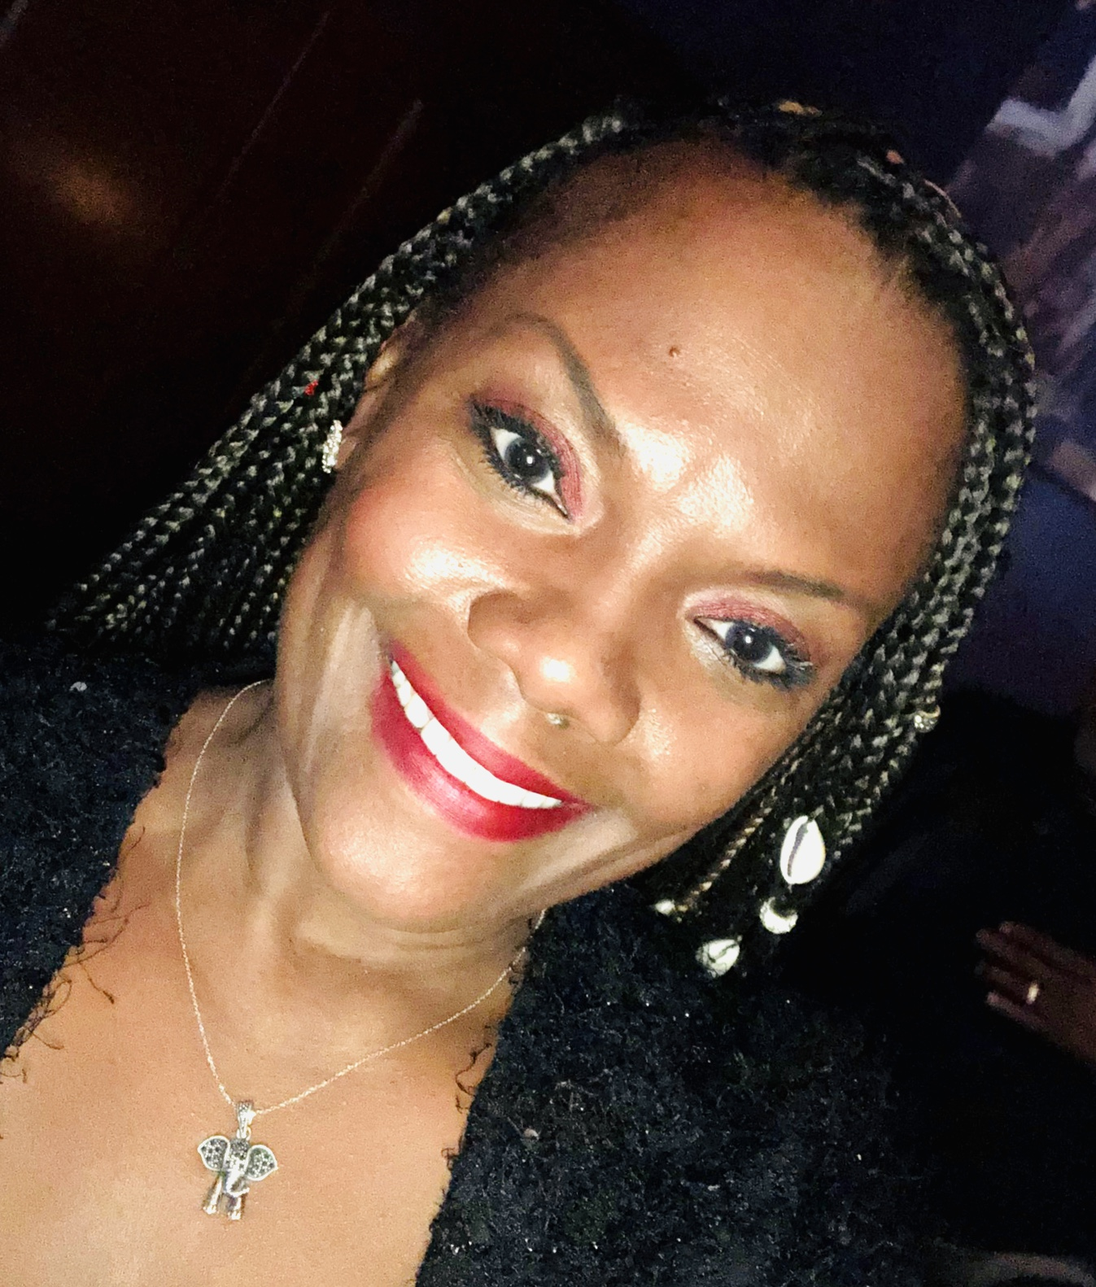
Hello Students and Parents! I am Mrs. Frazier, the Middle School Social Worker. It is with great excitement that I welcome you all to the Coastal Georgia Comprehensive Academy 2020-2021 School Year. I trust that everyone is as excited as I am about coming together again.
Certainly, we are returning in a manner that is very different to us all, however, the sense of Family and Supportive environment remains the same!
Students, I have every faith that you will receive the never-ending support that your teachers have always given. The team has worked very hard to ensure that your Distance Learning Experience will begin with ease. You will continue to gain academic knowledge and receive social and emotional support, as we travel this virtual journey together.
Parents, as always, We Are A Team! Together, our Principal, Program Managers, Teachers and Support Teachers will make every effort to ensure that your children are successful in this new environment. I will work closely with you and the staff to provide your child with support and a sense of safety and security in this virtual setting.
I am accessible to you daily. Please feel free to email, text or call me with questions or concerns. Most of you have my personal mobile phone number. If you do not, I will be happy to provide it to you as I make my daily parent contacts or through email requests. My email address is Jeannine.Frazier@sccpss.com. Please, do not hesitate to contact me. No question is too big or too small. If I do not have an answer for you, I will make every effort to find one. Again, Welcome Back! I Look Forward to Seeing Everyone Soon!

