

Functional Behavioral Assessment/Behavior Intervention Plan

Webinar 4 Training Packet

Contact Dr. Emily Graybill [egraybill1@gsu.edu](mailto:egraybill1@gsu.edu) or

Allison O’Hara, EdS [aohara@gsu.edu](mailto:aohara@gsu.edu)

for questions about this packet

|  |  |  |
| --- | --- | --- |
| **Webinar** | **Title of Form** | **Page #** |
| **Webinar 4** | Functional Behavior Assessment (FBA) Form: “S. Cakes” | 2-3 |
| Depicting Data in Graphs: Slow Triggers | 4-6 |
| Depicting Data in Graphs: Fast Triggers | 7 |
| Depicting Data in Graphs: Consequences | 7 |
| Hypothesis Statement Step-by-Step Process | 8-11 |
| Full Hypothesis Statement Framework: S. Cakes | 12 |
| Additional Set of Graphs (Voluntary Practice): S. Dolores | 13-14 |
| Blank FBA Form | 15-16 |
| Blank Hypothesis Statement Framework | 17 |

**Functional Behavior Assessment (FBA) Form**

|  |  |  |  |  |  |
| --- | --- | --- | --- | --- | --- |
| **Student’s Name:** | **S. Cakes** | | **School Name:** | **Cool School** | |
| **Student’s DOB:** | **1-1-11** | | **School District:** | **District** | |
| **Student’s ID:** | **XXXXXXXXXXX** | | **Date of FBA:** | **2-9-15** | |
|  |  | |  |  | |
| **Data Sources (circle all that apply):** | **Direct Observations** | **Student Interview** | **Teacher Interview** | **Parent Interview** | **Rating Scales** |

**Brief Student Background**

S. Cakes is a 3rd grade student who began engaging in verbal outbursts during the Fall 2015 school year. She struggles to remember peer names and is unsure about appropriate ways to get attention from others

**Strengths:**

S. Cakes is an outgoing and jovial student who loves dancing and music. She loves to be around a lot of people, and has 5 siblings she lives with at home, along with her mother and stepfather.

**Educational History:** S. Cakes is being served in a GNETS classroom after transitioning out of her home school for intensive behavior support services on 1-20-15.

|  |
| --- |
| 1. **Description of Target Behavior, Choose 1 or 2 (operationally defined, easily observable and measurable, include examples and nonexamples):**   *Verbal Outbursts- Anytime Sadie screams or curses at a volume level that could be heard outside of the classroom. Verbal outburst begins upon the first instances of cursing and/or screaming and ends after 10 seconds without and cursing or screaming.* |
| 1. **Frequency (how often does behavior occur according to data collected):** |
| 1. **Duration (length of time each episode lasts according to data collected):** |
| 1. **Intensity (Consequences of problem behavior on student, peers, instructional environment; rate the intensity of the behavior on a three point scale – low intensity, medium intensity, high intensity):** |
| 1. **Setting Events (i.e., slow triggers; antecedent events that set the stage for a higher likelihood of target behavior):** |
| 1. **Antecedent Events (Immediate triggers) Identify what happens immediately before the target behavior occurs:** |
| 1. **Identify events or times and/or situations when the target behavior does not usually occur:** |
| 1. **Consequences (i.e., how others respond immediately after the problem behavior occurs):** |
| 1. **Hypothesis (includes antecedent events, behavior, consequence, function, and what the student is trying to communicate through the behavior):** |
| 1. **Function of Behavior:**  |  |  |  |  |  |  | | --- | --- | --- | --- | --- | --- | |  | Attention |  |  | Tangible |  | |  | Escape |  |  | Sensory |  | |
| **Additional Notes (if needed):** |

**Webinar 4 – FBA Data in Graphs: Slow Triggers**

Please have your blank FBA form (pages 2-3 in this packet) available in order to complete the following tasks. All responses should be recorded within your Blank FBA Form for S. Cakes.

**“Day of the Week”**

Mon. Tues. Wed. Thurs. Fri.

*“Please identify the overall number of behavioral incidents that occurred during the FBA data collection process. Record this response*

*in Item #2 of your FBA Form (Frequency).”*

*“Please locate the day of the week (e.g, a slow trigger) when Sadie’s verbal outbursts were most frequent. Record this response as the first part of Item #5 of your FBA Form (Setting Events).”*

**“Time of Day”**

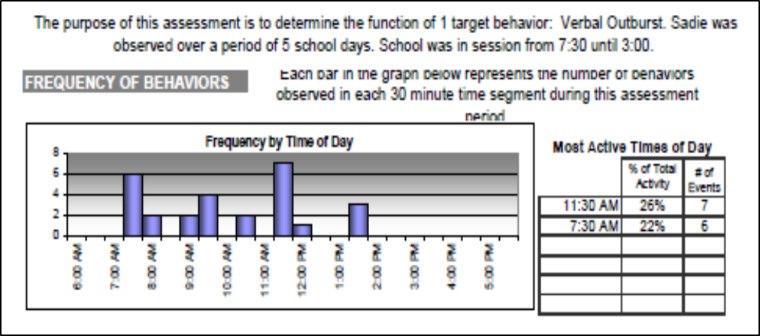

*"Please identify the two windows of time when was Sadie’s target behavior the most frequent. Record this response as an addition in Item #5 of your FBA Form (Setting Events).”*

*“Please list 2-3 windows of time between 7:30-3:00pm when Sadie did not engage in any verbal outbursts. Record this response as one part of your report within Item #7 of your FBA Form (Identify events or times and/or situations when the target behavior does not usually occur).”*

**“Context/Setting Events”**

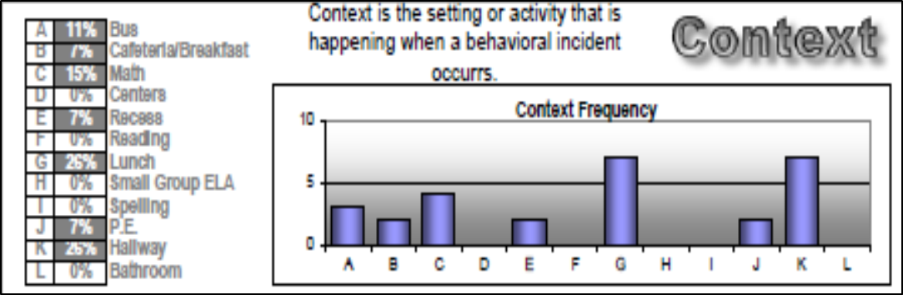

*“Please identify the two contexts where verbal outbursts occurred most often. Record this response as another addition in Item #5 of your FBA Form (Setting Events).”*

*“Please list 2-3 contexts where Sadie did not engage in any verbal outbursts. Record this response as an addition to Item #7 of your FBA Form*

*(Identify events or times and/or situations when the target behavior does not usually occur).”*

**“Fast Triggers/Antecedent Events”**

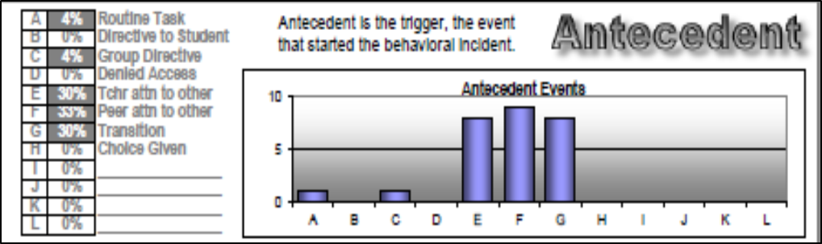

*“Please list the top 2-3 most common triggers or antecedent events that led to the occurrence of the target behavior and record this response in Item #6 of your FBA form (Antecedent Events).”*

**“ Consequences/Responses”**

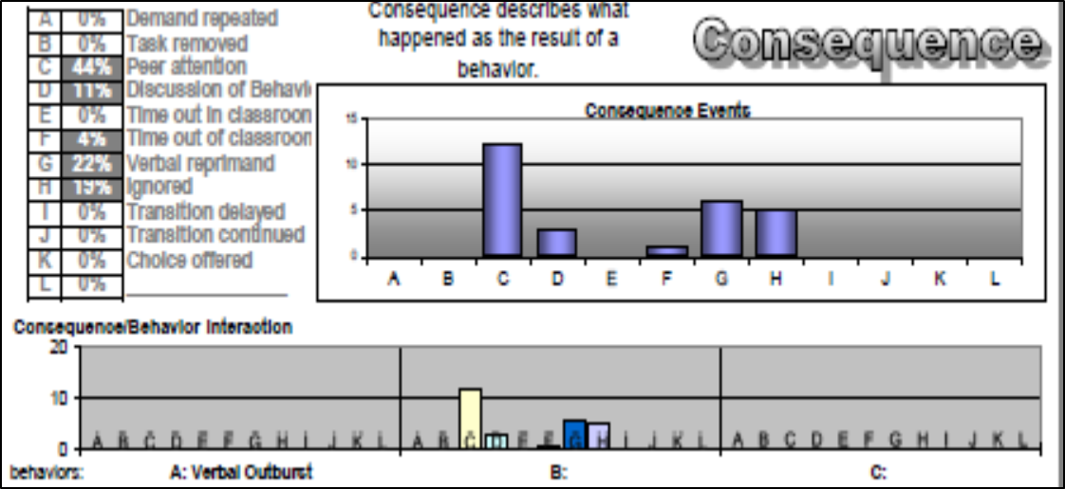

*“Please list the two most frequently delivered consequences in response to Sadie’s target behavior, and record this information in Item #8 of your FBA Form (Consequences).”*

**Webinar 4 – Hypothesis Statement Step-by-Step Practice**

Please begin inserting your responses to the next 4 items within the boxes provided above each item. We will return to our FBA Form once we reach page [12] of this process packet.

**“Hypothesis Statement Step 1: Fast Triggers and Context”**

|  |
| --- |
| **Part One**  *“When (fast trigger) occurs in (context)…”* |
|  |

*“Use the information you recorded in Items #5 and #6, (‘Setting Events’ and ‘Antecedent Events’) of your FBA form to complete Part One of your hypothesis statement. Insert Part One of your hypothesis statement in the box above.”*

NOTE: A hypothesis statement is meant to be concise, so focus first on including information related to fast triggers and locations where behaviors occurred for this portion. Only include specific windows of time or days of the week if you feel it is particularly relevant for your student.

**“Hypothesis Statement Step 2: Behavior”**

|  |
| --- |
| **Part Two**  *“…the student does (behavior)…”* |
|  |

*“Please complete Part Two of your hypothesis statement. Write Part Two of your hypothesis statement in the box above.”*

**“Hypothesis Statement Step 3: Consequences”**

|  |
| --- |
| **Part Three**  *“Others (staff/peers) typically respond by doing (consequence)…”* |
|  |

*“Please complete Part Three of your hypothesis statement using the Item #8 in your FBA Form to describe the two most frequently delivered consequences that follow Sadie’s verbal outbursts. Write Part Three of your hypothesis statement in the box above.”*

**“Hypothesis Statement Step 4: Function”**

|  |
| --- |
| **Part Four**  *“Sadie is trying to communicate (function).”* |
|  |

*“Please complete Part Four of your hypothesis statement, hypothesizing function by using the FBA data derived from our FBA data collection process. Please write Part Four of your hypothesis statement in the box above.”*

**Webinar 4 – Hypothesis Statement (Full Framework)**

|  |  |  |  |
| --- | --- | --- | --- |
| **Step 1:**  ***“When (fast trigger) occurs in (context),*** | **Step 2:**  ***the student does (behavior).*** | **Step 3:**  ***Others respond by doing (consequence).*** | **Step 4:**  ***The student is communicating (function).”*** |
|  |  |  |  |

*“Please combine Steps 1-4 to draft your hypothesis statement in its entirety. Write this hypothesis statement in Item #9 of your FBA Form. You may use the framework above as a guide as you place this statement in your FBA Form”*

*“In Item #10 of your FBA form, check the appropriate function.”*





**Functional Behavioral Assessment (FBA) Form**

|  |  |  |  |  |  |
| --- | --- | --- | --- | --- | --- |
| **Student’s Name:** | Click here to enter text. | | **School Name:** |  | |
| **Student’s DOB:** |  | | **School District:** |  | |
| **Student’s ID:** |  | | **Date of FBA:** |  | |
|  |  | |  |  | |
| **Data Sources (circle all that apply):** | **Direct Observations** | **Student Interview** | **Teacher Interview** | **Parent Interview** | **Rating Scales** |

**Brief Student Background:**

**Strengths:**

**Educational History:**

|  |
| --- |
| 1. **Description of Target Behavior, Choose 1 or 2 (operationally defined, easily observable and measurable, include examples and nonexamples):** |
| 1. **Frequency (how often does behavior occur according to data collected):** |
| 1. **Duration (length of time each episode lasts according to data collected):** |
| 1. **Intensity (Consequences of problem behavior on student, peers, instructional environment; rate the intensity of the behavior on a three point scale – low intensity, medium intensity, high intensity):** |
| 1. **Setting Events (i.e., slow triggers; antecedent events that set the stage for a higher likelihood of target behavior):** |
| 1. **Antecedent Events (Immediate triggers) Identify what happens immediately before the target behavior occurs:** |
| 1. **Identify events or times and/or situations when the target behavior does not usually occur:** |
| 1. **Consequences (i.e., how others respond immediately after the problem behavior occurs):** |
| 1. **Hypothesis (includes antecedent events, behavior, consequence, function, and what the student is trying to communicate through the behavior):** |
| 1. **Function of Behavior:**  |  |  |  |  |  |  | | --- | --- | --- | --- | --- | --- | |  | Attention |  |  | Tangible |  | |  | Escape |  |  | Sensory |  | |
| **Additional Notes (if needed):** |

**Hypothesis Statement (Full Framework)**

|  |  |  |  |
| --- | --- | --- | --- |
| **Step 1:**  ***“When (fast trigger) occurs in (context),*** | **Step 2:**  ***the student does (behavior).*** | **Step 3:**  ***Others respond by doing (consequence).*** | **Step 4:**  ***The student is communicating (function).”*** |
|  |  |  |  |