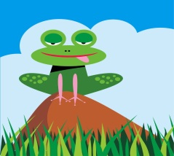
August 19, 2020

Dear Parents,
Welcome to the 2020-2021 school year! I hope each and every one of you had a safe and relaxing summer. I wanted to write to each of you to tell you about myself and give you a little information about the virtual learning environment.
As some of you know because your child has had me in the past, I’m Dr. Kim Thomas. Your child will also be working with the finest paraprofessionals that I’ve had the pleasure of working with, Ms. Miya and Ms. Sheila. I have worked with children with autism for the past 23 years and loved every minute of it!
I know some of you are concerned with what our virtual learning will look like this year, please know that we will be working with each of your children on a daily basis. The virtual learning format will look completely different than this previous Spring. If you have any questions or concerns, please feel free to email me at Kimberly.thomas2@sccpss.com or call me at 912-604-0126.
When we go back to school in the school setting, I will send home another letter with a list of school supplies that your child will need.

I look forward to working with your child and having a great 2020- 2021 school year.
Dr. Kim

