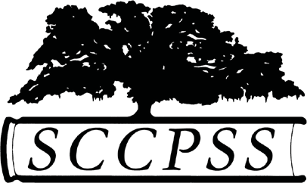

Purpose
Savannah-Chatham County Public School System
Student Learning Device Loan Form

Savannah-Chatham County Public School System (SCCPSS) is providing students with a learning device to support the continuation of teaching and learning through online software and Internet resources.

Student’s/Parent’s Responsibilities
- The Learning Device is provided for the student only. Student ID and password is required to access the device.
- The student is required to practice good digital citizenship and adhere to the Acceptable Use Policy IFBG-R.
- Student/Parent agrees to use the device for learning during the period of assignment, protect the device, maintain it, and promptly return the device (including power cable) when requested.
- The Learning Device will remain checked out to the student until it is returned to the issuing school. This means that the record will follow the student until the equipment has been returned in the same condition that it is issued (reasonable ware is expected).
- If the device is stolen, you are required to file a police report and notify the school. If the device is lost, stolen, or damaged, you are responsible for repairs or replacement.

By accepting the Learning Device, I agree to the Student’s/Parent’s Responsibilities.

Student’s Name: Student’s Signature:

Parent’s Name: Parent’s Signature:

Main Contact Phone Number: ________

School Site: ______________________________________ Check out date:________________
Equipment Issued
Equipment Brand Model Serial Number/Barcode Condition Issued Condition Returned

Non-Fixed Asset Administrator’s Initial: ___________

Equipment Returned

Date:

I acknowledge that I have returned the above equipment.

User Signature: Date: ____________________

Non-Fixed Asset Administrator’s Signature: Date:
REVISED 3/18/20

