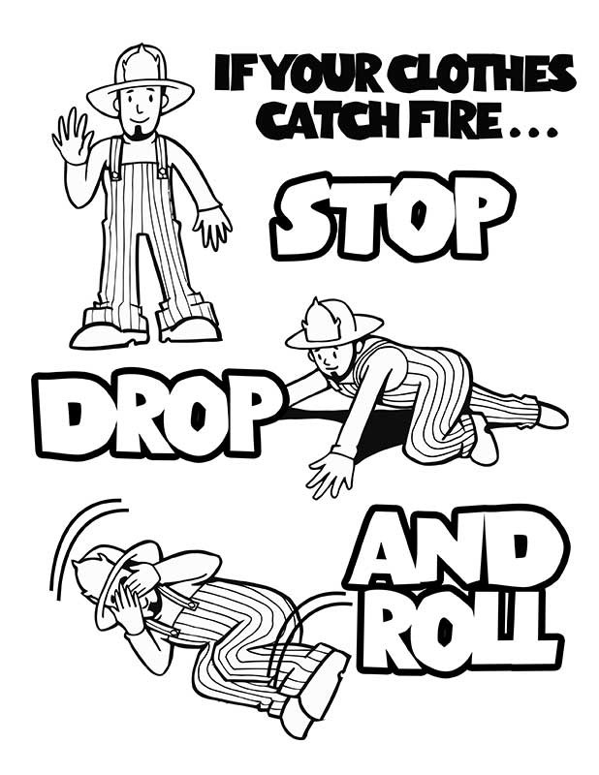

**Elementary Fire Safety Week Coloring Contest!**

**Put your name and room number on the BACK!**