Staying Drug Free Assignment
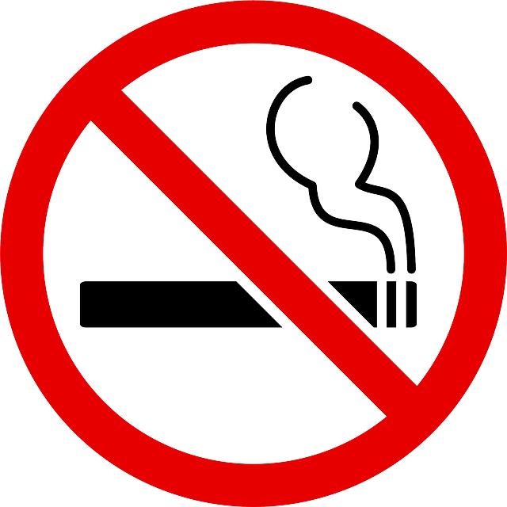
How would drug abuse impact your personal goals, educational opportunities, and occupational choices verses being drug free?
Directions: Explain in at least three to five sentences how using drugs could affect each of the following (below) in your life. Be specific.
- Personal Goals:

- Education Opportunities:

- Occupational Choices:

- Family Goals/Dreams:

