Registered Behavior Technician (RBT)
Observation Competency Assessment
Candidate Guide

The RBT Competency Assessment

Following the completion of an approved 40-hour RBT course, such as TeachTown’s online RBT course, all RBT candidates are required to pass a competency assessment by demonstrating mastery of 12 key applied behavior analysis skills and/or topics. Candidates must pass this assessment in order to apply for and be granted initial RBT certification from the Behavior Analyst Certification Board (BACB). Once initially certified, all RBTs will be required to pass this competency assessment annually to maintain their certification.

The assessment is conducted on an individual basis by a Board Certified Behavior Analyst (BCBA) in good standing with the BACB. The RBT Competency Assessment requires a BCBA assessor to observe the RBT candidate performing the task in a competent manner in vivo with an actual client or in a role-play scenario OR via video. Observation of video-recorded behavioral samples is only acceptable if the recordings are made specifically for the purpose of this assessment. For example, candidates may not submit videos created as part of their school district’s evaluation system or videos created for data collection purposes for individual students or clients.

Role-play scenarios in which the candidate demonstrates skills with colleagues or other adults may be used when circumstances do not permit using students or clients. However, the entire set of tasks may not be demonstrated only using role-play scenarios.

Candidates may demonstrate more than one skill per video. Instructions for how to denote the skills demonstrates in a video and submit the video are included later in this document.

If a candidate does not demonstrate competency of a specific task, the assessor(s) can provide performance feedback, and the candidate can record and submit a new video no earlier than the following day. This process may be repeated until skill is demonstrated correctly. In addition, the BCBA will determine whether or not the RBT candidate demonstrates mastery of each competency individually. If a video includes multiple competencies and the candidate fails to demonstrate one skill appropriately, they need only resubmit a video for that skill.

The Competency Assessment Within the RBT Timeline

The RBT candidate may only begin their competency assessment after they have completed their 40-hour training course. For those candidates taking their competency assessment with TeachTown, they have one calendar year from the end date on their certificate of completion to finish the competency assessment. Individual school districts or organizations may instruct their candidates to complete the competency assessment by an earlier date.

Once the competency assessment has been completed, the RBT candidate has one year to apply to the BACB for their exam and subsequent certification. If they do not apply within one year, their competency assessment will expire, and they will need to take their competency assessment again.

After completing the RBT competency assessment and applying to the BACB, the RBT candidate must pass a computer-based examination at a Pearson Learning Center testing facility. Once a candidate’s RBT application is approved by the BACB, they will be able to sign up for the examination and will receive directions from the BACB on how to do so. Passing the RBT examination is the final step in the RBT certification process.

The 12 Skill Areas for Which Demonstration of Competency is Required via Video Recording or Direct Observation

- Implement continuous measurement procedures (e.g., frequency, duration).
- One of the below:
  - Implement discontinuous measurement procedures (e.g., partial & whole interval, momentary time sampling).
  - Implement permanent product recording procedures
- Enter data and update graphs.
- Conduct preference assessments.
- Assist with functional assessment procedures.
- Use contingencies of reinforcement (e.g., conditioned/unconditioned reinforcement, continuous/intermittent schedules).
- One of the below:
  - Implement discrete trial training procedures.
  - Implement naturalistic teaching procedures (e.g., incidental teaching).
  - Implement task analyzed chaining procedures.
- One of the below:
  - Implement discrimination training.
  - Implement stimulus control transfer procedures.
  - Implement stimulus fading procedures.
  - Implement prompt and prompt fading procedures.
- One of the below:
  - Implement interventions based on modification of antecedents such as motivating/establishing operations and discriminative stimuli.
  - Implement differential reinforcement procedures (e.g., DRA, DRO).
  - Implement extinction procedures.
- Implement crisis/emergency procedures according to protocol. **(Should be recorded as a role-play scenario.)**
- Generate objective session notes by describing what occurred during sessions.
- Respond accordingly to feedback and maintain or improve performance accordingly.

Preparing Video Samples

Video samples will only be accepted following parental or guardian permission, as indicated by the candidate signing and dating “Availability of Media Releases” on the Video Identification Form for each video submitted. Permission must be obtained prior to video recording students or clients, and it may be possible to use a school district or organization’s media releases for this purpose. Consent must include the disclosure of the purpose of the video samples and the intent to submit the video samples via the Canvas platform for further review by Board Certified Behavior Analysts (BCBAs).

Video samples can be collected naturally in the classroom, clinical, or home setting with clients or students or can be conducted as role-play scenarios, although at least one video must be natural. Role-play scenarios can be completed with colleagues, friends, or family members in which the candidate will act out the various competencies. Written permission for all minors or students in role-play samples must be obtained. A candidate cannot use role-play scenarios for all observation competencies. At least one sample must include actual students or clients, or in the case of “responding appropriately to feedback,” colleagues or supervisors.

The Do’s and Don’ts of Recording TeachTown RBT Competency Video Samples

The Do’s
- Identify yourself at the beginning of each video sample. This will help TeachTown’s team of BCBA’s correctly identify and organize each candidate’s assessment. Begin each recording with, “My name is _____, and this video is submitted as part of my RBT Competency Assessment.”
- Identify the tasks that will be demonstrated in the video sample, if possible. For example, state, “In this video sample, you will see frequency recording and a preference assessment.”
- Explain any data that you collect during the video. For example, if you are using frequency recording to count the number of times a student calls out, state at the end of the video the number of times the student called out OR upload the completed data sheet to the assignments on Canvas.
- It is possible to demonstrate competency on more than one skill per video sample. In Canvas, there are 12 assignments under which candidates will submit video samples. However, you do not need to submit a video for each assignment. Submit as many videos as necessary to demonstrate competency across all 12 skill areas.
- A video should only be as long as it takes you to demonstrate the task(s). Each video sample must be no longer than 10 minutes in length. An exception will be made for samples that include more than one task. Please identify this at the onset of the video sample.
- Include at least one video that is not a role-playing scenario but rather includes actual students, clients, or supervisors.
- Record “Implement crisis/emergency procedures according to protocol” as a role-play scenario.

The Don’ts
- Do NOT use punishment or aversive negative reinforcement strategies in your video samples. (For example, introducing a highly-aversive sensory stimuli to the environment and only removing it when a child begins to follow directions.) If the behavior of the candidate is unethical, TeachTown’s team of BCBAs who assess the candidate is required to disclose information about the specific to the scenario to the district/organizational facilitators.
- Do NOT record anyone engaging in self-care tasks that require any state of undress, such as dressing or toileting tasks. It is important to maintain and protect the rights of each individual captured in the video samples.
- Do NOT record anyone engaging in illegal activities or using illegal substances. If situations are deemed illegal or unethical, additional actions will be taken by the assessor to further investigate the specifics of the scenario.

Steps to Submit a Video Sample via Canvas

You may begin submitting videos once you have received your certificate of completion for the RBT training course. Please upload both the video and corresponding Video Identification Form to Canvas under the assignment for that skill. If you are demonstrating multiple skills in one video, upload the video to the assignment for any one of the skills demonstrated in the video. You will generally receive a response from your assessing BCBA indicating whether or not you have passed the competencies based on your submitted videos within 5 business days.

When creating your videos, keep in mind the specific video file formats the Canvas supports. Acceptable video formats include:

.flv (Flash video) .asf (Windows Advanced System Format)
.qt (Apple QuickTime) .mov (Apple QuickTime)
.mpg .mpeg
.avi .m4v
.wmv (Windows Media) .mp4
.3gp

To determine which types of files you can record using the technological devices at your disposal (i.e., phone, iPad, laptop, etc.), look in the device’s instructional manual or record a short video, save it, and look at the file format at the end of the file name.

To submit a video sample,

- After obtaining written permission from parents or guardians as needed, record a video sample, while maintaining ethical and professional guidelines.
- Name the file identifying the candidate’s last name, school district or place of employment, and date of recording.
For example, Smith_Riverside_1.21.15
- Complete the “Video Identification Form” for each video sample recorded. A new form must be completed, signed, dated, and submitted with each video sample.
- Upload the video sample and identification form to Canvas. A step-by-step guide is provided below. (If you are submitting a single video that demonstrates multiple skills, please submit it for the assignments corresponding to only ONE of the skills.)
- 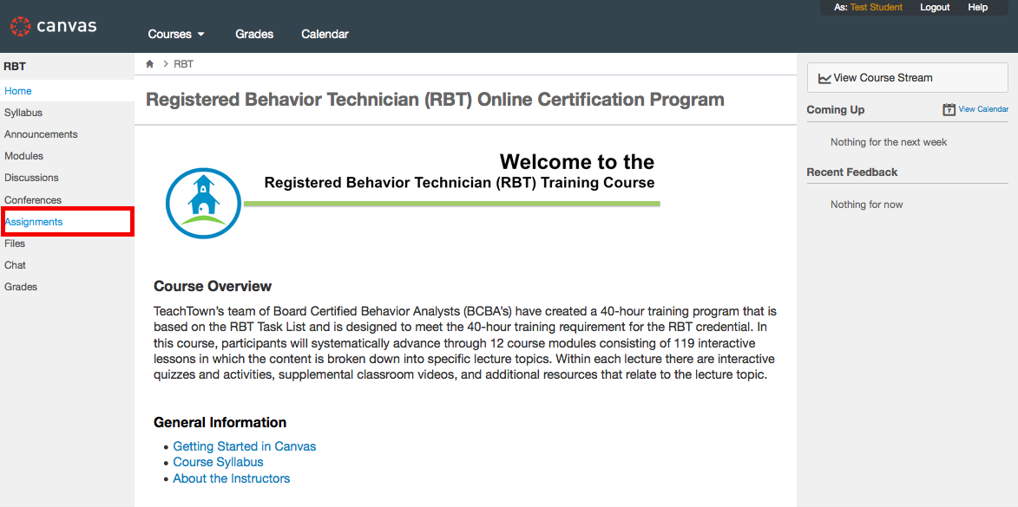
- 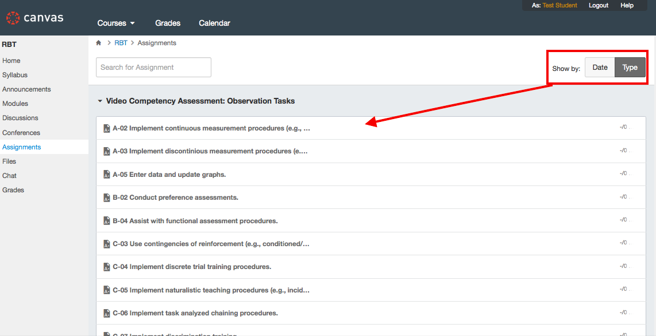
- 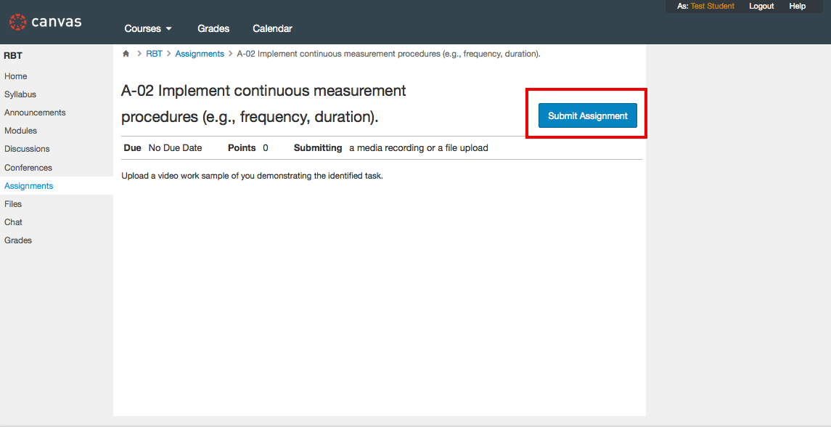
- 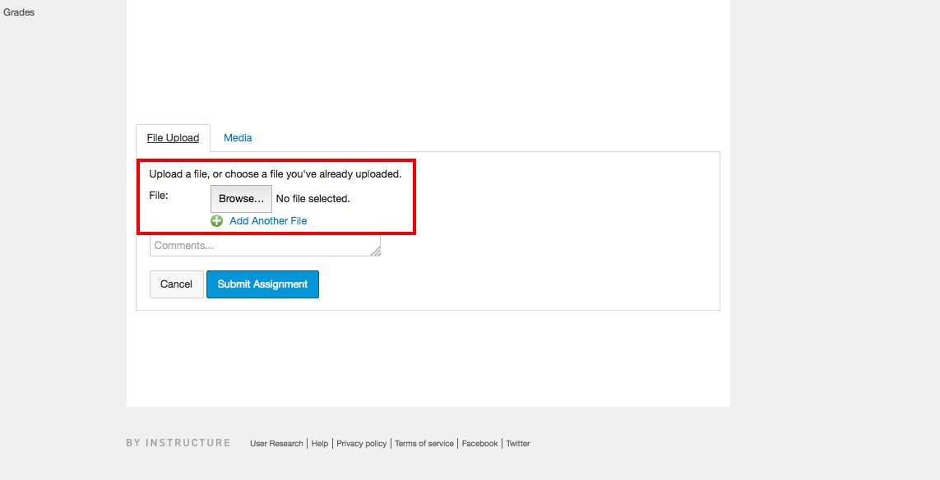
- 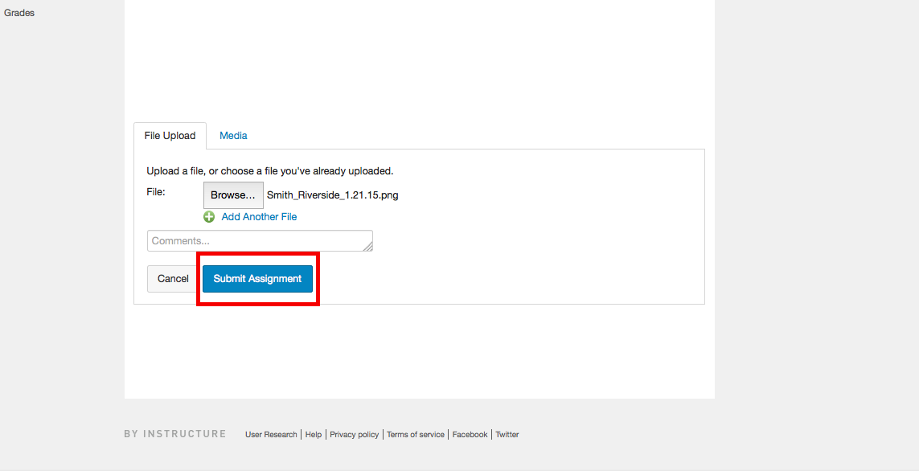
- 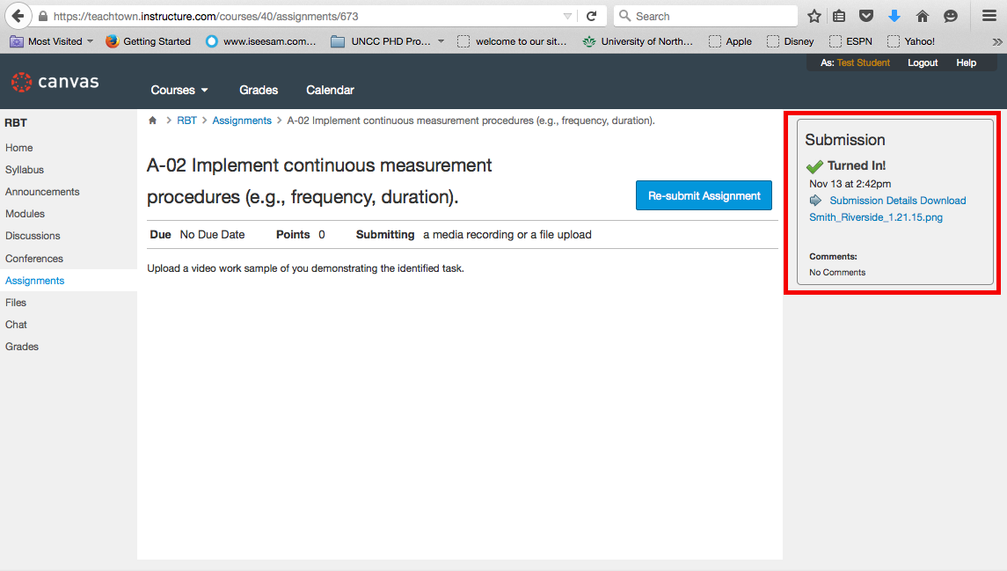

After you have submitted your video, it will be graded on a pass/fail (complete/incomplete) basis, based on whether or not you effectively demonstrate the skill. If you do not effectively demonstrate the skill, you will receive feedback on what needs to done differently, and you can record a new video no earlier than the day after you submitted the first video and resubmit. You can submit as many videos as needed for a single skill.

Frequently-Asked Questions

How Can I Prepare for the RBT Competency Assessment?
1.) Read the BACB’s Registered Behavior Technician Competency Assessment document to know what will be assessed.
2.) Use your course documents and other recommended materials from the lessons to determine how to demonstrate the skills being assessed on video.
3.) Review lecture videos and quizzes for concepts that you feel you do not fully understand.

What Happens Once I Pass the RBT Competency Assessment?
After passing the RBT Competency Assessment, you are able to formally apply for the RBT examination through the BACB. After successfully completing your application, the BACB will review your information and, if all criteria are met and successfully documented, the BACB will allow you to register for the RBT examination. Once you successfully pass the RBT examination, you will be a BACB-certified RBT.

