Proximity Control
Reference Articles:
May, M. E., & Howe, A. P. (2013). Evaluating Competing Reinforcement Contingencies on Off-Task Behavior in a Preschooler with Intellectual Disability: A Data-Based Case Study. Education & Treatment Of Children, 36(1), 97-109.

Lampi, A. R., Fenty, N. S., & Beaunae, C. (2005). Making the Three Ps Easier: Praise, Proximity, and Precorrection. Beyond Behavior, 15(1), 8-12.

Used for function of behavior: (escape, attention, tangible, sensory):
Attention
Escape
Steps of intervention:
- Set up definition**
  - How far away from the student should staff be? Be specific – 3 feet? 2 feet?
  - What does it look like during class periods? Desk close to teacher’s desk?
- Set up classroom so that staff can be successful
  - Move student desk; move teacher desk
Examples: (if intervention looks different for Elementary vs. Middle/High or EBD vs ASD, please indicate):
Staff attention example: Because David enjoys attention from staff at a high rate and often will engage in inappropriate behavior to get that attention, his teacher has moved his desk close to hers so that she is able to give him a high rate of reinforcement without disrupting the rest of the class.

Peer attention example: When Katie sits next to a specific peer, the frequency of her behavior increases. Keeping that in mind, the teacher increases proximity to that peer by placing Katie’s desk on the opposite side of the classroom from the peer. The teacher takes data on this by using momentary time sampling.

Escape example: When distressed, Johnny has a tendency to jump up and leave the classroom by the door or the window. In order to reduce this behavior, his teacher has moved his desk away from the door and the window and close to hers, blocking him from being able to leave the classroom easily without her being able to block.
Data Collection Method: (how would you take data on this intervention?)
Staff self monitoring – Time Interval (do not include in student behavior plan as it is a staff monitoring data collection)

If intervention includes proximity to peers, time intervals can be used to record if the student successfully remained out of proximity to peer.

Example of Momentary Time Sampling Data recording sheet:
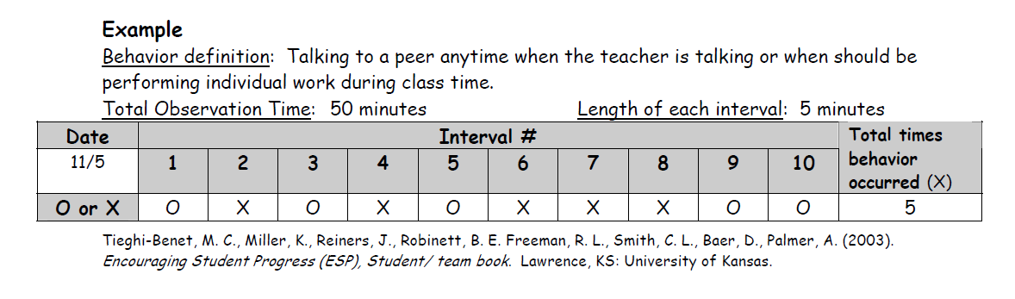
Important notes:
**Proximity Control can be used in defining space between peers too

