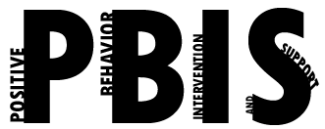
Coastal Georgia Comprehensive Academy
PBIS Team Meeting Agenda

September 15, 2021

Welcome/Call to Order (Ms. Holmes)

Review of minutes from last meeting (Ms. Boyles)

Director’s Report (Mr. Ackerman)
Lawsuit
PBIS Coach’s Report (Ms. Campbell)
SAS
PBIS Data Review (Mr. Barbaree)
Top areas of concern

Division Reports
- Auxiliary Report (Mrs. Durdley)
- High School Report (Dr. Matthews)
- Middle Grades Report (Mr. Heyman)
- Elementary Report (Mrs. Porter)
- Parent Advocate Report (Ms. Capers)

Next meeting date: ____10-20-21_________________________

