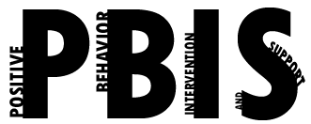
Coastal Georgia Comprehensive Academy
PBIS Team Meeting Agenda

August 25, 2021

Welcome/Call to Order (Ms. Holmes)

Review of minutes from last meeting (Ms. Boyles)

Director’s Report (Mr. Ackerman)
Teaching while in quarantine
PBIS Coach’s Report (Ms. Campbell)
Parent Zoom Meeting on PBIS
PBIS Data Review (Mr. Barbaree)
Top areas of concern

Division Reports
- Auxiliary Report (Mrs. Durdley)
- High School Report (Dr. Matthews)
- Middle Grades Report (Mr. Heyman)
- Elementary Report (Mrs. Porter)
- Parent Advocate Report (Ms. Capers)

Next meeting date: ____9-18-21_________________________

