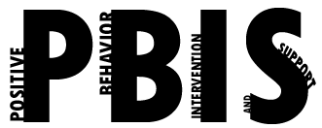

Coastal Georgia Comprehensive Academy
PBIS Team Meeting Agenda

April 28, 2022

Welcome/Call to Order (Ms. Holmes)

Review of minutes from last meeting (Ms. Boyles)

Director’s Report (Mr. Ackerman)

PBIS Coach’s Report (Ms. Campbell)
Upcoming walkthrough with D. Roesal from GLRS, End of Year TFI

PBIS Data Review (Mr. Barbaree)

Division Reports
- Auxiliary Report (Mrs. Durdley)
- High School Report (Dr. Matthews)
- Middle Grades Report (Mr. Heyman)
- Elementary Report (Mrs. Porter)
- Parent Advocate Report (Ms. Capers)

Next meeting date: __May 27_____

