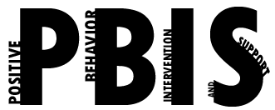

Coastal Georgia Comprehensive Academy
PBIS Team Meeting Agenda

March 15, 2022

Welcome/Call to Order (Ms. Holmes)

Review of minutes from last meeting (Ms. Boyles)

Director’s Report (Mr. Ackerman)

PBIS Coach’s Report (Ms. Campbell)

PBIS Data Review (Mr. Barbaree)

Division Reports
- Auxiliary Report (Mrs. Durdley)
- High School Report (Dr. Matthews)
- Middle Grades Report (Mr. Heyman)
- Elementary Report (Mrs. Porter)
- Parent Advocate Report (Ms. Capers)

Next meeting date: __________________________________________

