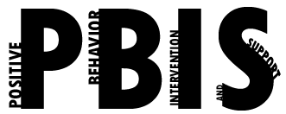

Coastal Georgia Comprehensive Academy
PBIS Team Meeting Agenda

February 15, 2022

Welcome/Call to Order (Ms. Holmes)

Review of minutes from last meeting (Ms. Boyles)

Director’s Report (Mr. Ackerman)

PBIS Coach’s Report (Ms. Campbell)

PBIS Data Review (Mr. Barbaree)
Data review

Division Reports
- Auxiliary Report (Mrs. Durdley)
- High School Report (Dr. Matthews)
- Middle Grades Report (Mr. Heyman)
- Elementary Report (Mrs. Porter)
- Parent Advocate Report (Ms. Capers)

Next meeting date: ___3-15-22______________

