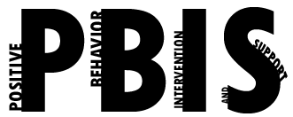

Coastal Georgia Comprehensive Academy
PBIS Team Meeting Agenda

November 18, 2021

Welcome/Call to Order (Ms. Holmes)

Review of minutes from last meeting (Ms. Boyles)

Director’s Report (Mr. Ackerman)

PBIS Coach’s Report (Ms. Campbell)
Review the SAS results

PBIS Data Review (Mr. Barbaree)
Data trends and Tier 2 supports for top referred students

Division Reports
- Auxiliary Report (Mrs. Durdley)
- High School Report (Dr. Matthews)
- Middle Grades Report (Mr. Heyman)
- Elementary Report (Mrs. Porter)
- Parent Advocate Report (Ms. Capers)

Next meeting date: __________________________________________

