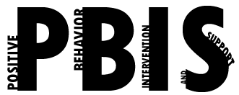

Coastal Georgia Comprehensive Academy
PBIS Team Meeting Agenda

January 4, 2022

Welcome/Call to Order (Ms. Holmes)

Review of minutes from last meeting (Ms. Boyles)

Director’s Report (Mr. Ackerman)
Opportunities for students to engage with Reg Ed peers

PBIS Coach’s Report (Ms. Campbell)
December TFI, Additions to action plan

PBIS Data Review (Mr. Barbaree)

Division Reports
- Auxiliary Report (Mrs. Durdley)
- High School Report (Dr. Matthews)
- Middle Grades Report (Mr. Heyman)
- Elementary Report (Mrs. Porter)
- Parent Advocate Report (Ms. Capers)

Next meeting date: __________________________________________

