LEARNING TARGETS

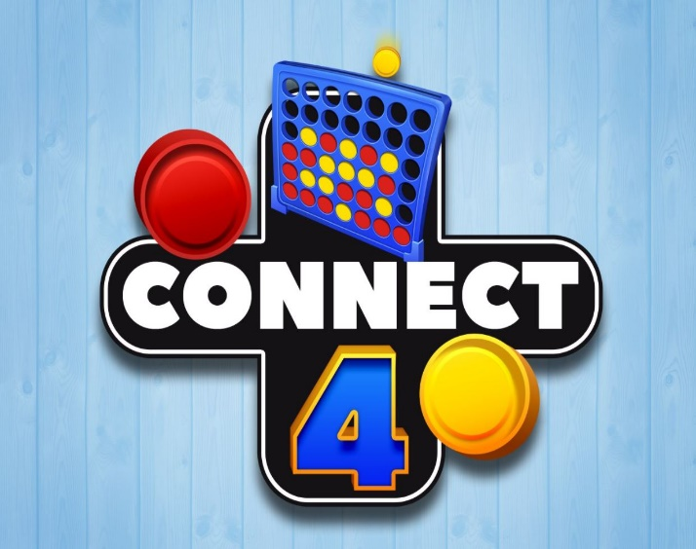
Social Skills:
Following Directions
Encouraging Others
Good Sportsmanship
Showing Empathy

Math Thinking Skills
Predict outcomes of certain moves – Yours AND your opponents!
Detect patterns – Essential to success!
Plan ahead – “Look” ahead to see possible next moves.

