**I can count to 100 by ones and tens.**

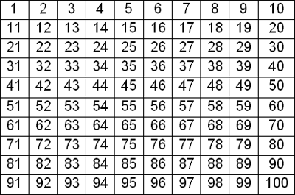 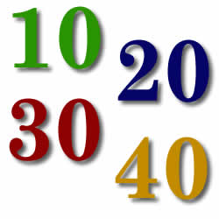

**CCGPS.K.CC.1**

**I can count to 100 from any given number.**

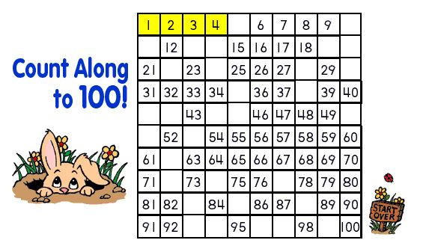

**CCGPS.K.CC.2**

**I can write**

**numbers**  **0-20.**

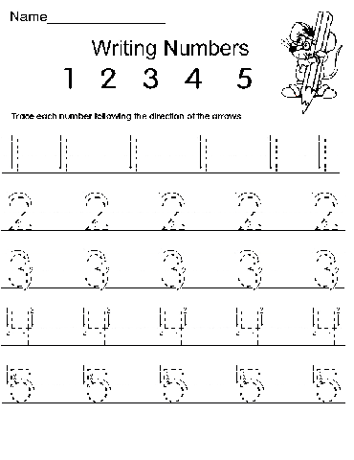[](http://www.google.com/imgres?q=pencils&hl=en&gbv=2&biw=1047&bih=515&tbm=isch&tbnid=j3Jf-Ioo6_qwWM:&imgrefurl=http://www.valdosta.edu/~apgreba/research6.html&docid=cz8ZbbT4PWbizM&imgurl=http://www.valdosta.edu/~apgreba/pencil.jpg.png&w=500&h=500&ei=8yqoT530JojM9QTD7KyzAw&zoom=1&iact=hc&vpx=429&vpy=154&dur=735&hovh=225&hovw=225&tx=114&ty=122&sig=102090236670549412883&page=1&tbnh=131&tbnw=131&start=0&ndsp=10&ved=1t:429,r:7,s:0,i:140)

**CCGPS.K.CC.3**

**I can write numbers**

**0-20 by labeling sets.**

[](http://www.google.com/imgres?q=pencils&hl=en&gbv=2&biw=1047&bih=515&tbm=isch&tbnid=j3Jf-Ioo6_qwWM:&imgrefurl=http://www.valdosta.edu/~apgreba/research6.html&docid=cz8ZbbT4PWbizM&imgurl=http://www.valdosta.edu/~apgreba/pencil.jpg.png&w=500&h=500&ei=8yqoT530JojM9QTD7KyzAw&zoom=1&iact=hc&vpx=429&vpy=154&dur=735&hovh=225&hovw=225&tx=114&ty=122&sig=102090236670549412883&page=1&tbnh=131&tbnw=131&start=0&ndsp=10&ved=1t:429,r:7,s:0,i:140) 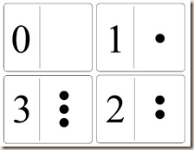 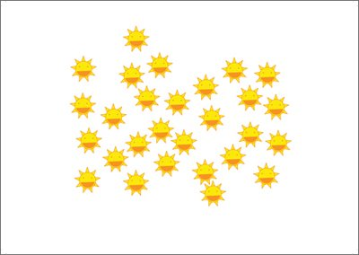

**CCGPS.K.CC.3**

**I can count a given number of objects, tell how many, and tell how many more.**

**5 balloons  10 balloons**

**CCGPS.K.CC.4a,b,c and CCGPS.K.CC.5**

**I can compare the number of objects as greater, less, and equal.**

**greater less equal**

**CCGPS. K.CC.6**

**I can compare two numbers as**

**greater and less.**

8

3

**less greater**

**I can represent addition and subtraction with drawings and manipulatives.**

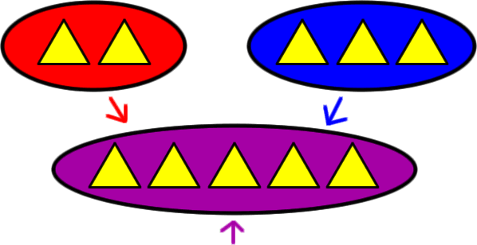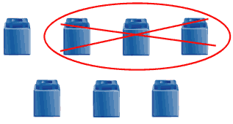

**2 + 3 = 5 7 – 3 = 4**

**CCGPS.K.OA.1, 2**

**I can decompose**

**(break apart) a number more than one way.**

**6 balls……how many red or blue?**

|  |  |  |  |  |  |  |
| --- | --- | --- | --- | --- | --- | --- |
|  |  |  |  |  |  |  |

**CCGPS.K.OA.3**

**Given a number, I can find the missing number that needs to be added to it to equal 10.**

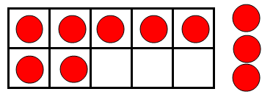

**CCGPS.K.O,4**

**I can fluently add 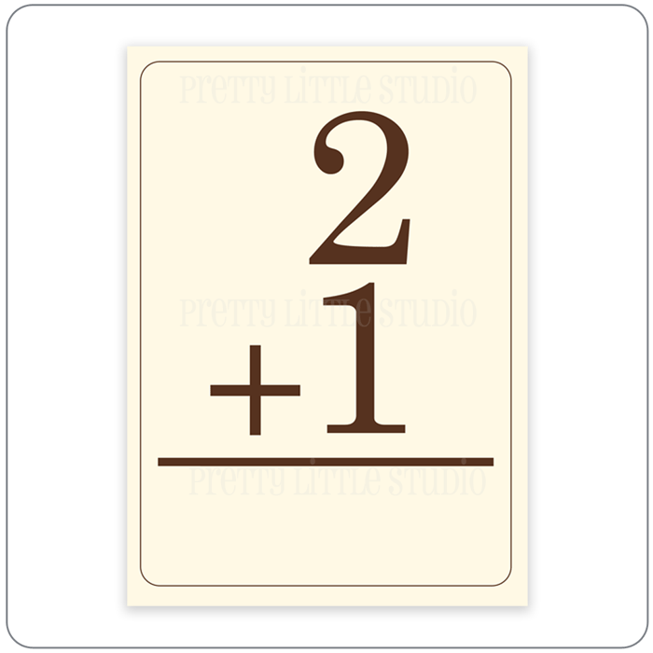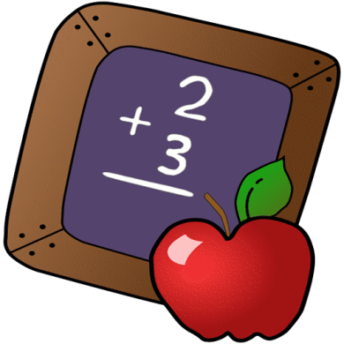 within 5.**  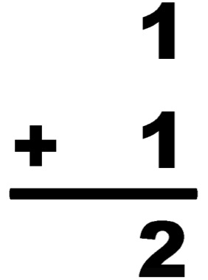

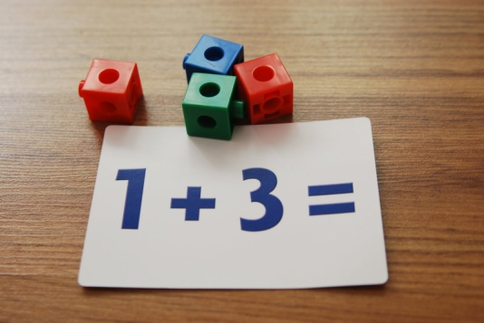

**CCGPS.K.OA.5**

**I can fluently subtract within 5.**

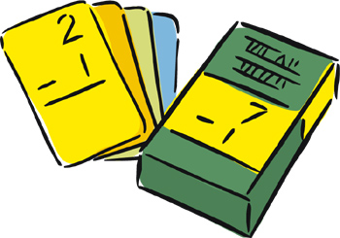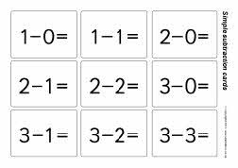

**CCGPS.K.OA.5**

**I can compose (put together) and decompose (break apart) numbers from 11-19 into tens and ones.**

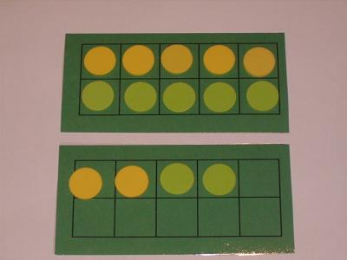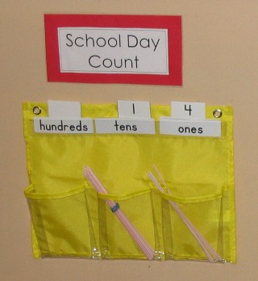

**CCGPS.K.NBT.1**

**I can describe length and weight of objects. I can compare two objects using 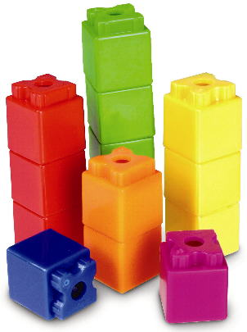 measureable 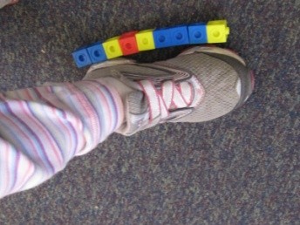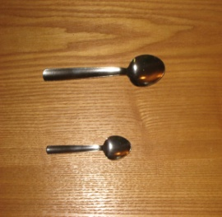 attributes.** 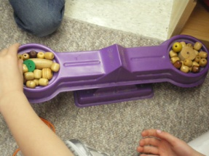

**CCGPS.K.MD 1 and 2**

**I can classify objects, count the objects, and sort the categories by count.**

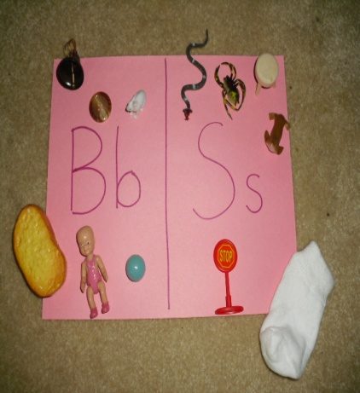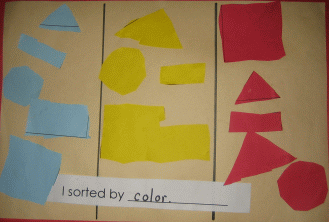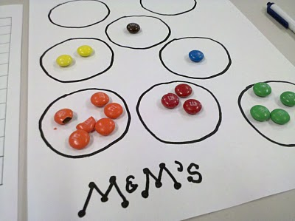

**CCGPS.K.MD.3**

**I can identify shapes that are flat or solid.**

**Flat Shapes Solid Shapes**

**C:\Documents and Settings\Teacher\Local Settings\Temporary Internet Files\Content.IE5\76SU0BUW\MC900048284[1].wmf**

**C:\Documents and Settings\Teacher\Local Settings\Temporary Internet Files\Content.IE5\SPYJ09YV\MC900048285[1].wmf**

**CCGPS.K.G.3**

**I can correctly name the shapes below.**

**hexagon triangle circle square**

**rectangle cylinder C:\Documents and Settings\Teacher\Local Settings\Temporary Internet Files\Content.IE5\76SU0BUW\MC900048284[1].wmf cone**

**C:\Documents and Settings\Teacher\Local Settings\Temporary Internet Files\Content.IE5\SPYJ09YV\MC900048285[1].wmf sphere cube**

**CCGPS.K.G.2**

**I can describe the position of shapes using the terms below.**

**The blue triangle is beside or next to the circle.**

**The rectangle is between the cube and square.**

**C:\Documents and Settings\Teacher\Local Settings\Temporary Internet Files\Content.IE5\76SU0BUW\MC900048284[1].wmf**

**The cone is above the hexagon.**

**The hexagon is below the cone. The cylinder is behind the rectangle.**

**The rectangle is**

**in front of the cylinder.**

**CCGPS.K.G.4**

**I can compare shapes to describe differences, similarities, and parts.**

**4 corners A cylinder is**

**4 sides made from 2 circles**

**and 1 rectangle.**

**No corners** 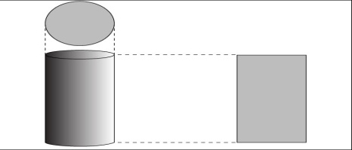

**CCGPS.K.G.4**

**I can create models of shapes and draw shapes.**

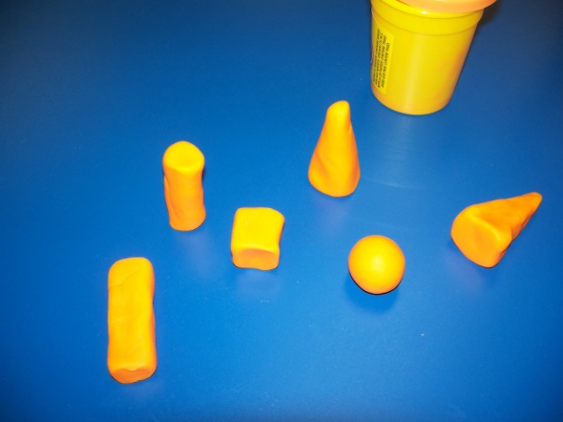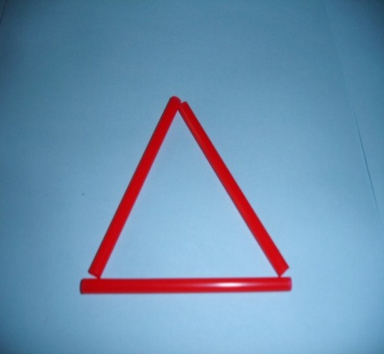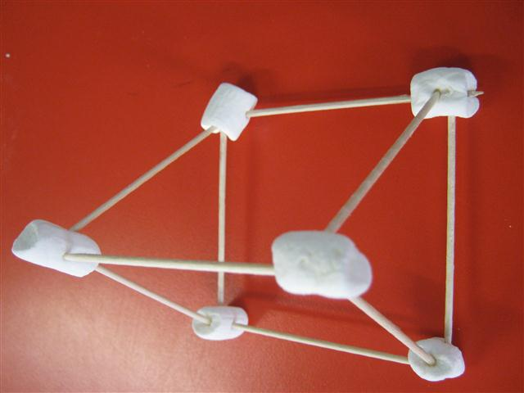

**CCGPS.K.G.5**

**I can compose larger shapes by sliding, rotating, and flipping simple shapes.**

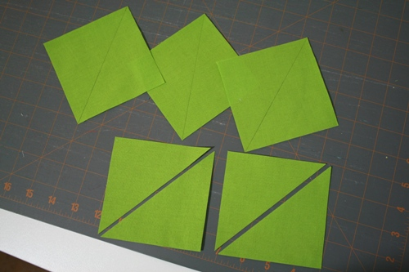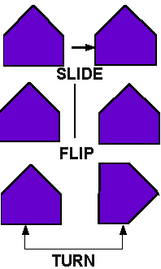

**CCGPS.K.G.6**