With help, I can ask and answer questions about key details in a text.
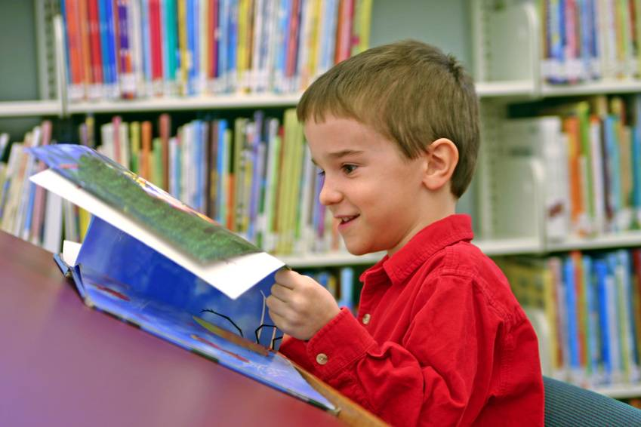
RL.K.1 and RI.K.1
With help, I can retell familiar stories, including key details.
LET ME TELL YOU ABOUT THIS STORY I READ!
RL.K.2
With help, I can identify characters, settings, and major events in a story.
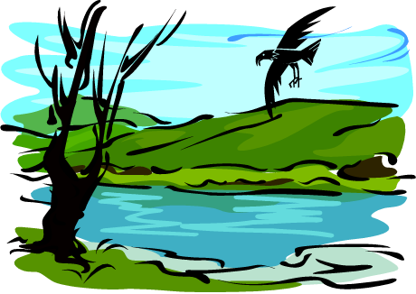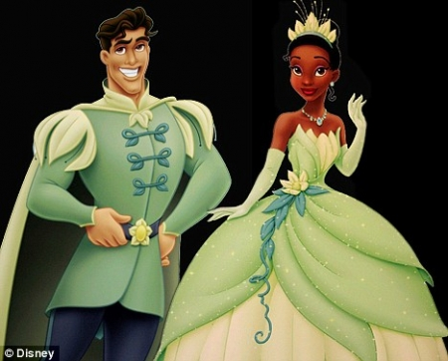
characters
setting
RL.K.3
I can ask and answer questions about unknown words
in a text.

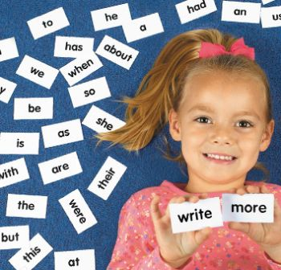
RL.K.4 and RI.K.4
I can recognize common types of texts, such as storybooks and poems.
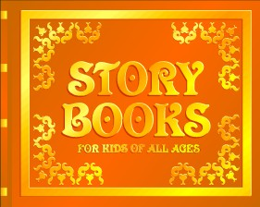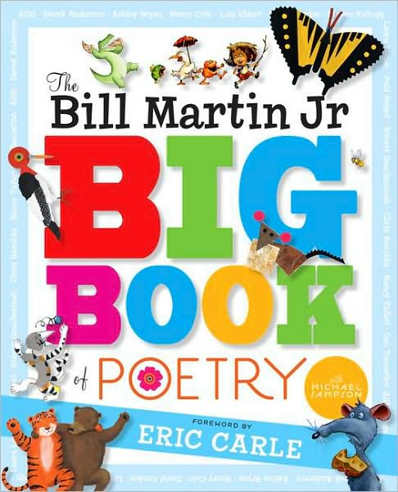
RL.K.5
With help, I can name and tell the role of the author and illustrator of a story.
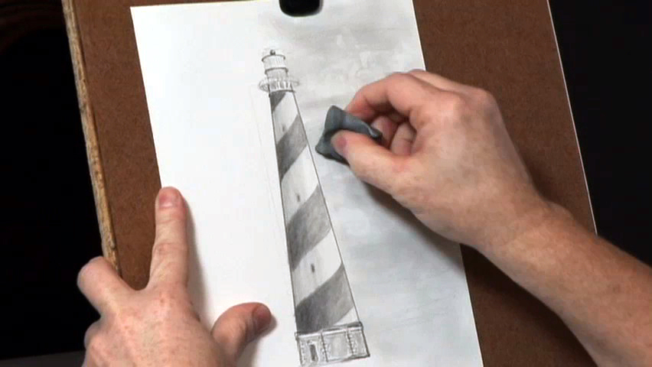
The illustrator
draws the pictures.

The AUTHOR
writes the words.

RL.K.6
With help, I can describe the relationship between illustrations and the story.

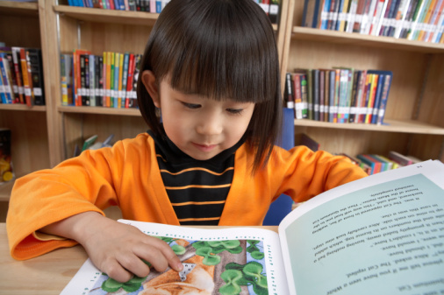
RL.K.7
With help, I can compare and contrast (tell how they are alike and different) the adventures and experiences of characters in stories.
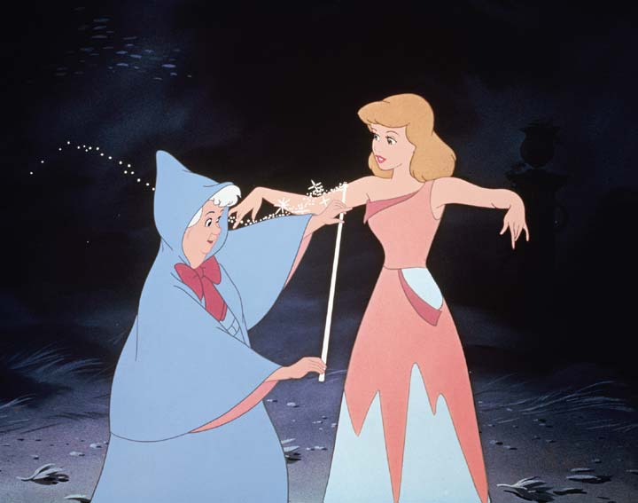

RL.K.9
I engage in group reading activities with purpose and understanding.
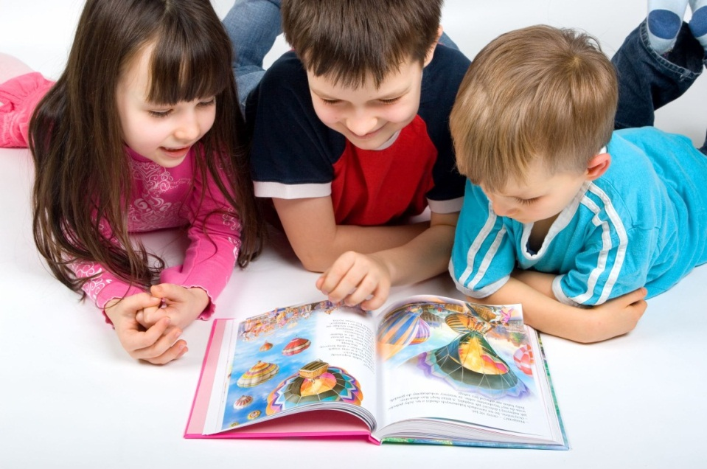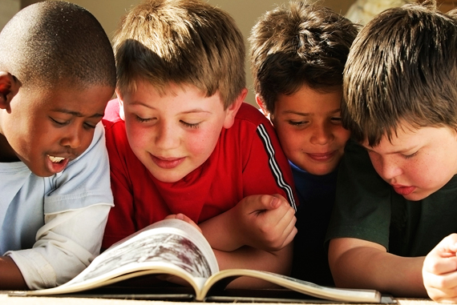

RL.K.10 and RI.K.10 and RF.K.4
With help, I can identify (tell) the main topic and retell key details of a text.
A lot of important things happened in this story too.
This story is mostly about…..

RI.K.2
With help, I can describe (tell about) the connection between two individuals, events, ideas, or pieces of information in a text.

Let me tell you how this all fits together.
RI.K.3
I can identify the front cover, back cover, and title page of a book.
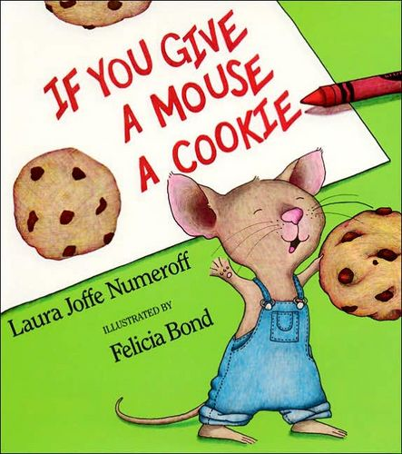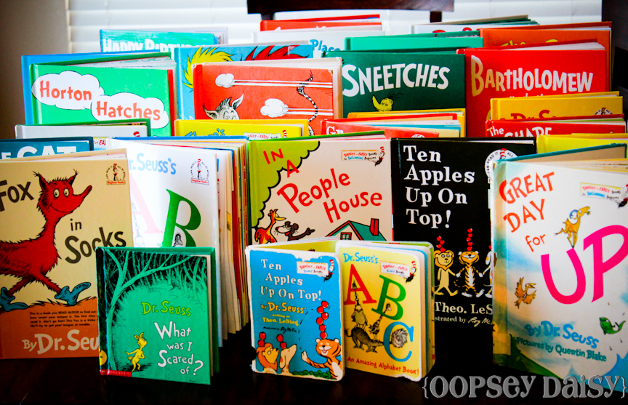
RI.K.5
I can name the author and illustrator and define their roles in presenting the ideas or information in a text.
I can tell a lot about the story by the author’s words and the illustrator’s pictures.

RI.K.6
With help, I can describe the relationship between
illustrations and the text.
I know how the words and pictures go together to make
the story make sense.

RI.K.7
With help, I can (tell why) identify the reasons an author gives to support points in a text.
I know what the author means in the story.

RI.K.8
With help, I can identify basic similarities and differences (tell how they are alike and different) between two texts
on the same topic.
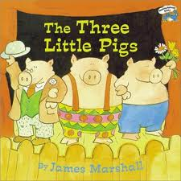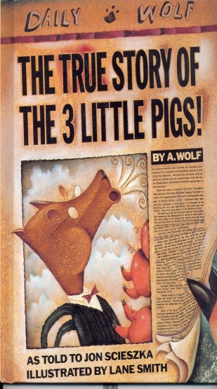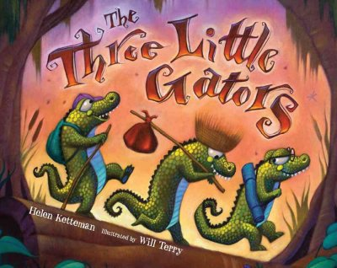
RI.K.9
I can follow words from left to right, top to bottom, and page-by-page.
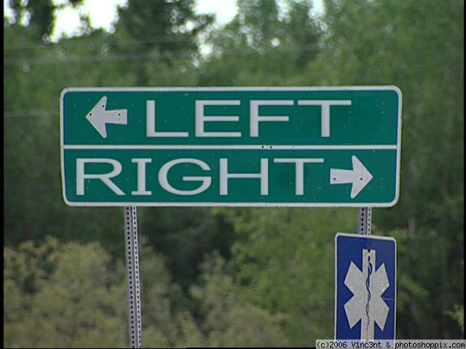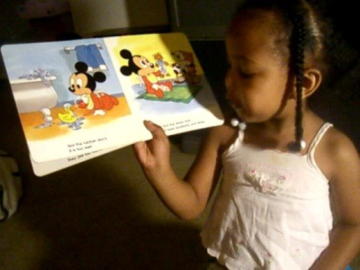
RF.K.1A
I can recognize that spoken words are written by using sequences of letters.
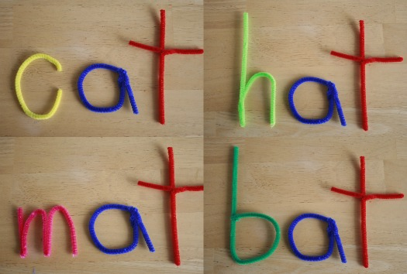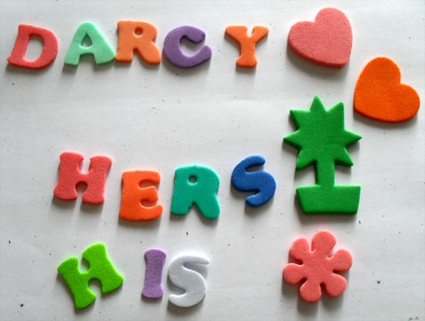
RF.K.1B
I understand that words are separated by spaces in print.

The dog ran after the cat.
Space

RF.K.1C
I can recognize and name all uppercase and lowercase letters of the alphabet.
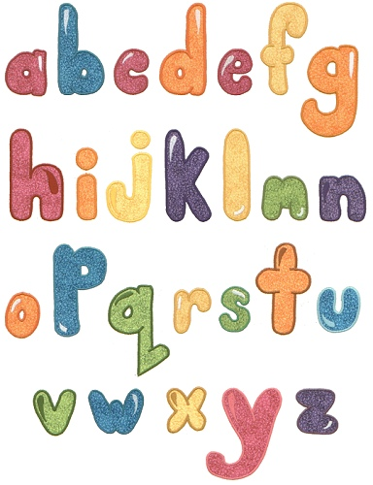
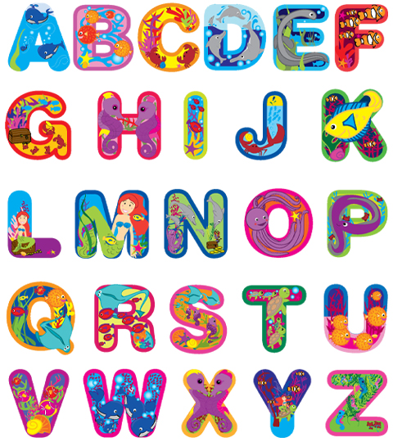

RF.K.1D
I can recognize (hear them) and produce (make) rhyming words.

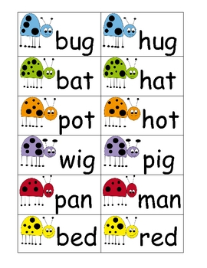

RF.K.2
I can count, pronounce (say), blend (put together), and segment (break apart) syllables in spoken words.

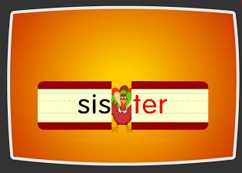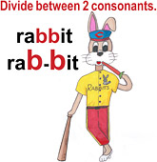

RF.K.2B
I can blend (put together) and segment (break apart) onsets and rimes of single (one)-syllable
spoken words.
\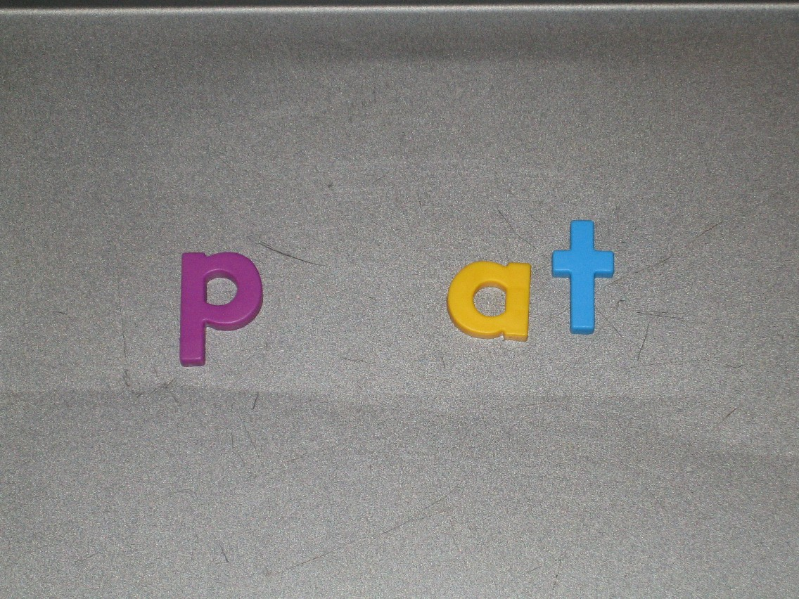
RF.K.2C
I can isolate and pronounce (say by itself) the initial, medial vowel, and final sounds (phonemes) in three-phoneme (CVC) words.
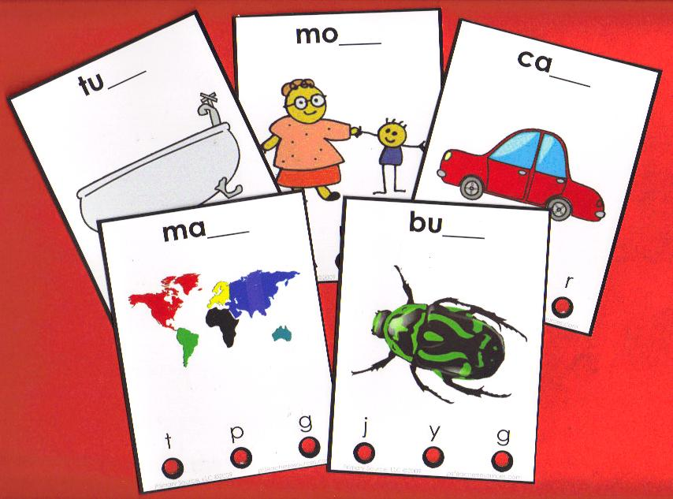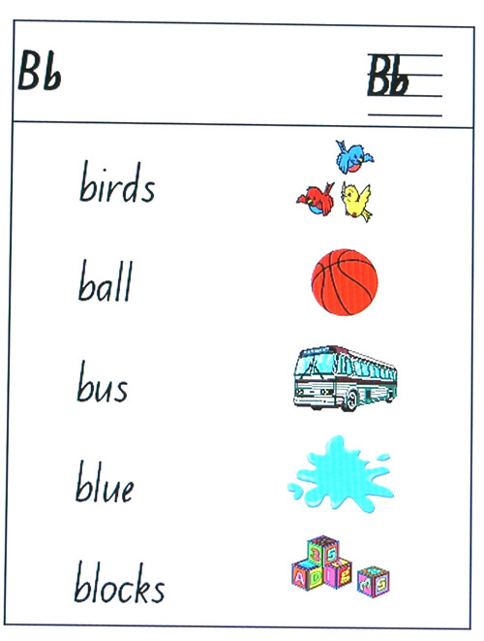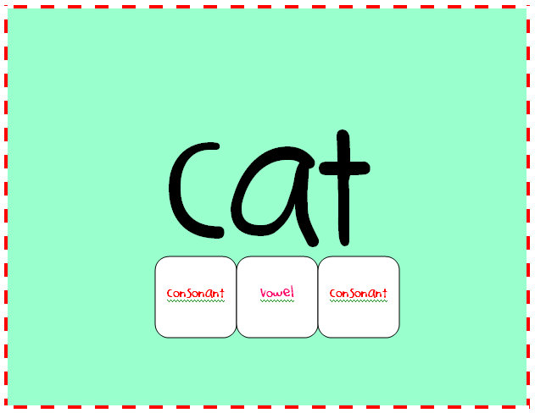

RF.K.2D
I can add or substitute individual sounds (phonemes) in simple, one-syllable words to make new words.
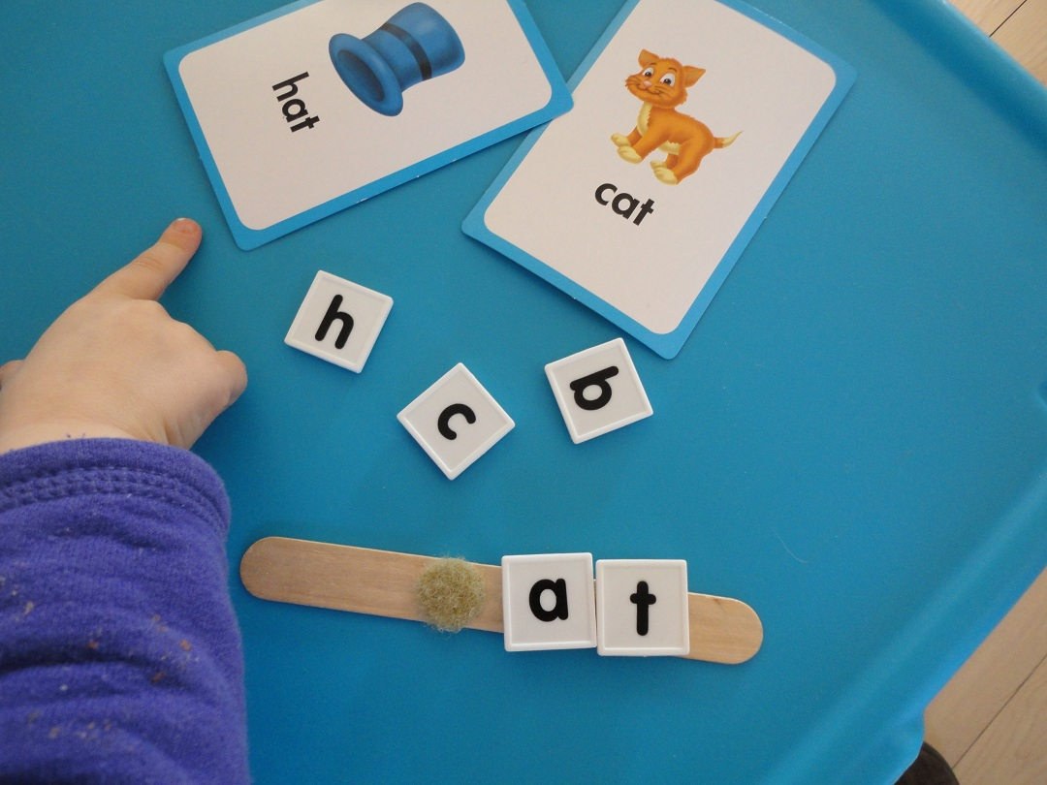
RF.K.2E

I can demonstrate basic knowledge of (show I know) letters and the sounds consonants make.
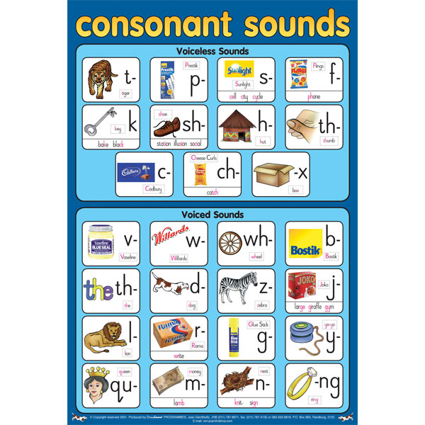
RF.K.3A
I can associate (connect) the long and short sounds with the spellings (graphemes) for the five major vowels.
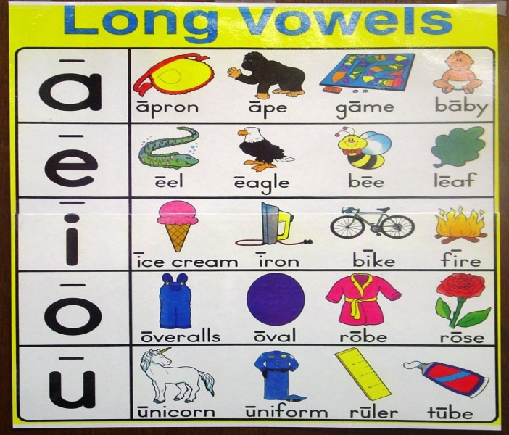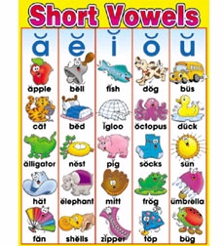

RF.K.3B
I can read common high-frequency words by sight.
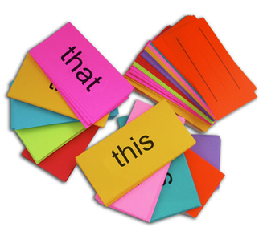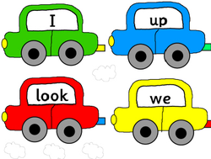

RF.K.3C
I can distinguish (tell the difference) between words spelled almost the same by looking at the different sounds of the letters.
cat bat pig pin

RF.K.3D

RF.K.3D
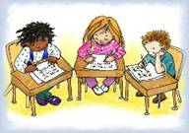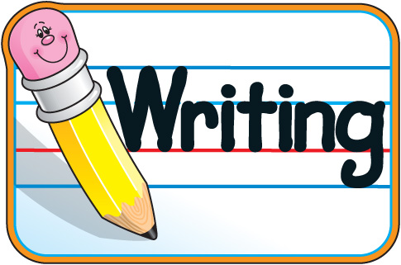
I can use drawings, dictating (telling my teacher what to write), and writing on my own to
compose my own opinions.

The writing will…

- tell the topic or the name of the book I am writing about, and
- state my opinion (my thoughts and feelings) about the topic or book.
W.K.1
I can use drawings, dictating (telling my teacher what to write), and writing on my own to compose informative explanatory texts.

The writing will…
- name what I am writing about and
- give some information about the topic.

W.K.2
I can use drawings, dictating (telling my teacher what to write) and writing on my own
to narrate (tell about) an event.

The writing will…
- tell about the events in the order and
- provide a reaction to what happened.
W.K.3
With help, I can use questions and suggestions from my friends to make my writing better.
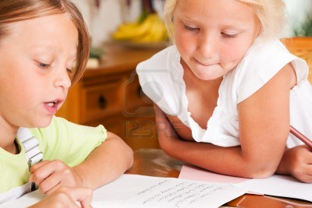
“I think I could understand better if you said……”

W.K.5
With help from my class, I can use different digital tools to produce and publish writing.
W.K.6
I can work on shared research
and writing projects.
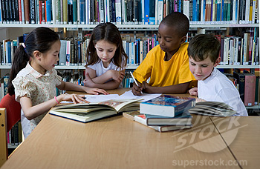
W.K.7
With help, I can recall information from experiences or gather information from other sources to answer a question.

W.K.8
I can follow rules we agree on for discussions.
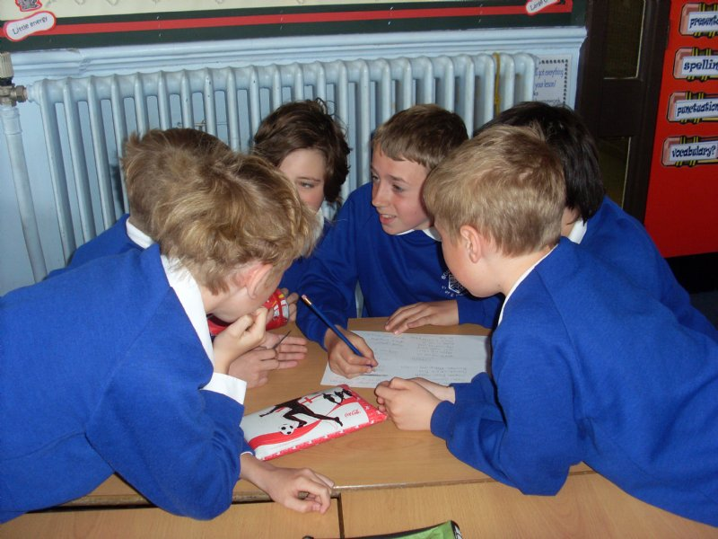
Take turns talking.
Listen to others.

SL.K.1A

I can have a conversation through multiple exchanges.
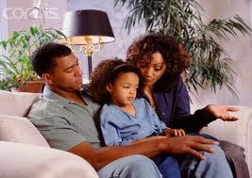

SL.K.1B
I can show I understand what is read or spoken aloud by asking and answering questions about key details and asking questions
if I don’t understand.
SL.K.2
I can ask and answer questions to seek help, get information, or clarify something that I don’t understand.

SL.K.3
I can describe (tell about) familiar people, places, things, and events and, with help, add details.
PEOPLE
DESCRIBING OR TELLING ABOUT
THINGS
EVENTS
PLACES

SL.K.4
I can add drawings or other visual displays to descriptions to give more detail.

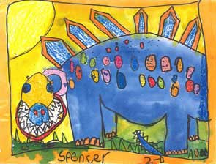
“This is what my animal looks like.”

SL.K.5
I can speak audibly (so people can hear) and express thoughts, feelings, and ideas clearly.
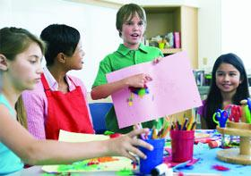
SL.K.6
I can print uppercase and lowercase letters.
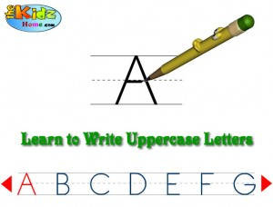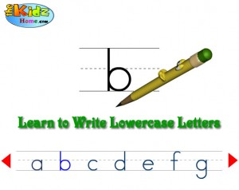
L.K.1A
I can use nouns and
verbs correctly.
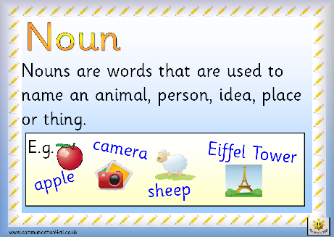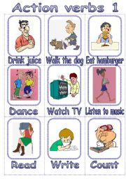

L.K.1B
I can say regular plural nouns by adding
/s/ or /es/.
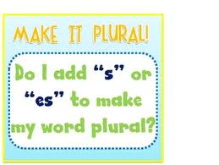
L.K.1C
I understand and use question words (interrogatives).

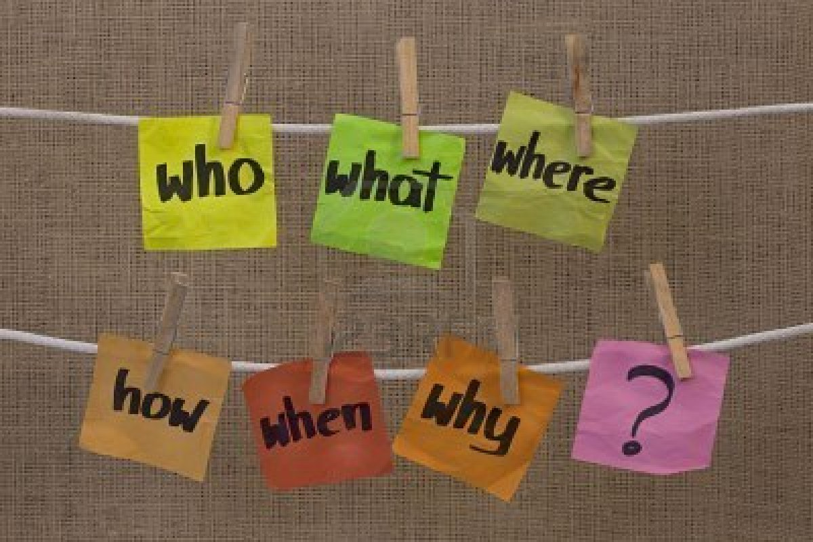

L.K.1D
I can use prepositions correctly.

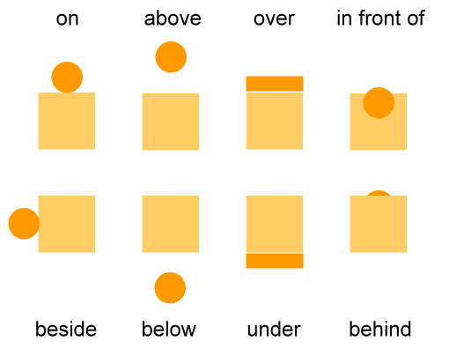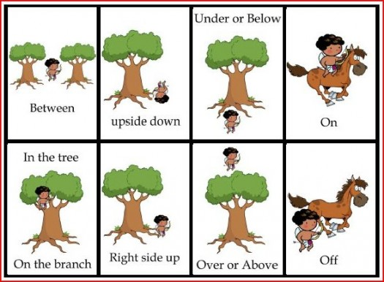
L.K.1E
I can produce and expand (make better) complete sentences in shared language activities.

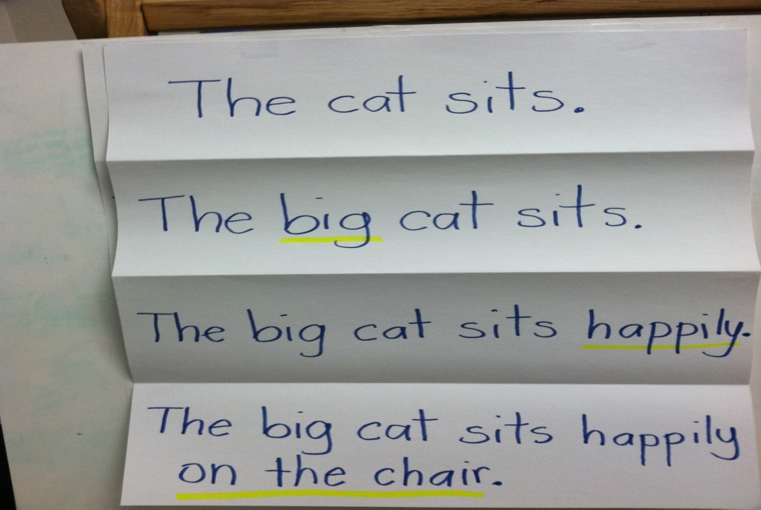
L.K.1F
I can capitalize the first word in a sentence and the pronoun I.
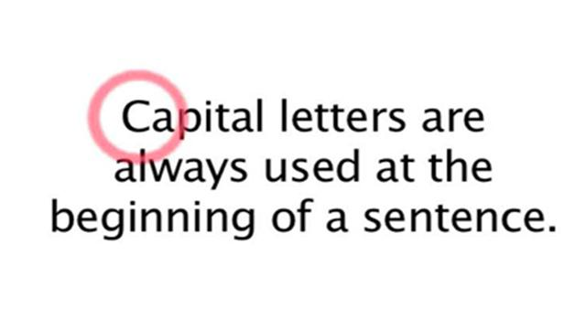
Susan and I went to the circus.

L.K.2A
I can recognize and name end punctuation.
L.K.2B
I can write a letter or letters for most consonant and short-vowel sounds (phonemes).
L.K.2C
I can spell simple words phonetically (by sounding them out), drawing on knowledge of sound-letter relationships.

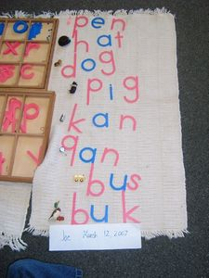
L.K.2D
I can identify new meanings for familiar words and apply (use) them accurately.
The duck said “Quack, quack”.
You must duck your head to go under the branch.
L.K.4A
I can use inflections and affixes as a clue to the meaning of an unknown word.
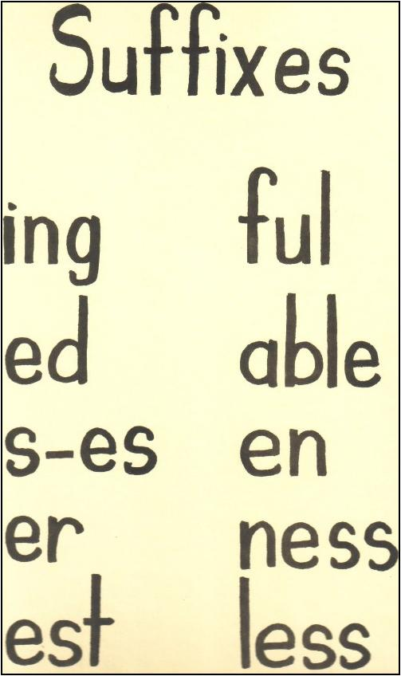
L.K.4B
I can sort common objects into categories to gain a sense of what they represent.

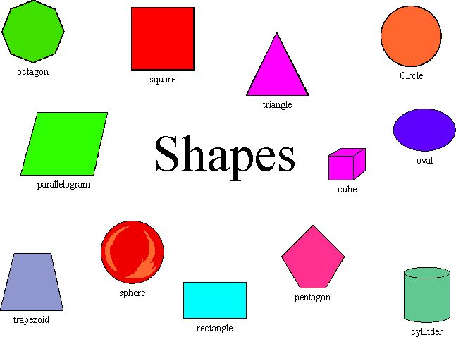
FOOD
L.K.5A
I can show my understanding of verbs and adjectives by relating them to their opposites (antonyms).
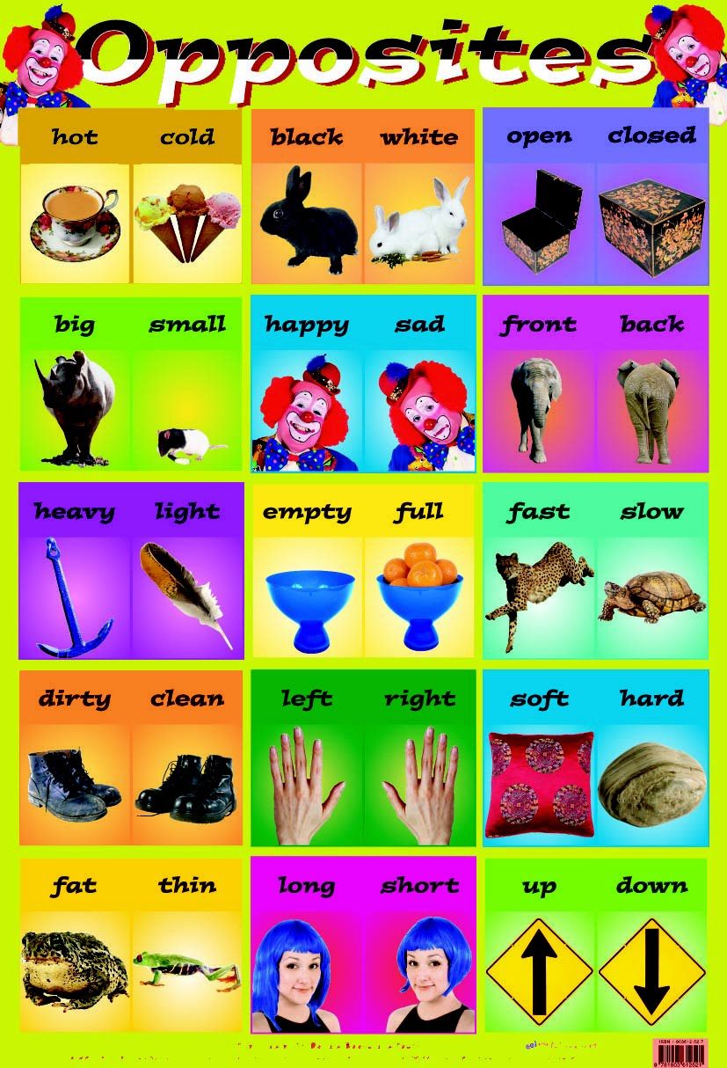
L.K.5B
I can make real-life connections between words and their use.
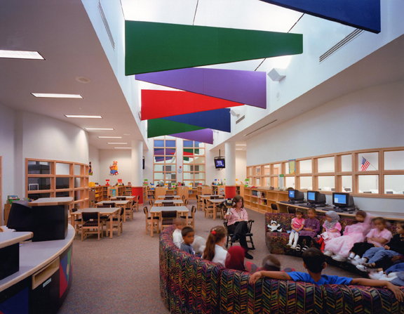
This media center is colorful.
L.K.5C
I can distinguish shades of meaning among verbs describing the same general action by acting out the meanings.
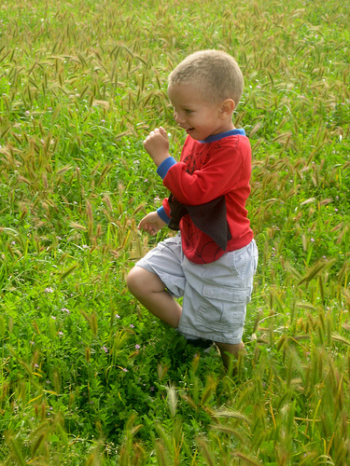
This child is prancing.
This child is walking.
This child is marching.

L.K.5D
I can use words and phrases I learn from conversations, reading and responding to texts.

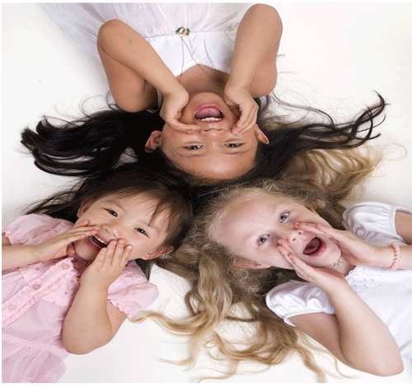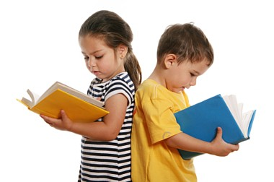

L.K.6

