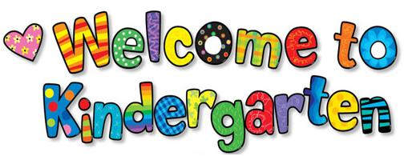bs00216_

**K-1 LEAP**

**Language Enrichment Autism Program**

Welcome to the 2020-2021 school year!!

My name is Kari Hunter and I excited to be your child’s teacher at Coastal Georgia Comprehensive Academy. I have a Master’s degree in Special Education and this is my 4th year teaching in the LEAP program. This year our class will be made up of students in Kindergarten and 1st Grade. Your student will also receive wonderful support from our Paraprofessionals, BCBA, Autism Interventionist and Speech and Language Pathologist.

* We will be doing distance learning until it is safe to return to the school building.
* Distance Learning will take place in the Its Learning LMS platform.
* Each student will have an individual Distance Learning Plan. This does not replace the IEP but is in addition to it as long as we are doing school virtually.

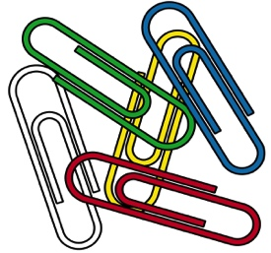

Materia Suggested supplies: (not required)

1. Paper (any kind to work on handwriting)
2. Pencils or crayons
3. Playdough (for sensory breaks)

I use ClassDojo to communicate with parents. You can connect to our class using the link [**https://tinyurl.com/cgcaleap1**](https://tinyurl.com/cgcaleap1). It is available by app or website and allows us to message back and forth in real time. I am also available by phone **(913) 303-1433** or by email [**Kari.Hunter@sccpss.com**](mailto:Kari.Hunter@sccpss.com). I truly believe in good communication with my families. If you have any questions or concerns about ANYTHING please do not hesitate to contact me.

Thank you,

Kari Hunter

