Food Diary Project for _________________________________ (insert name)
*Please Note: This is a 10-page document.
Grading Procedure for this Project:
- Dietary Intake Record: 30 points
- Construction/Description of Personal Food Guide Plate: 15 points
- Evaluation of Daily Caloric Expenditure: 30 points
- Properly calculate BMR: 15 points
- Seven "wrap up" questions: 10 points

Total Possible Points: 100

You should be using the food labels on the drink/food products you consume to determine the caloric value - remember that you will need to keep in mind your portion (serving) size of each item and adjust the numbers accordingly (as you did on your food label homework assignment).
Once you have recorded your dietary intake for the one day, you will be responsible for calculating your daily caloric and fat intake. If you have trouble locating calorie/fat gram numbers for any of the foods you consume, you may do a google search for "nutritional values". If you go out to eat during this project, you should ask an employee of the restaurant if they have nutritional information on their food/drink products (many should). If they don't, you can most likely find it on the company's website.

Food Diary Record for Day #1
(insert day and date here)

Early Day:

Food or Drink Serving Size Total # of Cals. Total Gs of Fat *Which
Food Group?

Mid-Day:

Food or Drink Serving Size Total # of Cals. Total Gs of Which
Food Group?

Late Day:

Food or Drink Serving Size Total # of Cals. Total Gs of Fat Which Food Group?

Total Calories Consumed in Day #1:
Total Grams of Fat Consumed in Day #1:

Did you take a multi-vitamin today? ________ (Just answer “yes” or “no”)

Food Diary Record for Day #2
(insert day and date here)

Early Day:

Food or Drink Serving Size Total # of Cals. Total Gs of Fat *Which
Food Group?

Mid-Day:

Food or Drink Serving Size Total # of Cals. Total Gs of Which
Food Group?

Late Day:

Food or Drink Serving Size Total # of Cals. Total Gs of Fat Which Food Group?

Total Calories Consumed in Day #2:

Total Grams of Fat Consumed in Day #2:

Did you take a multi-vitamin today? ________ (Just answer “yes” or “no”)

Food Diary Record for Day #3
(insert day and date here)

Early Day:

Food or Drink Serving Size Total # of Cals. Total Gs of Fat *Which
Food Group?

Mid-Day:

Food or Drink Serving Size Total # of Cals. Total Gs of Which
Food Group?

Late Day:

Food or Drink Serving Size Total # of Cals. Total Gs of Fat Which Food Group?

Total Calories Consumed in Day #3:

Total Grams of Fat Consumed in Day #3:

Did you take a multi-vitamin today? ________ (Just answer “yes” or “no”)

Your Plate

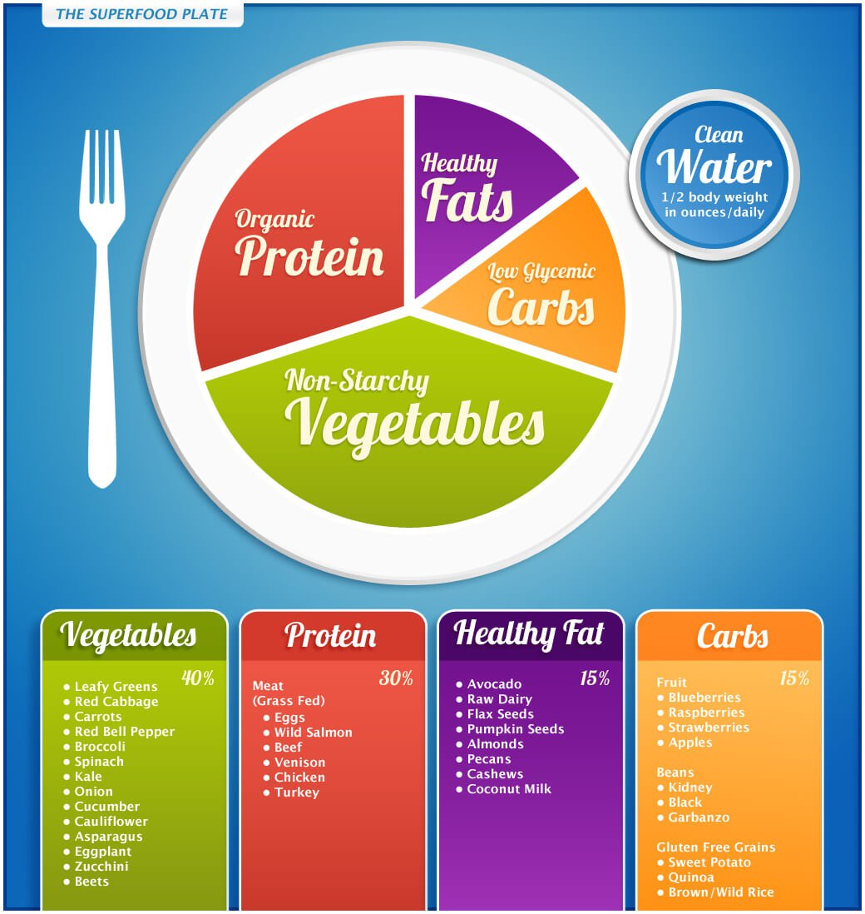

Remember the first discussion question for the nutrition unit: what would the average American’s food guide plate look like if it was based on their dietary consumption and not on what they should eat?

Well, what do you think yours looks like? By using the far right column on your diet records sheet, take the average of your three days and fill in the chart below (in the highlighted areas)

- Fats, Oils, Sweets: _______ servings/day
- Dairy: Milk, Yogurt, Cheese: _______ servings/day
- Meats, Eggs, Nuts: _________ servings/day
- Vegetables: _________ servings/day
- Fruits: __________ servings/day

Does your intake match the recommendations? ________

Comparison of Your Daily
Caloric Intake versus Caloric Expenditure

In order to completely fill out the charts on the next three pages, you will need to refer to use Mozilla Firefox to search for a “Caloric Expenditure Calculator” to approximate the number of calories you have expended per day of your Food Diary project.

You will need to calculate the caloric expenditure for each instance of physical activity for the entire day, and for all three days. This not only includes obvious examples of physical activity such as exercising BUT ALSO should include getting ready for school in the morning, sitting in class, and your Resting Metabolic Rate – which is discussed in a content tab in the Nutrition Unit. You will add your resting metabolic rate to the activities you perform each day for your total!

MY RESTING METABOLIC RATE BASED ON MY AGE, GENDER, HEIGHT AND WEIGHT:
w=weight (pounds)
h=height (inches)
a= age (years)
Formulas to use:
Boys: 4.5w + 15.9h - 5a +5 =
Girls: 4.5w + 15.9h - 5a - 161=

Answer: ___________________________

Day One:

Activity | Approx. Level of Intensity | Approx. Length of Time | Total # of Calories Expended

Total # of Calories Expended (with RMR added) for Day 1:
Total # of Calories Taken in for Day 1:
Difference in Intake vs. Expenditure: (+ or -)

Day Two:

Activity | Approx. Level of Intensity | Approx. Length of Time | Total # of Calories Expended

Total # of Calories Expended (with RMR added) for Day 2:
Total # of Calories Taken in for Day 2:
Difference in Intake vs. Expenditure: (+ or -)

Day Three:

Activity | Approx. Level of Intensity | Approx. Length of Time | Total # of Calories Expended

Total # of Calories Expended (with RMR added) for Day 3:
Total # of Calories Taken in for Day 3:
Difference in Intake vs. Expenditure: (+ or -)

Conclusion Questions

I sincerely hope that you have learned a lot about your personal diet from this project – both the good and the bad. To conclude, please answer the following questions honestly and completely.

- How would you rate your current diet? (great, good, needs a little work, needs a lot of work)

- Please explain your personal diet rating in question #1.

- What disease(s) are you currently putting yourself at risk for just based on your diet alone? Why did you pick this/these disease(s)?

- What are three actions you could take to make your diet a healthier one?

- What are some ways you can reduce fat and sodium in your diet? Be Specific.
(Example: Skim Milk Verses Whole Milk)

- Why would grilled items be healthier than fried items?

- Create one day worth of meals that would meet the recommended guidelines:

Breakfast:

Snack One:

Lunch:

Snack Two:

Dinner:

