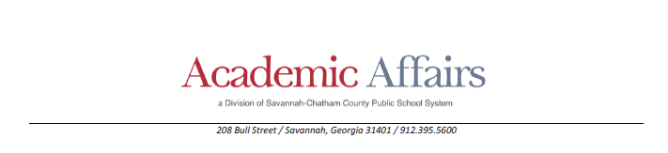

SAFETY INTERVENTION FORM
Student Name: Click here to enter text. | Student DOB: Click here to enter text. |  |  | School: Click here to enter text.
Teacher/ Class: Click here to enter text. | Staff involved in intervention: Click here to enter text. |  |  | Witnesses: Click here to enter text.
Date of Report: Click here to enter a date. | Mindset certified: ☐Yes ☐ No |  |  | Certification date:  Click here to enter a date.
Date of Intervention: Click here to enter a date. | Location: Click here to enter text. |  |  | Activity Preceding Intervention:  Click here to enter text.
Time in: Click here to enter text. | Time out: Click here to enter text.
Total time in Intervention:
☐ <1 min☐2 min ☐ 3 min ☐ 4 min☐ 5 min ☐6 min ☐7 min☐ 8 min☐9 min☐ 10 min (max)
Student able to return to class: ☐ Yes ☐ No
Behavior/s displayed: ☐Harm to self ☐Harm to others ☐ Harm is imminent
Describe: Click here to enter text.
De-escalation Techniques Attempted |  |  | Physical Intervention *  (Must complete a Log Entry in PS)
☐ Four-Step Counseling Model  Avoiding Contact:  ☐ Movement (slide step)  ☐ Protection (upper, Lower, Back against the wall)  Physical Contact:  ☐ Aggression from the front Grasp, Choke, Bite)  ☐ Aggression from behind (Arm Twist. Choke, Hair Pull)  ☐ Assisted Choke Release |  |  | Vertical Containment  ☐ Embrace  ☐ Leveraged Embrace  ☐ Assisted Relocation  Horizontal Containment  ☐ Single Staff  ☐ Dual Staff  ☐ Object Containment & Release
Were there injuries to the student, to a staff member, or to another student?
☐ Yes ☐ No If yes, describe:Click here to enter text.
Was the student seen by the nurse following the intervention? ☐ Yes ☐ No
Student behavior & physical status during intervention:
☐ Student maintained heightened level of agitation ☐ Student calmed ☐ Other: Click here to enter text.
Student behavior & physical status after the intervention:
☐ Calm ☐ aware ☐agitated ☐ Other: Click here to enter text.
How/ why the Intervention ended:
☐ Safety attained ☐ Student de-escalated
Parent/guardian notified (Name):  Click here to enter text. |  | Method of notification:  ☐ call ☐ In person
Date contacted:  Click here to enter a date. |  | Staff Making contact & Witness (Names):  Click here to enter text.
Debriefing with student (DATE):  Click here to enter a date. |  | Debriefing with staff (DATE):  Click here to enter a date.
Name of person completing the form |  | Click here to enter text.
Signature of person completing form
Witness name |  | Click here to enter text.
Witness signature
Administrator name |  | Click here to enter text.
Administrator signature |  | Click here to enter text.
DISTRIBUTION: PARENT/GUARDIAN- COPY POWERSCHOOL SPED -UPLOAD PRINCIPAL/ IS (LOG ENTRY)- ORIGINAL

