**I can ask and answer questions to demonstrate understanding of a text, referring explicitly to the text as the basis for the answers.**

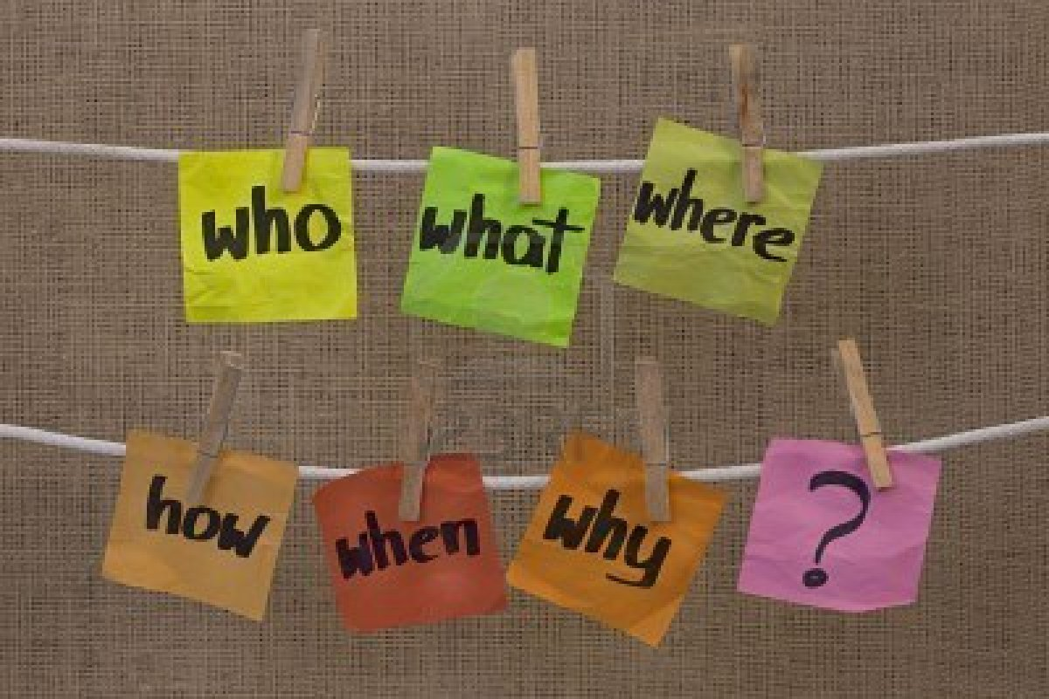 

**I know the answer because it says it right here in the story.**

**RL.3.1 and RI.3.1**

**I can recount stories, determine the central message, lesson, or moral and explain how it is conveyed through key details in the text.**



**What I was supposed to learn from this story is that …….**

**RL.3.2**

**I can describe characters in a story and explain how their actions contribute to the**

**sequence of events.**



**I like the main character and the way he did…..at the beginning and**

**end of the story.**

**RL.3.3**

**I can determine the meaning of the words and phrases as they are used in a text, distinguishing literal from non-literal language.**

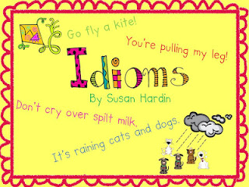

**RL.3.4**

**I can talk about the reading by referring to parts of stories, dramas, and poems, using terms such as chapter, scene, and stanza, and describing how each part builds on earlier sections.**



stanza

scene

chapter

**RL.3.5**

**I can distinguish my own point of view from that of the narrator or those of the characters.**



Even though the narrator says…

**I think**…….

**RL.3.6**

**I can explain how specific aspects of a text’s illustrations contribute to what is conveyed**

**by the words in a story.**

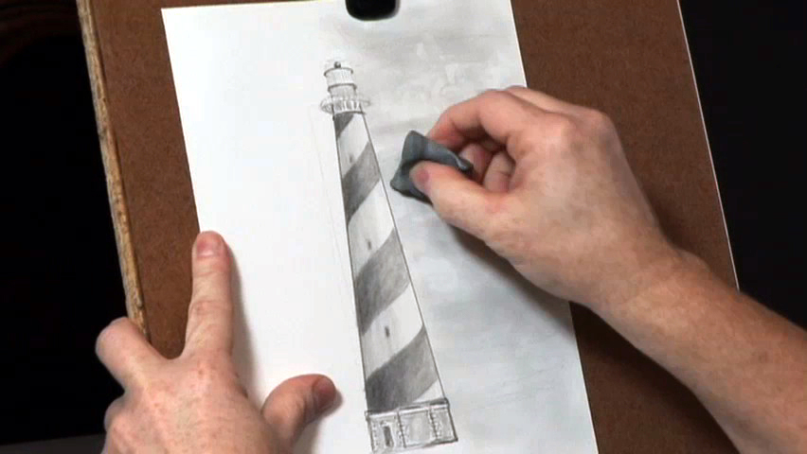

**I can really feel the character’s mood when I look at the illustrations.**

**RL.3.7**

**I can compare and contrast (tell how they are alike and different) the themes, settings, and plots of stories written by the same author about the same or similar characters.**

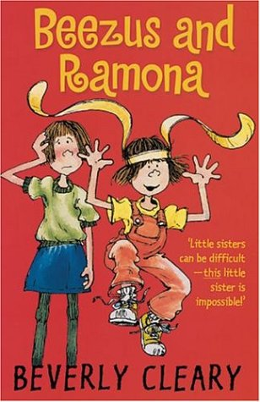

**RL.3.9**

**I can read and comprehend literature, including stories, dramas, and poetry, at or above grade level.**



**RL.3.10**

**I can determine the main idea of a text; recount the key details and explain how they support the main idea.**



**Let me tell you the main idea and what happened**

**in the story .**

**RI.3.2**

**I can describe the relationship between a series of historical events, scientific ideas or concepts, or steps in technical procedures in a text, using language that pertains to time, sequence, and cause/effect.**



**I can see how all this connects and fits together.**

**RI.3.3**

**I can determine the meaning of words and phrases in a text relevant to 3rd graders.**



**RI.3.4**

**I can use text features and search tools to locate information relevant to a given topic quickly and efficiently.**



**RI.3.5**

**I can distinguish my own point of view from that of the author of a text.**



Even though the author says…

**I think**…….

**RI.3.6**

**I can use information from illustrations and the words in a text to demonstrate understanding of the text.**

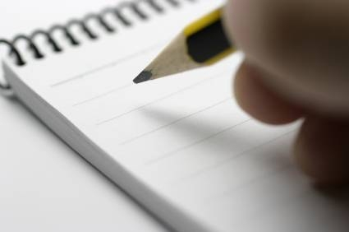



**The words and pictures help me**

**understand the story.**

**RI.3.7**

**I can describe logical connections between particular sentences and paragraphs in a text.**



Third

Second

First

Cause/effect

Comparison

**RI.3.8**

**I can compare and contrast (tell how they are alike and different) the most important points and key details presented in two texts on the same topic.**

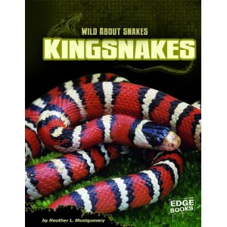 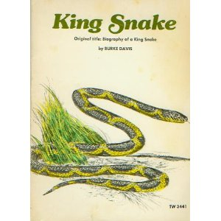

**RI.3.9**

**I can read and comprehend informational texts, including history/social studies, science, and technical texts, on or above third grade level.**

  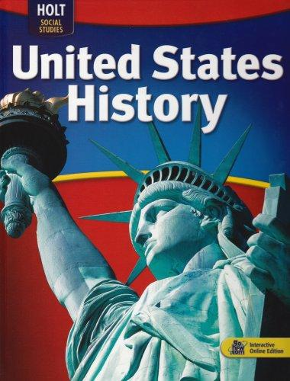

**RI.3.10**

**I can identify and know the meaning of the most common prefixes and suffixes.**

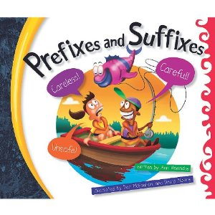

**RF.3.3A**

**I can decode words with common Latin suffixes.**

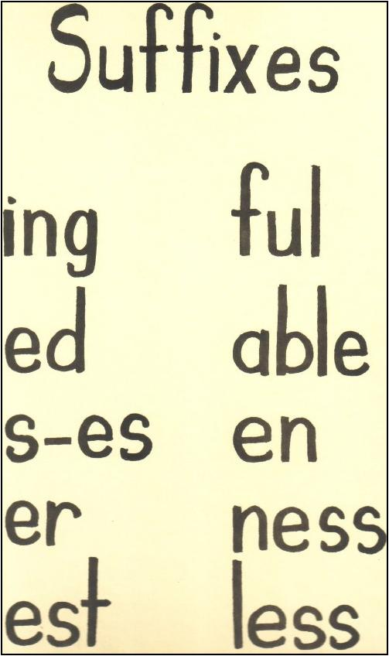

**RF.3.3B**

**I can decode multi-syllable words.**

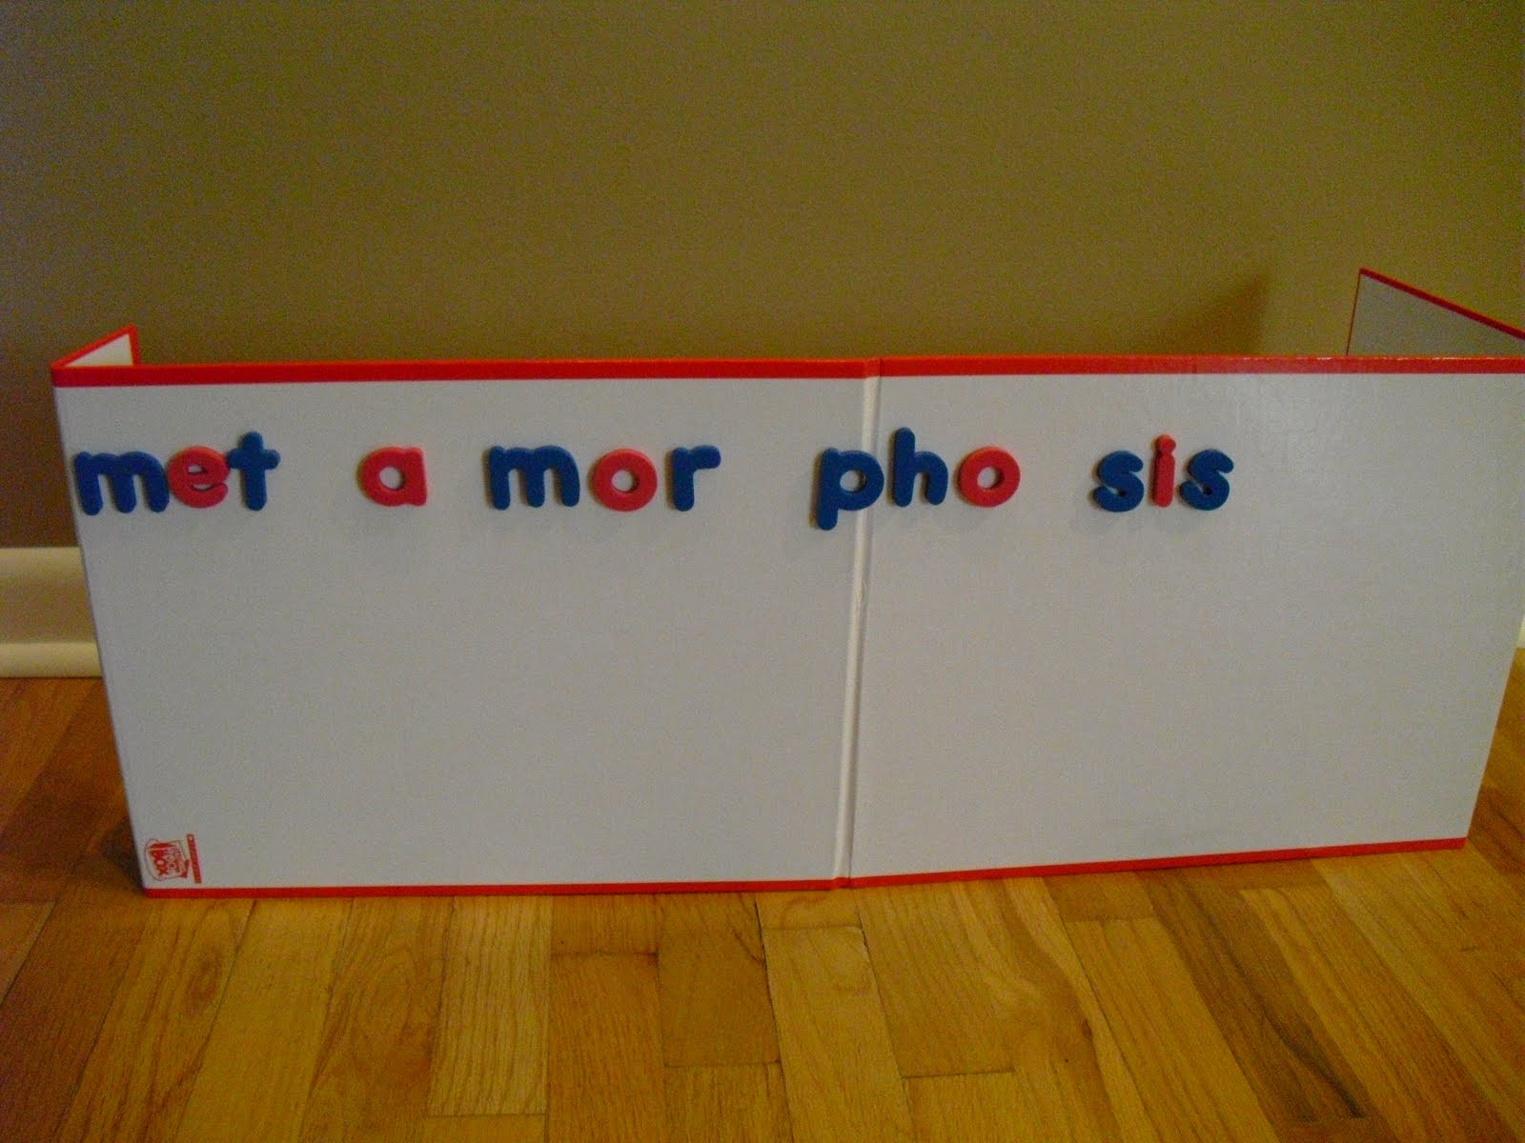

**RF.3.3C**

**I can read grade-appropriate irregularly spelled words.**

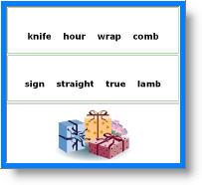

**RF.3.3D**

**I can read on-level text with purpose and understanding.**



**RF.3.4A**

**I can read on-level prose and poetry orally with accuracy, appropriate rate and expression on successive readings.**

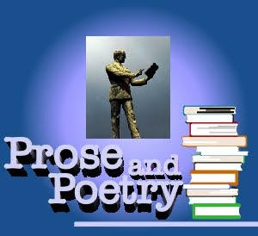

**I can read with expression.**

**I can read fluently.**

**I can read without missing many words.**

**RF.3.4B**

**I can use context to confirm or self-correct words and understanding, rereading**

**when needed.**



**I can use other ideas and**

**words in the story to help me figure out words and understand**

**the story.**

**RF.3.4C**

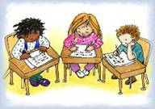 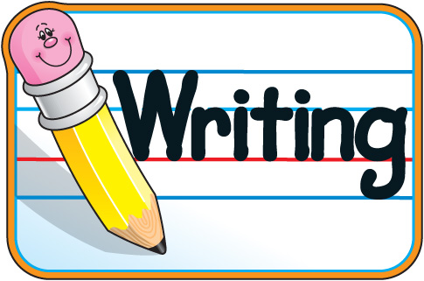 

**I can write opinion pieces that….**

* **introduce the topic or book I am writing about, state an opinion, and create an organizational structure that lists reasons.**
* **provide reasons that support the opinion.**
* **use linking words and phrases to connect opinions and reasons.**
* **provide a concluding statement or section.**

**W.3.1**

**  **

**I can write informative/explanatory pieces that…**

* **introduce a topic and group related information together and include illustrations to help with comprehension.**
* **develop the topic with facts, definitions, and details.**
* **use linking words and phrases (e.g., also, another, and, more, but) to connect ideas within categories of information.**
* **provide a concluding statement or section.**

**W.3.2**

**  **

**I can write narrative pieces that…**

* **establish a situation and introduce a narrator and/or characters and organize an event sequence that unfolds naturally.**
* **use dialogue and descriptions of actions, thoughts, and feelings to develop experiences and events or show the response of characters to situations.**
* **use temporal words and phrases to signal event order.**
* **provide a sense of closure.**

**W.3.3**

**  **

**With help, I can produce writing in which the development and organization are appropriate to talk and purpose.**

**W.3.4**

**With help, I can develop and strengthen writing by planning, revising, and editing.**

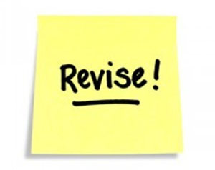 

**W.3.5**

**With help, I can use technology to produce and publish writing and to interact and collaborate with others.**

 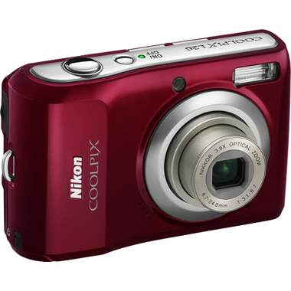

**W.3.6**

**I can conduct short research projects.**



**W.3.7**

**I can recall information from experience or gather information from print and digital sources, take brief notes on sources and sort evidence into provided categories.**



**W.3.8**

**I can write routinely over extended time frames (time for research, reflection, and revision) and shorter time frames (a single sitting or a day or two) for a range of discipline-specific tasks, purposes, and audiences.**

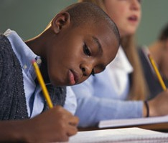

**W.3.10**

**I come to discussions prepared, having read or studied the material and use what I’ve learned to explore ideas under discussion.**

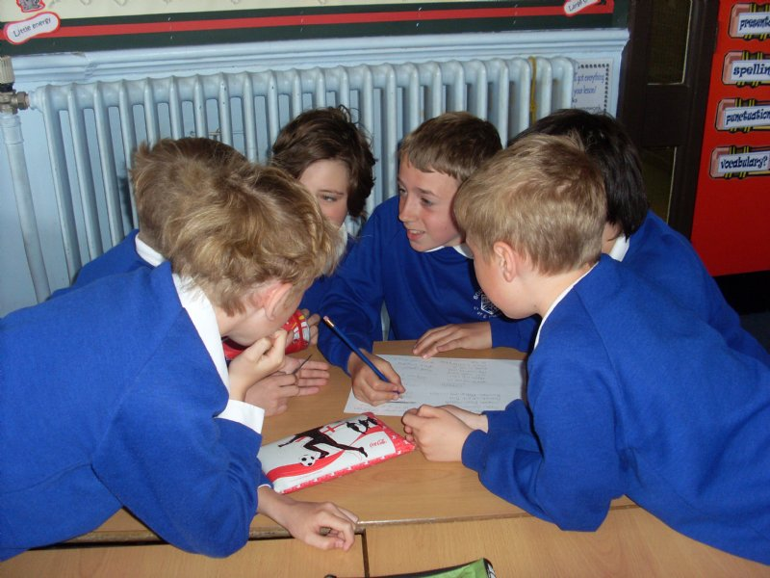

**I am prepared for the discussion.**

**I have read the material.**

**SL.3.1A**

**I can follow agreed-upon rules for discussions.**



**Take turns talking.**

**Listen to others.**

**SL.3.1B**

**I can ask questions to check understanding of information presented, stay on topic, and link comments to the remarks of others.**



**I agree with what Susan said to John and**

**I also think……**

**SL.3.1C**

**I can explain my own ideas and understanding in light of the discussion.**



**Now that I’ve heard the discussion, let me explain my ideas.**

**SL.3.1D**

**I can determine the main ideas and supporting details of a variety of texts and presentations.**



**Let me tell you what the story is mostly about.**

**SL.3.2**

**I can ask and answer questions about information from a speaker, offering appropriate elaboration and detail.**

** **

**SL.3.3**

**I can report on a topic or text, tell a story, or recount an experience with appropriate facts and details, speaking clearly at an understandable pace.**



**SL.3.4**

**I can create engaging audio recordings of stories or poems that demonstrate fluid reading; add visual displays to emphasize or enhance certain facts or details.**

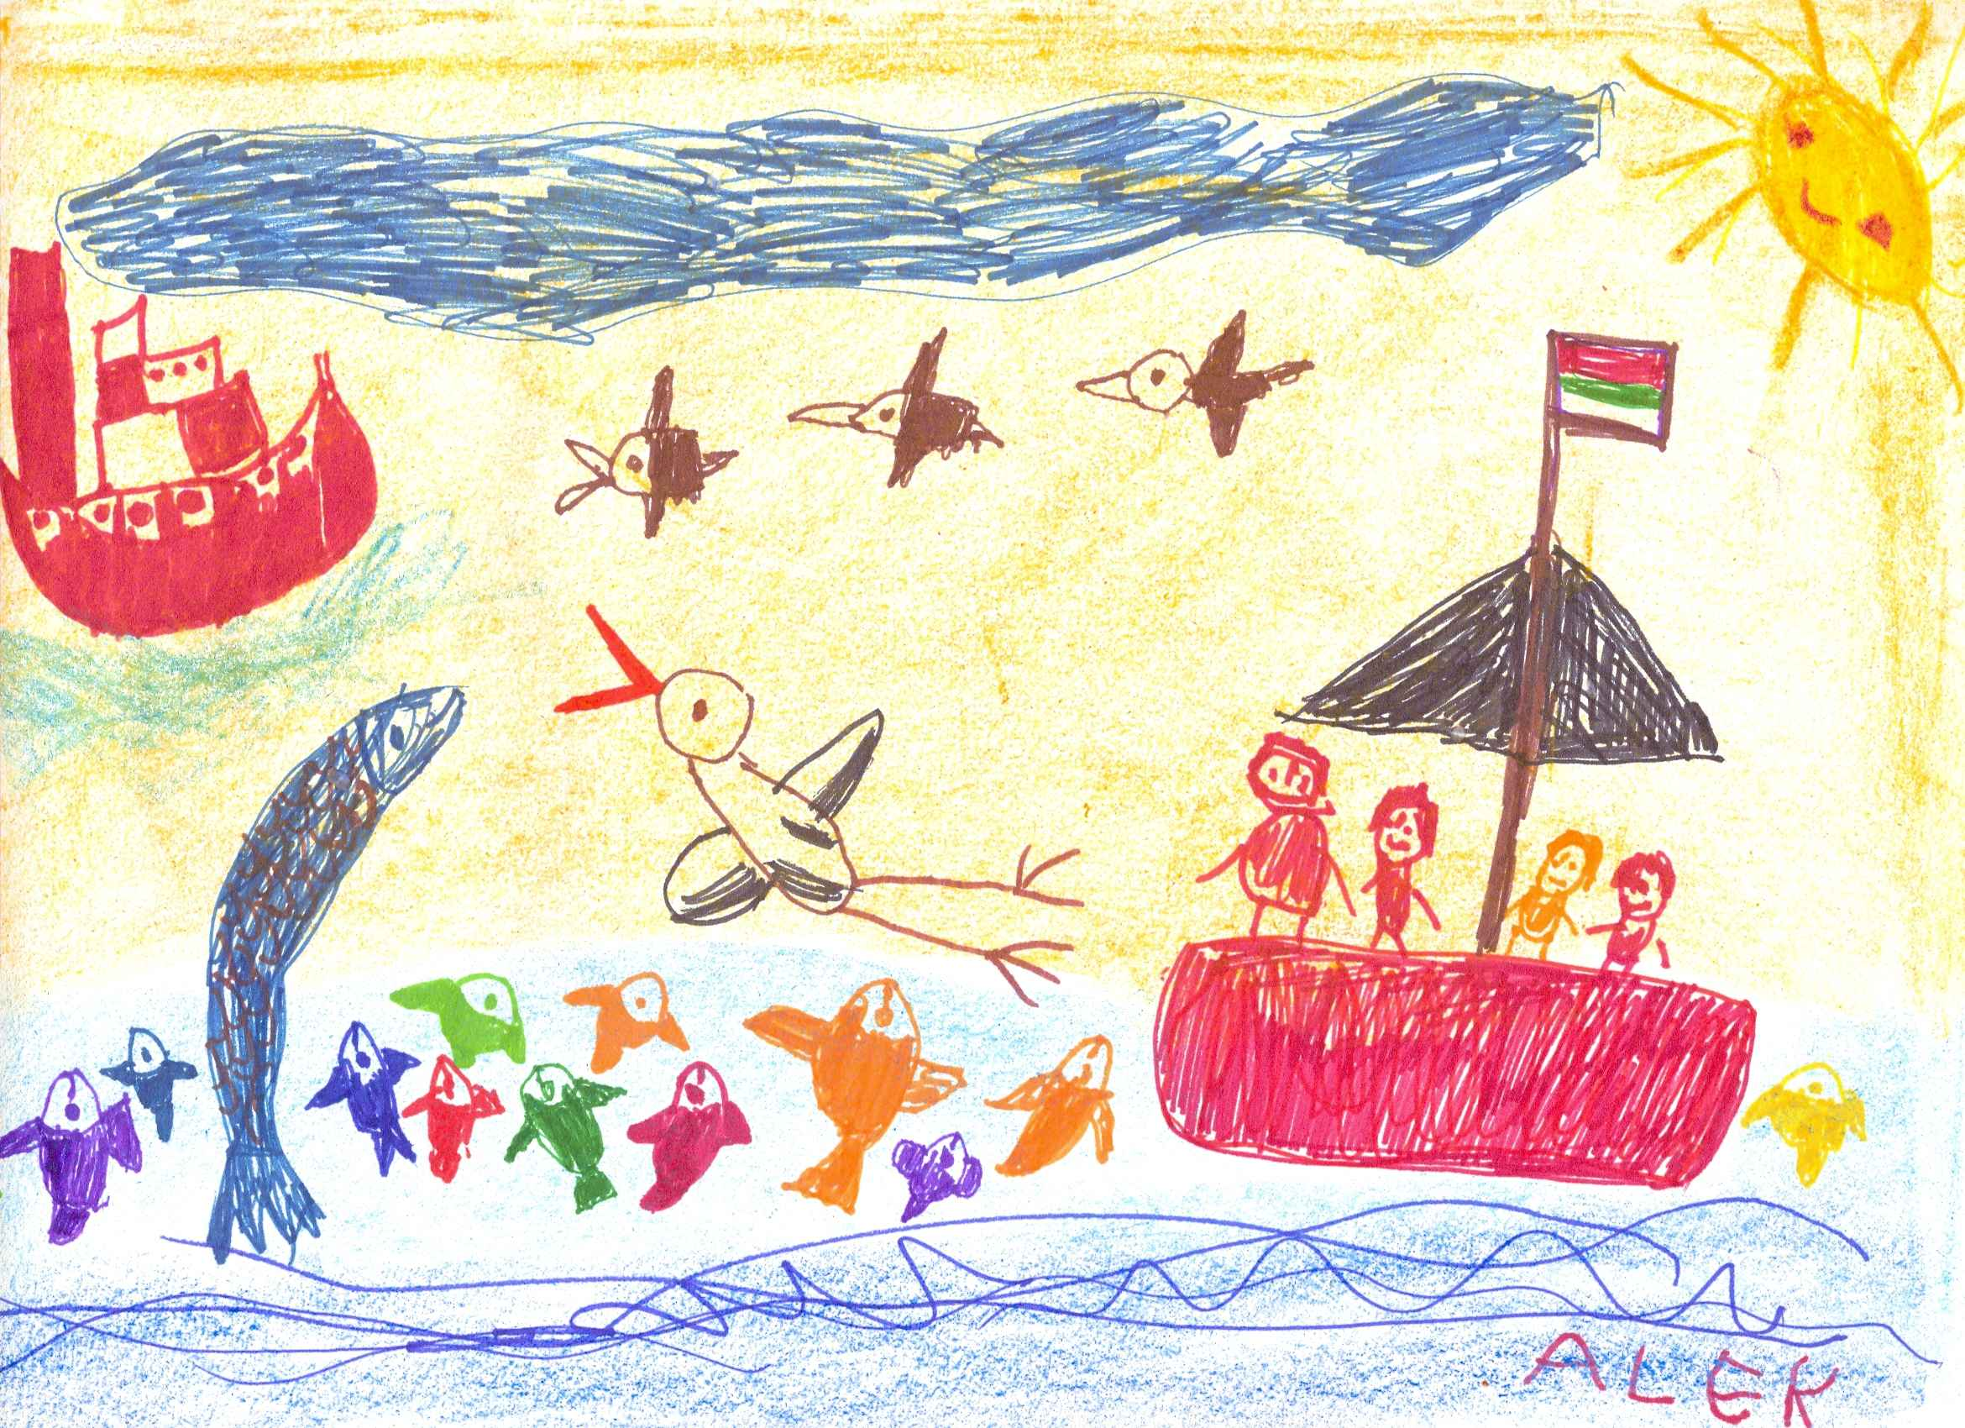

**SL.3.5**

**I can speak in complete sentences in order to provide requested detail or clarification.**

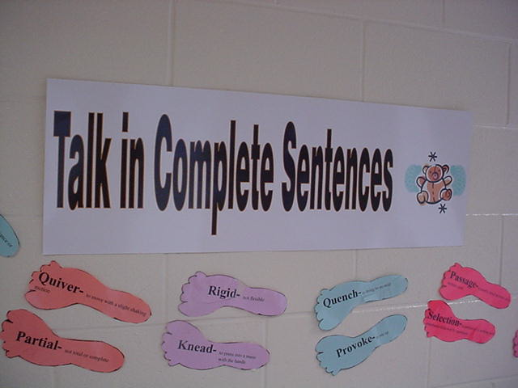

**SL.3.6**

**I can demonstrate command of the conventions of standard English grammar and usage when writing and speaking.**

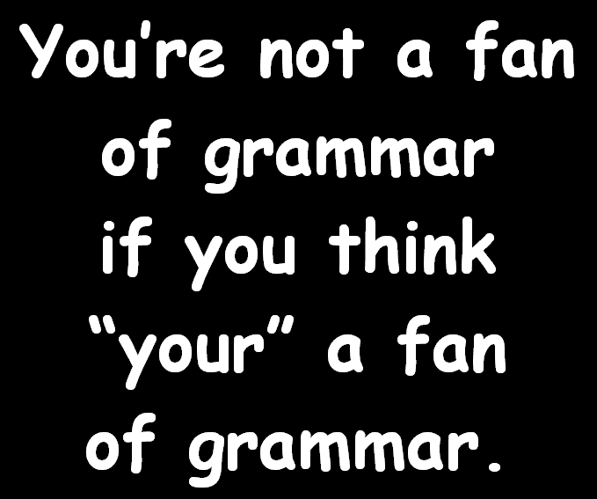

**L.3.1**

**I can explain the function of nouns, pronouns, verbs, adjectives, and adverbs in general and their functions in particular sentences.**

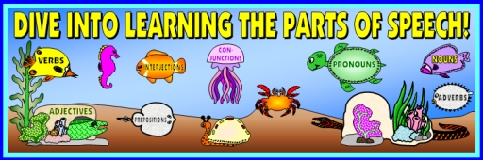

**L.3.1A**

**I can form and use regular and irregular plural nouns.**

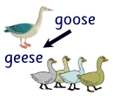 **[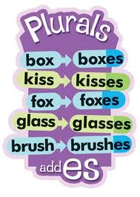](http://www.google.com/imgres?q=adding+es+to+make+words+plural&hl=en&biw=1366&bih=592&tbm=isch&tbnid=sgKrt4mbAJiRtM:&imgrefurl=http://ajilbab.com/plurals/plurals-add-es.htm&docid=pfSaBmRqfV0nxM&itg=1&imgurl=http://www.playgroundbasics.co.uk/products_pictures/normal_LT342.jpg&w=284&h=400&ei=2hYWUPqbDpSq8AT2_YGgAw&zoom=1&iact=hc&vpx=286&vpy=206&dur=2203&hovh=267&hovw=189&tx=98&ty=173&sig=109892877799333547793&page=3&tbnh=134&tbnw=95&start=54&ndsp=30&ved=1t:429,r:8,s:54,i:269)** 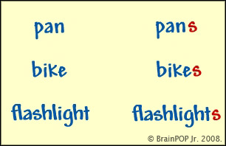

**L.3.1B**

**I can use abstract nouns.**

childhood

anger

hatred

pride

**L.3.1C**

**I can form and use regular and irregular verbs.**

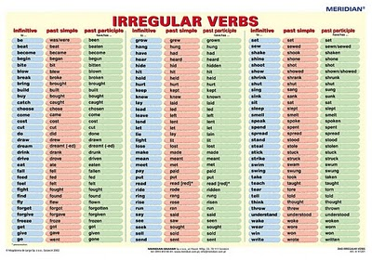 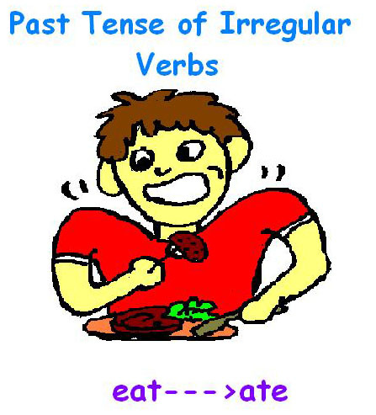

**L.3.1D**

**I can form and use**

**simple verb tenses.**

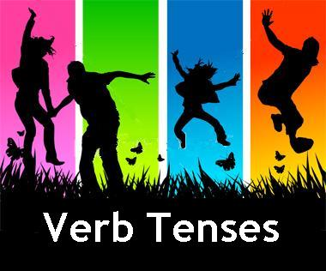

**I walked. I walk. I will walk.**

**L.3.1E**

**I can ensure subject-verb and pronoun-antecedent agreement.**

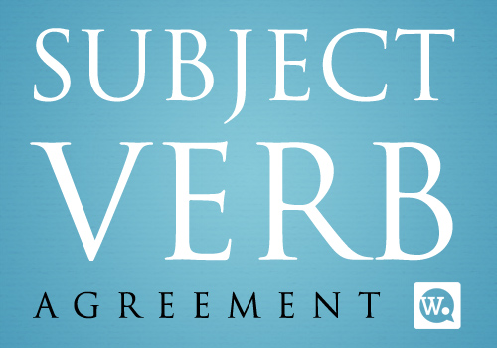

**The boy walks to school every day.**

**The boys walk to school every day.**



**The can of lima beans sits on its shelf.**

**The children brought their bookbags to school.**

**L.3.1F**

**I can form and use comparative and superlative adjectives and adverbs, and choose**

**between them appropriately.**

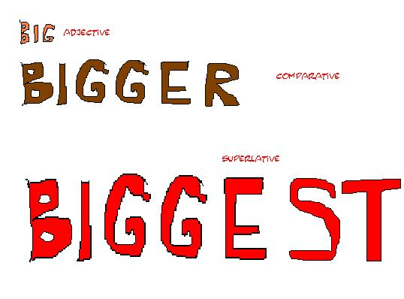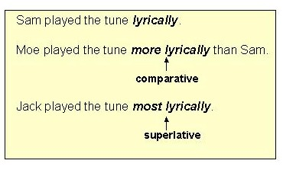

**L.3.1G**

**I can use coordinating and subordinating conjunctions.**

[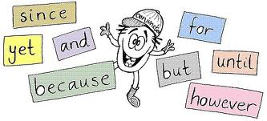](http://www.google.com/imgres?q=coordinating+and+subordinating+conjunctions.&um=1&hl=en&biw=1366&bih=592&tbm=isch&tbnid=lRvu7Kthtd5kSM:&imgrefurl=http://www.bloggingtips.com/2009/11/09/conjunction-junction-whats-your-function-part-2/&docid=bcRjyKgjK2WMSM&imgurl=http://bloggingtips.moneyreigninc.netdna-cdn.com/wp-content/uploads/2009/11/Conjunctions-main_Full.jpg&w=531&h=242&ei=JsUYUPS3A4n48gTdvYCgCA&zoom=1&iact=hc&vpx=511&vpy=298&dur=5188&hovh=151&hovw=333&tx=207&ty=72&sig=109892877799333547793&page=1&tbnh=72&tbnw=159&start=0&ndsp=23&ved=1t:429,r:10,s:0,i:103)[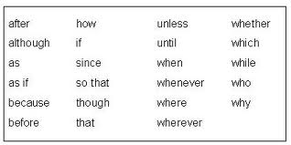](http://www.google.com/imgres?q=coordinating+and+subordinating+conjunctions.&um=1&hl=en&biw=1366&bih=592&tbm=isch&tbnid=-fF9h2ZjdkyVWM:&imgrefurl=http://www.towson.edu/ows/modulecs_fs.htm&docid=R7bM9tRXXOcC8M&imgurl=http://www.towson.edu/ows/moduleCS_FS27.jpg&w=422&h=211&ei=JsUYUPS3A4n48gTdvYCgCA&zoom=1&iact=hc&vpx=241&vpy=161&dur=3500&hovh=159&hovw=318&tx=150&ty=103&sig=109892877799333547793&page=1&tbnh=84&tbnw=167&start=0&ndsp=23&ved=1t:429,r:1,s:0,i:75)

**L.3.1H**

**I can produce simple, compound and complex sentences.**

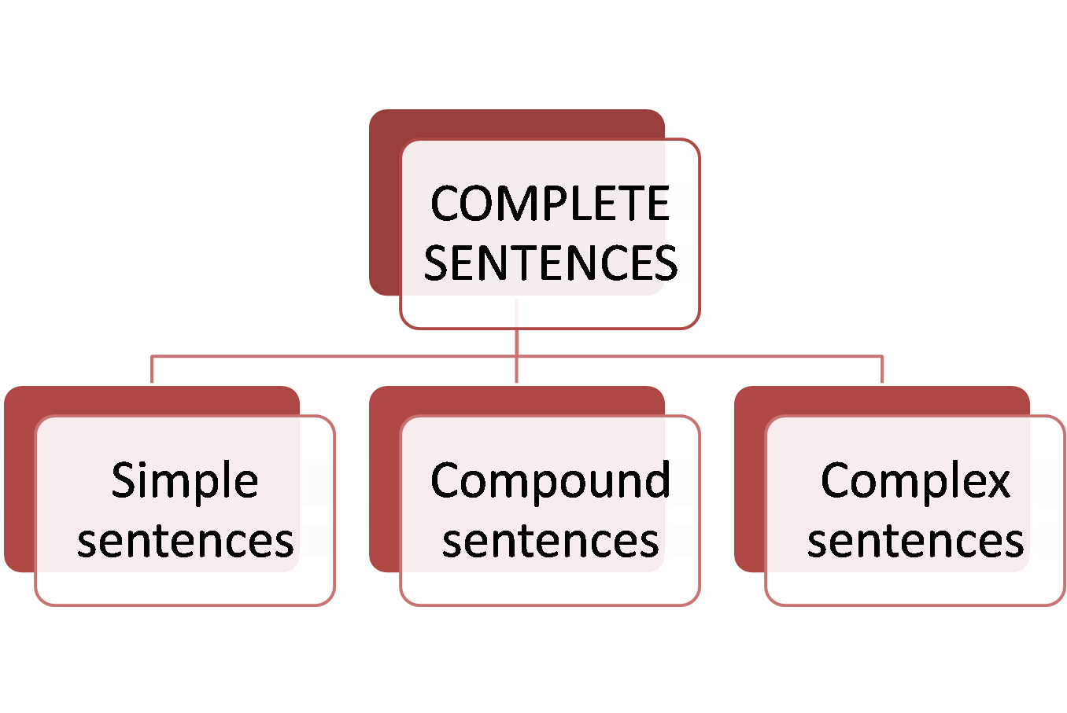

**The boy ate a hamburger for supper.**

**(Simple sentence)**

**The boy ordered a hamburger, but the girl ordered a hot dog for supper. (Compound sentence)**

**After the boy ordered his hamburger, he sat at the table to wait.**

**(Complex sentence)**

**L.3.1I**

**I can write legibly in cursive.**

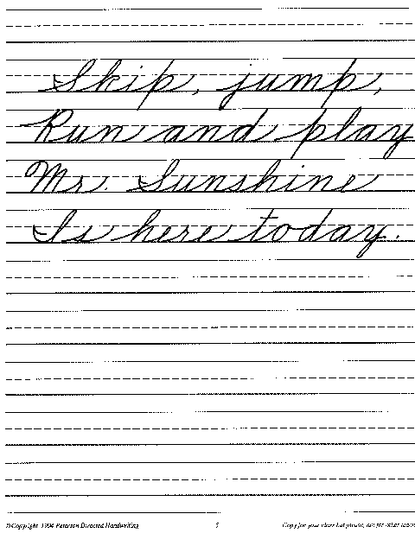

**L.3.1J**

**I can capitalize appropriate**

**words in titles.**

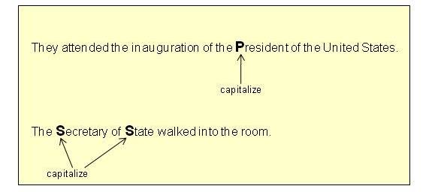

**L.3.2A**

**I can use commas in addresses.**

Send the flowers to 910

East Robert Toombs Ave., Augusta, GA 30673

My address is 314 North Alexander Avenue, Washington, GA 30673

PUT A COMMA BETWEEN THE CITY AND THE STATE

IN AN ADDRESS.

**L.3.2B**

**I can use commas and quotation marks in dialogues.**

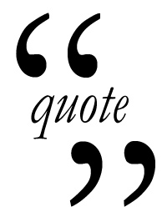

“Please put all your papers in your desk”, said Mrs. Jones.

**L.3.2C**

**I can form and use possessives.**

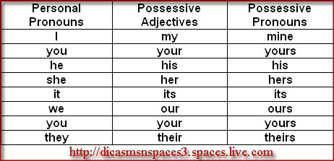

**L.3.2D**

**I can use conventional spelling for high-frequency and other studied words and for adding suffixes to base words.**

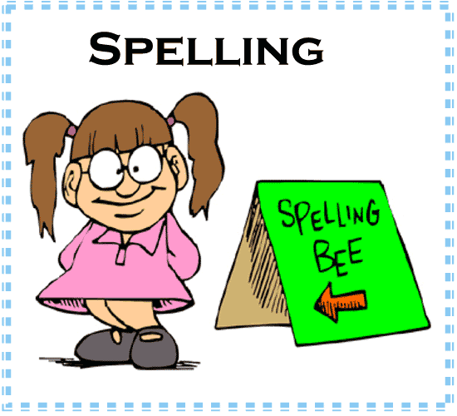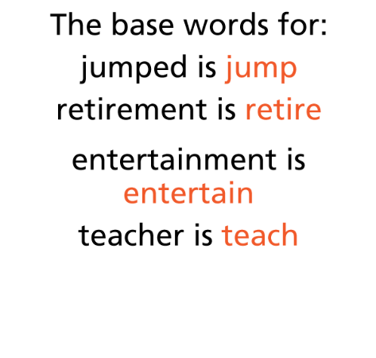

**L.3.2E**

**I can use spelling patterns and generalizations in writing words.**

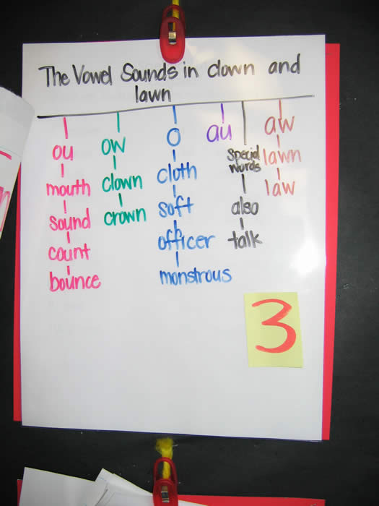

**L.3.2F**

**I can consult reference materials, including dictionaries, as needed to check and correct spelling.**

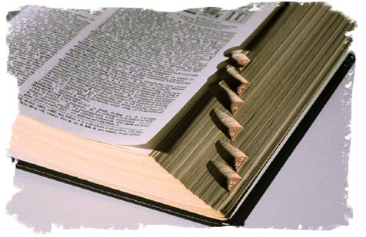

**L.3.2G**

**I can choose words and**

**phrases for effect.**

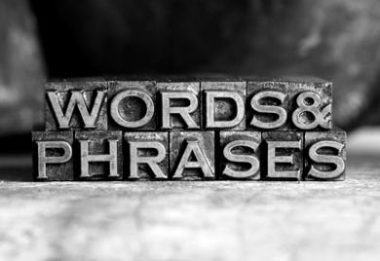

**L.3.3A**

**I can recognize and observe differences between the conventions of spoken and written standard English.**

**There are times to use informal language and times to use**

**formal language.**

**For instance, I know that I talk**

**differently than I write.**



**L.3.3B**

**I can use different strategies to determine the meaning of unknown and multiple-meaning words and phrases.**

***There are many strategies to use to help figure out words you don’t know.***

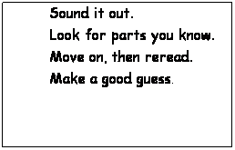

**L.3.4**

**I can use sentence-level context as a clue to the meaning of a word or phrase.**



**I can read the rest of the sentence to help me figure out the meaning of a word**

**I don’t know.**

**L.3.4A**

**I can determine the meaning of the new word formed when a known affix is added**

**to a known word.**

**Happy means “to feel pleased or glad”.**

**Un- means NOT so…….**

**Unhappy must mean NOT happy.**

**L.3.4B**

**I can use a known root word as a clue to the meaning of an unknown word with the same root.**

**L.3.4C**

**I can use glossaries or beginning dictionaries, both print and digital, to determine or clarify the precise meaning of**

**key words and phrases.**

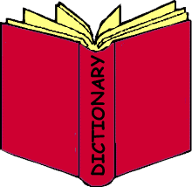 

**L.3.4D**

**With help, I can demonstrate understanding of word relationships and nuances**

**in word meanings.**

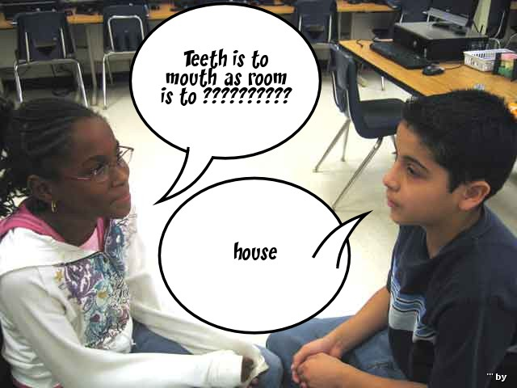

**L.3.5**

**I can distinguish the literal and non-literal meanings of words and phrases in context**



**L.3.5A**

**I can identify real-life connections between words and their use (e.g., describe people who are**

**friendly or helpful).**



**The nurses at the hospital are very friendly and take good care of the patients.**

**L.3.5B**

**I can distinguish shades of meaning among related words that describe states of mind or degrees of certainty.**



When I saw the little boy’s reaction, I **wondered** if he was really telling the truth.

I **knew** by the look on his face that he was the one who broke the lamp!

Although the little boy said he didn’t break the lamp, the look on his face made me **suspect** he wasn’t telling the truth.

**L.3.5C**

**I can acquire and use correctly grade level vocabulary, including words and phrases that signal spatial and temporal relationships.**

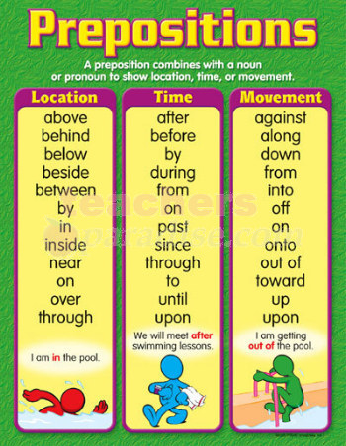

**L.3.6**