I can use addition and subtraction within 100 involving one- and two-step word problems.

CCGPS2.OA.1
Result Unknown  There are 29 students. Then 18 more show up. How many in all?  29 + 18=___ | Change Unknown  There are 29 students. Some more show up. Now there are 47. How many students came?  29 + ___=47 | Start Unknown  There are some students. Then 18 left. Now there are 47. How many at the beginning?  __ - 18 = 47
Three Types of Addition and Subtraction Problems CCGPS.OA.1 con’t

CCGPS.OA.1 con’t
Two-step Example: In the morning there are 25 students in the cafeteria. 18 more students join them. After a few minutes, some students leave. If there are 14 students in the cafeteria now, how many left? 25+18 - ____=14
Using place value blocks

Using a
number line
Using a hundreds chart

Using place value blocks: Step 1:Make a group of 25 and 18. Join
them together to equal 43.
Step 2: Remove 14 blocks to show how
many are in the cafeteria now.
Step 3: Count the remaining blocks to
find how many left the cafeteria.

Step 1 Step 2 Step 3=answer

+ =
Using a number line: Step 1: Start at 25 and move 18 spots to
43.
Step 2: Then move backwards to 14
counting as I move.
Step 3: Answer = moved back 29 steps.

Using a hundreds chart: Step 1: Start at 25. Move down 1 row
which is 10 more. Then move 8
steps to 43.
Step 2: To get to 14 students in the
cafeteria move up 10 less to 33,
then 10 less to 23 for a total of
20 steps so far. Then move back
9 steps to the number 14 for a
total of 29 steps.
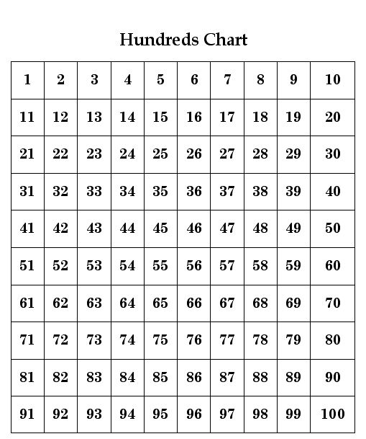

CCGPS2.OA.1 con’t
I can fluently add and subtract within 20.

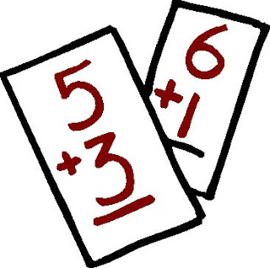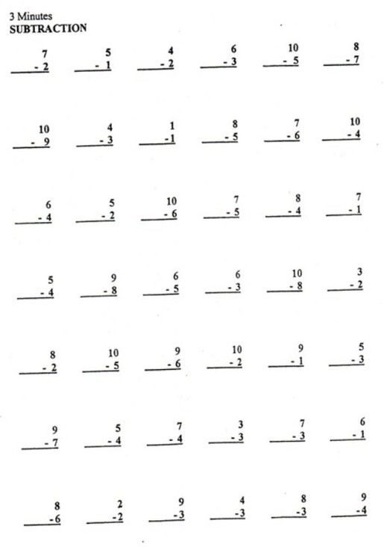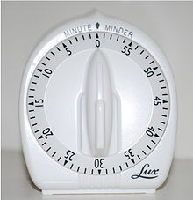

CCGPS.2.0A.2
I know odd and even numbers up to 20.

I can prove a number is even in an equation of 2 equal addends.

CCGPS.2.0A.3
CCGPS.2.0A.3 con’t

ODD  9  5 + 4 = 9 | EVEN  10  5 + 5 = 10
15  6 + 8 +1 = 15 | 6  3 + 3 = 6

I know all numbers 100-999 can be broken
into hundreds, tens,
and ones.

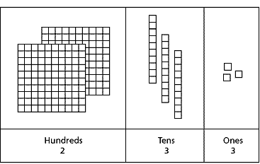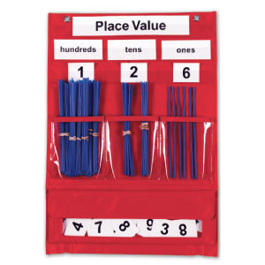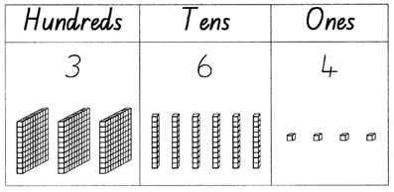

CCGPS.2.NBT.1
I understand that
100 (1 hundred) is the same as 10 tens.

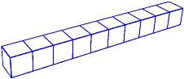
= 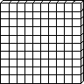

CCGPS.2.NBT.1a
I know numbers
100, 200, 300, 400, 500, 600, 700, 800, 900
equal 0 tens and 0 ones.

= 300
3 hundreds 0 tens 0 ones

CCGPS.2.NBT.1b
I can count within 1000 from any given point.

Count Forward  …877, 888, 889, 990….  …705, 706, 707, 708… | Count Backward  …995, 994, 993, 992…  …150, 149, 148, 147…

CCGPS.2.NBT.2
I can count by 5s, 10s, and 100s to 1000 from any given point.

5s  …955, 960, 965, 970, 975, 980…. | 10s  ….950, 960, 970, 980, 990, 1000 | 100s  …500, 600, 700, 800, 900, 1000

CCGPS.2.NBT.2

I can read and write numbers to 1000.

Using base  ten numbers or place value blocks  954 | Using number names  Nine hundred fifty four | Using expanded form  900 + 50 + 4

CCGPS.2.NBT.3
I can compare three digit numbers using
< less than, > greater than, and = equal to.

465 > 378 because 400 is greater than 300
232 < 256 because 230 is less than 250
988 = 988

CCGPS.2.NBT.4

I can fluently add and subtract within 100.

67+28 = 63–32 =
Place Value Strategy  Break 67 and 28 into tens and ones.  6tens + 2tens = 8tens  7ones + 8ones = 1ten5ones  8tens + 1 ten + 5ones = 95 | Commutative Property  I broke 67 and 28 into tens and ones. 60 + 7 + 20 + 8  60 + 20 = 80  80 + 7 = 87  87 + 8 = 95 | Relationship between Addition and Subtraction  I know 2 + 1 = 3 so 3-2 = 1. And, I know 3 + 3 = 6 so 6 – 3 = 3. The answer is 31.

CCGPS.2.NBT.5
I can add up to four two-digit numbers.

43 + 34 + 57 + 24 =

Associative Property Strategy  43 + 57 = 100  100 + 34 = 134  134 + 24 = 158 | Place Value Strategy  40+30+50+20=140  3+4+7+4=18  140 + 18 = 158 | Both Strategies  (same as place value but change order of numbers)  30+20+50 = 100  100+40 = 140  7+3=10 and 4+4=8  10+8=18  140 + 18 = 158

CCGPS.2.NBT.6
I can add and subtract within 1000.

354 + 287  Using Place Value  Add the ones…4+7=11  Add the tens…50+80=130  Add the hundreds…300+200=500  Combine…500+130=630  630+11=641  Using Place Value Blocks  Make 354 and 287 with blocks.  5 hundreds 13 tens 11 ones.  Trade ones to make tens.  14 tens 1 one  Trade tens to make hundreds.  6 hundreds 4 tens  6 hundreds 4 tens 1 one | 213 – 134  Using Place Value Blocks  Make 213 with blocks.  2 hundred 1 ten 3 ones  Trade 1 hundred to 10 tens.  1 hundred 11 tens 3 ones.  Trade 1 ten for 10 ones.  1 hundred 10 tens 13 ones.  Subtract:  1 hundred 10 tens 13 ones  -1 hundred 3 tens 4 ones  7 tens 9 ones  10  1 11 13  213  - 134  79

CCGPS.2.NBT.7

I can mentally add 10 or 100 to a number
from 100-900.

CCGPS.2.NBT.8
499+10=509

477+10=577

500+100=600

680+100=780

I can mentally subtract 10 or 100 from a number between 100-900.
CCGPS.2.NBT.8
477-100=377

509-10=499

477-10=467

500-100=400

I can explain why addition and subtraction strategies work using place value and properties of operations.

CCGPS.2.NBT.9
There are 36 birds in the park. 25 more birds arrive. How many birds are there?

I broke 36 and 25 into tens and ones and then added them. 30+6+20+5. I can change the order of the numbers so I added 30+20 and got 50. Then I added 6 more to get 56. Then I added 5 to get 61. This is the strategy of properties of operations.

I used place value blocks and made a pile of 36. Then I added 25. I had 5 tens and 11 ones. I had to trade 10 ones for 1 ten. Then I had 6 tens and 1 one. That makes 61. This is the strategy of using place value.

CCGPS.2.NBT.9 con’t

I can choose the appropriate tool and measure the length of an object.

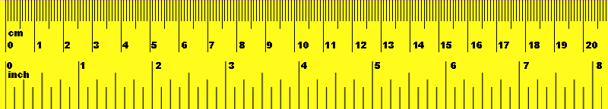 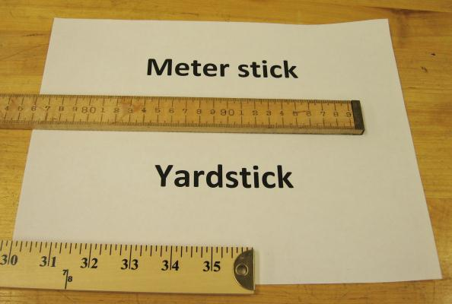 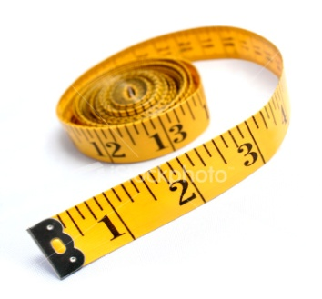 CCGPS.2.MD.1
I can compare the length of an object using two measurements.

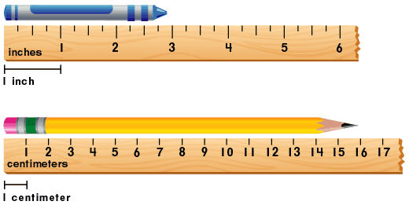
CCGPS.2.MD.2
I can estimate lengths using inches, feet, centimeters,
and meters.

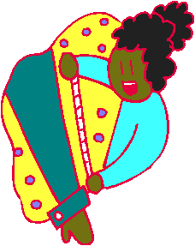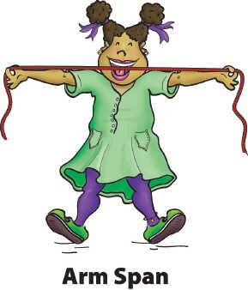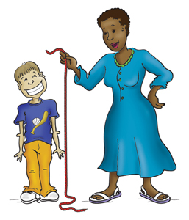

CCGPS.2.MD.3

I can determine the difference in length between two objects.

The pencil is 16 cm. The crayon is 7 cm.
The pencil is 9 cm. longer than the crayon. (16-7=9)

CCGPS.2.MD.4
I can use addition and subtraction within 100 to solve word problems involving length.

CCGPS.2.MD.5
Kate jumped 14 inches. Mary jumped 23 inches. How much farther did Mary jump than Kate? Write an equation and solve.

14 + ____ = 23

Using place value blocks I counted out 14. Then I added blocks until I got to 23. I needed to add 9 blocks. Mary jumped 9 more inches than Kate.

+ ______ =
23 – 14 = ____

Using a number line I started at 23. I moved back 14 and counted how far I moved. I moved back 9. Mary jumped 9 more inches than Kate.
I can create a number line using numbers within 100 to solve problems. I can use evenly spaced points.

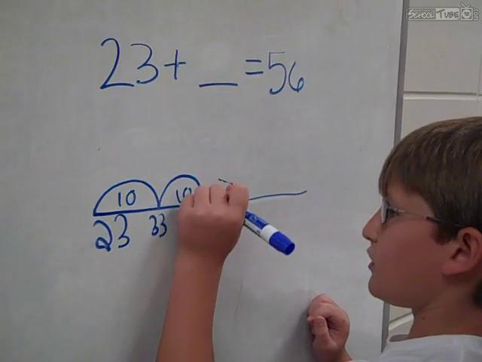
CCGPS.2.MD.6
I can tell and write time to the nearest five minutes.

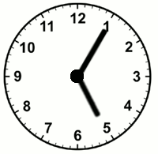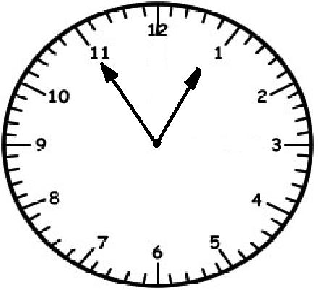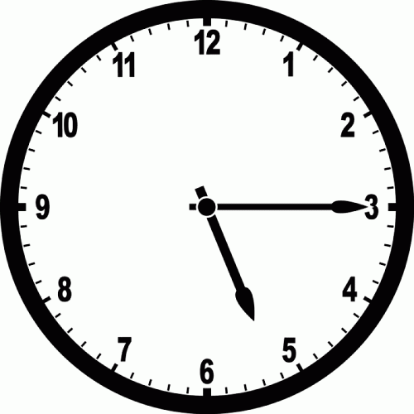
5:05 12:55 5:15

CCGPS.2.MD.7
I can use a.m. and p.m. correctly.

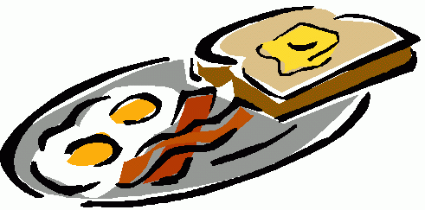Eating Breakfast 7:30 a.m.
Sleeping 2:15 a.m.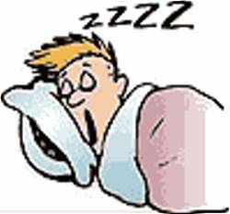
Watching fireworks 9:30 p.m.

CCGPS.2.MD.7
I can solve word problems involving dollar bills, quarters, dimes, nickels, and pennies.
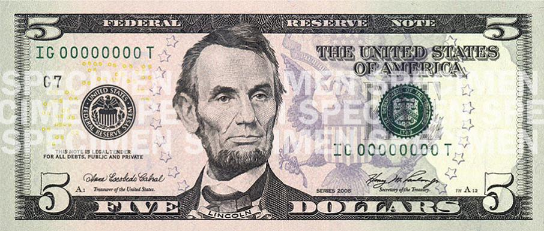
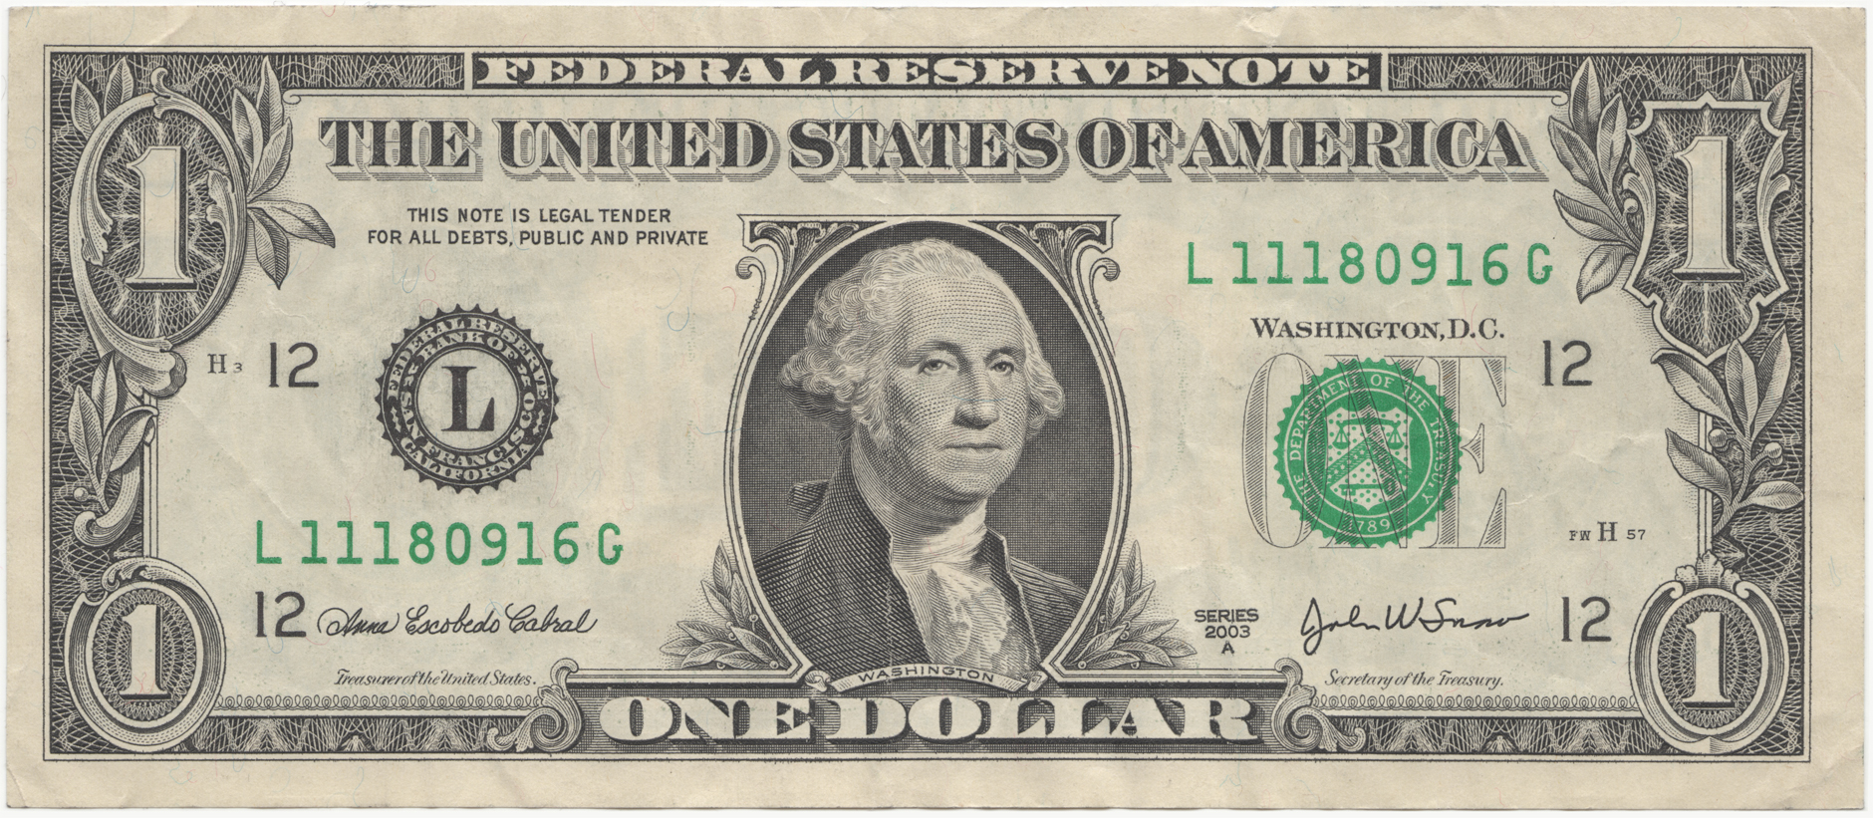

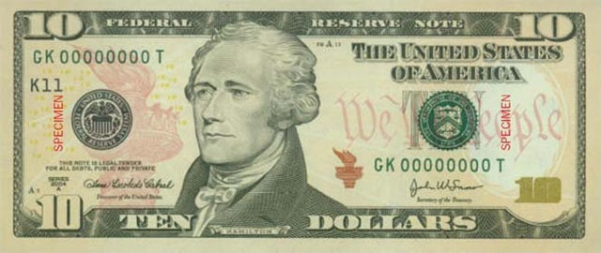
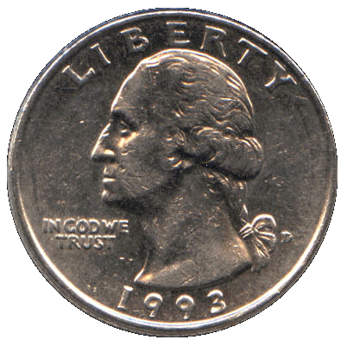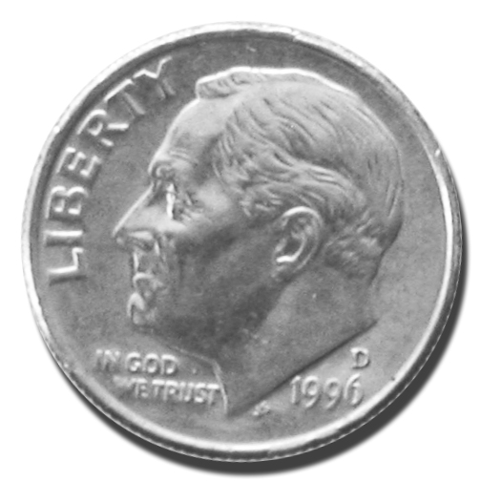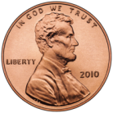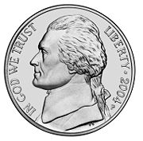

CCGPS.2.MD.8
If you have 2 dimes and 3 pennies, how many cents do you have?  23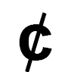 | What are some possible combinations of coins that equal 37 cents?  1 quarter 1 dime 2 pennies  3 dimes 7 pennies  37 pennies | What are some possible combinations of dollar bills that equal 12 dollars?  1 ten dollar bill 2 dollar bills  2 five dollar bills 2 dollar bills

CCGPS.2.MD.8
I can use $ and symbols appropriately.

$1.25 =125
$ 0.50 = 50
$0.10 = 10

CCGPS.2.MD.8
I can create a line plot.
Example:
Collect data by measuring the length of several objects. Create line plot graph where the horizontal scale is marked off in whole number units. Plot data and use graph to organize data and make comparisons.
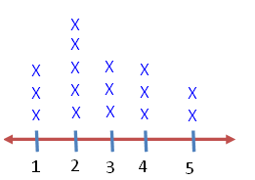
Length of Objects Measured:
Safety pin = 1 inch
Yellow Pencil = 5 inches
Blue Crayon = 3 inches
Small paper clip =1 inch
Small Eraser = 1 inch
Notebook = 4 inches
Red Crayon = 2 inches
Blue Pencil = 2 inches
Large Eraser = 3 inches
Green Pencil = 4 inches
Sticky Note = 2 inches
Large paper clip = 2 inches
2 pair of scissors = 5 inches each
Glue stick = 3 inches
Sticker = 2 inches
Marker = 4 inches

How many objects are 5 inches long?
How many objects are 1 inch?
Which length had the most number of objects?

CCGPS.2.MD.9
I can draw a picture graph and a bar graph and use the information to answer problems.
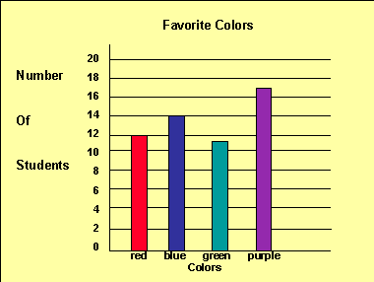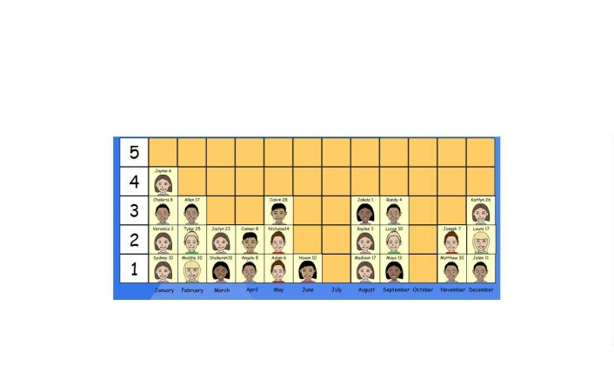

CCGPS.2.MD.10
I can identify shapes.

Quadrilaterals

Rectangle Square Trapezoid

Triangle Hexagon Pentagon Cube

CCGPS.2.G.1
I can recognize and draw shapes having specified attributes.

Draw a shape with 5 sides.
Draw a shape with 4 angles.

Draw a shape with 6 faces.
CCGPS.2.G.1
I can partition a rectangle into rows and columns of same size squares and count to find the total number.
CCGPS.2.G.2
I can partition (split) a circle and a rectangle into two, three, or four equal shares.

CCGPS.2.G.2
I can describe the equal shares of divided shapes using halves, thirds, half of, a third of, a fourth of,
or a quarter of.

A

CCGPS.2.G.2
I know that equal shares do not have to have the same shape.

Divide the rectangle into halves a different way.

CCGPS.2.G.2

