I can ask and answer questions to demonstrate understanding of key details in a text.

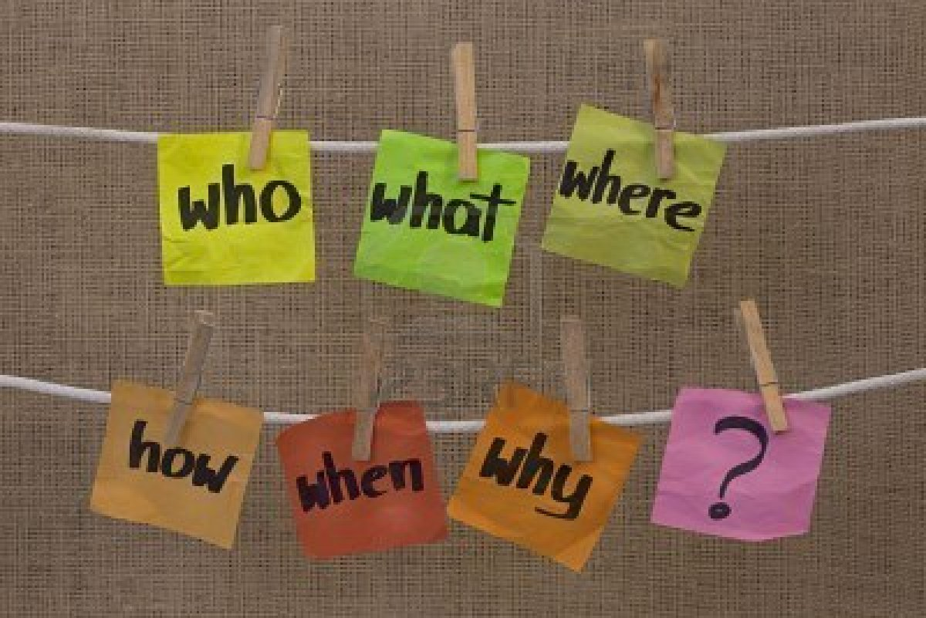

RL.2.1 and RI.2.1
I can recount stories and determine their central message, lesson or moral.
FABLES AND FAIRYTALES
What I was supposed to learn from this story is that …….

RL.2.2
I can describe how characters respond to major events and challenges.

In the story, didn’t you like how the boy fought
the giant?

RL.2.3
I can describe how words and phrases supply rhythm and meaning in a story, poem or song.

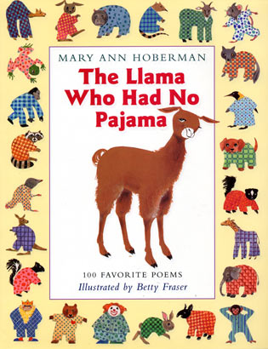
RL.2.4
I can describe the overall
structure of a story.
Every story has a beginning that introduces the story and an end that concludes it.

RL.2.5

I can acknowledge differences
in the points of view of characters and can speak in different voices
for each character when reading.

I can see how the two characters had different ideas about things.
RL.2.6
I can use information from the illustrations and words to demonstrate understanding of the story’s characters, setting, or plot.

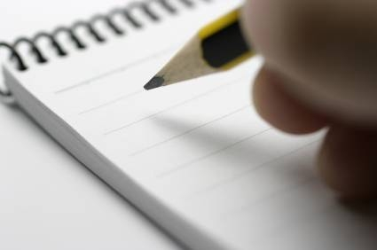
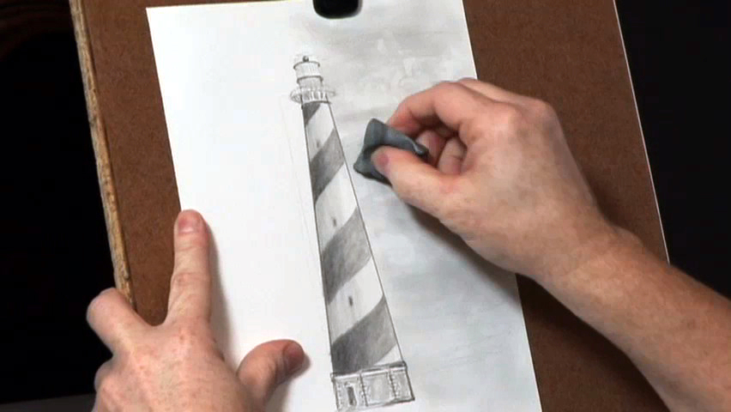
The words and pictures tell me about the characters, setting and plot.

RL.2.7
I can compare and contrast (show how they are alike and different) two or more versions of the same story by different authors or from different cultures.
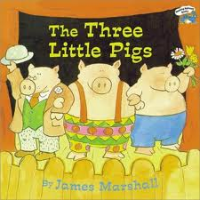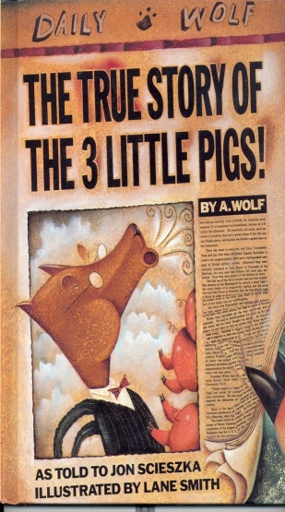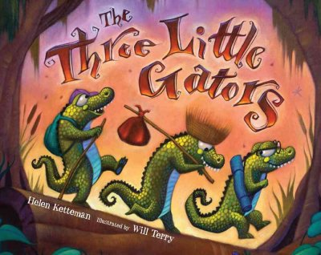
RL.2.9
I can read and comprehend literature, including stories and poetry, in grades 2-3 text.

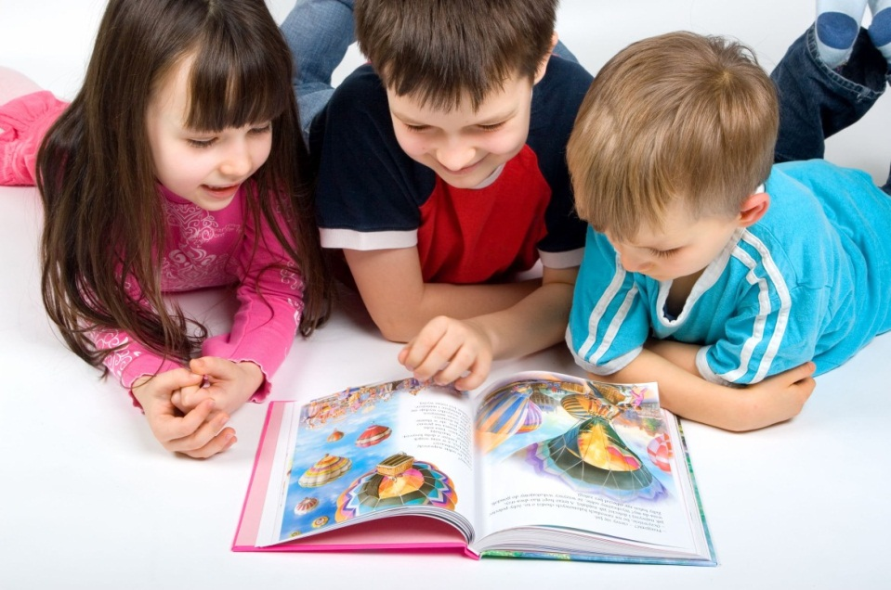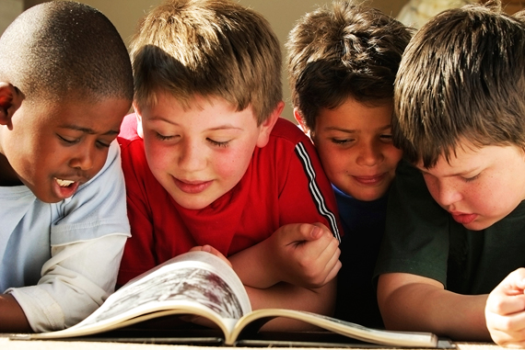

RL.2.10
I can identify the main topic and focus of specific paragraphs in multi-paragraph texts.
The main idea of this story is…..

RI.2.2
I can describe the connection between a series of historical events, scientific ideas or concepts, or steps in technical procedures in a text.

I can see how all this connects and fits together.

RI.2.3
I can determine the meanings of words and phrases in texts relevant to 2nd grade.
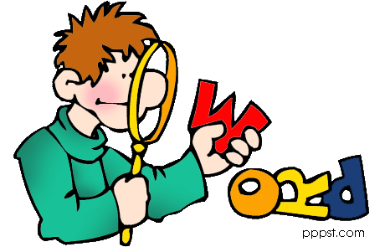
RI.2.4
I know and use various text features to locate key facts or information in a text.
GLOSSARY
SUBHEADING
CAPTION
INDEX

RI.2.5
I can identify the main purpose of a text, including what the author wants to answer, explain, or describe.

I know why the author wrote this story.

RI.2.6
I can explain how specific images help a text
make sense.
The pictures really help me understand the story.

RI.2.7
I can describe how reasons support specific points the author makes in a text.

I can see the reasons for what the author wrote.

RI.2.8
I can compare and contrast (show how they are alike and different) the most important points presented by two texts
on the same topic.

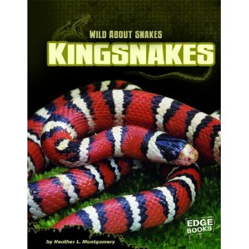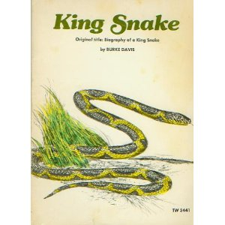

RI.2.9
I can read and comprehend grade level informational texts, including history/social studies, science, and technical texts.

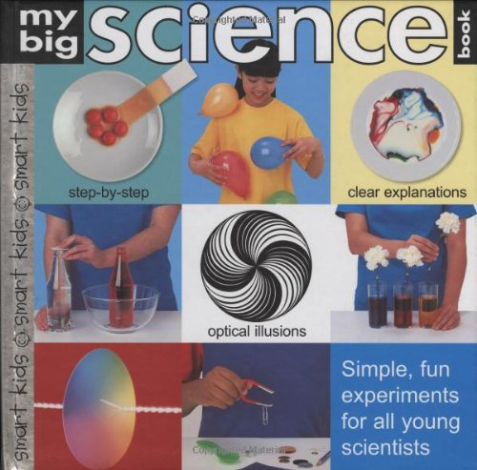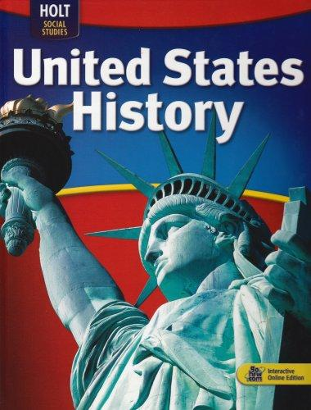

RI.2.10
I can distinguish long and short vowels when reading regularly spelled one-syllable words.
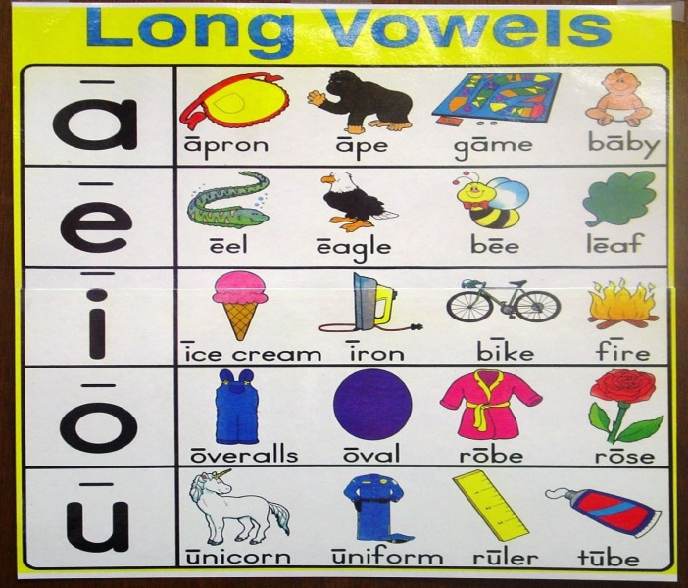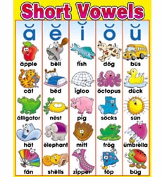
RF.2.3A
I know spelling-sound correspondences for additional common
vowel teams.
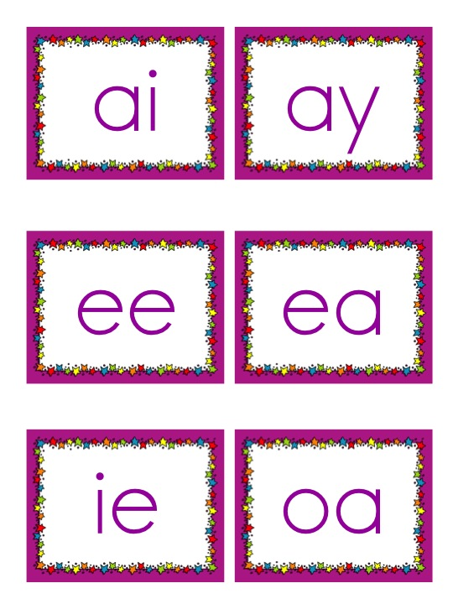

RF.2.3B
I can decode regularly spelled two-syllable words with long vowels.

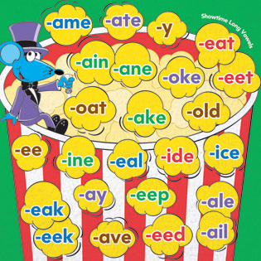

RF.2.3C
I can decode words with common prefixes
and suffixes.
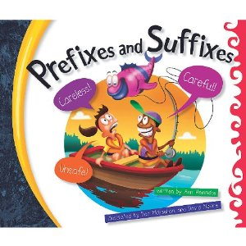
RF.2.3D
I can identify words with inconsistent but common spelling-sound correspondences.

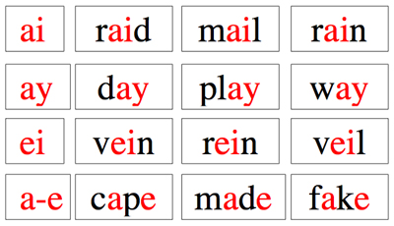
RF.2.3E
I can recognize and read grade-appropriate irregularly spelled words.
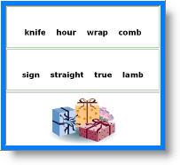

RF.2.3F
I can read on-level text with purpose and understanding.

RF.2.4A
I can read on-level text orally with accuracy, appropriate rate, and expression on successive readings.

I can read with expression.
I can read fluently.
I can read without missing many words.

RF.2.4B
I can use context to confirm or self-correct words and understanding, rereading
as necessary.
I can use other ideas and words in the story to help me figure out words and understand the story.

RF.2.4C
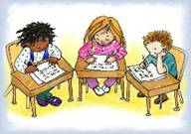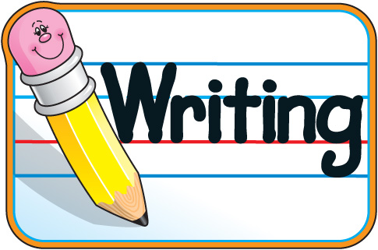

I can write opinion pieces that…

- introduce the topic or book
- state an opinion,
- supply reasons that support the opinion,
- use linking words to connect opinion and reasons, and
- provide a concluding statement or section.
W.2.1

I can write informative/explanatory texts that…

- introduce a topic,
- use facts and definitions to develop points, and
- provide a concluding statement or section.
W.2.2

I can write narratives in which I…

- recount a well-elaborated event or short sequence of events,
- include details to describe actions, thoughts, feelings,
- use temporal words to signal event order,
- provide a sense of closure.

W.2.3
With help, I can focus on a topic and strengthen writing as needed by prewriting, revising and editing.
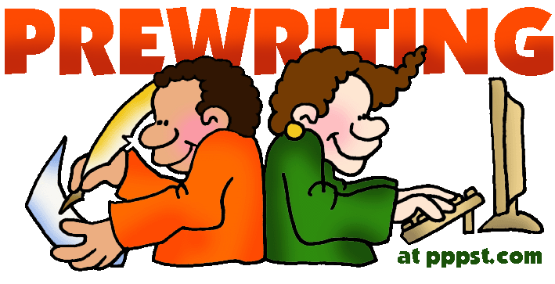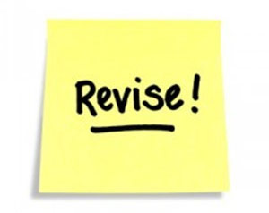

W.2.5
With help from my class, I can use a variety of digital tools to produce and publish writing.
W.2.6
I can participate in shared research and writing projects.
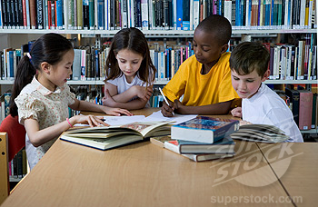

W.2.7
I can recall information from experiences or gather information from provided sources to answer a question.

W.2.8
I can follow agreed-upon
rules for discussions.

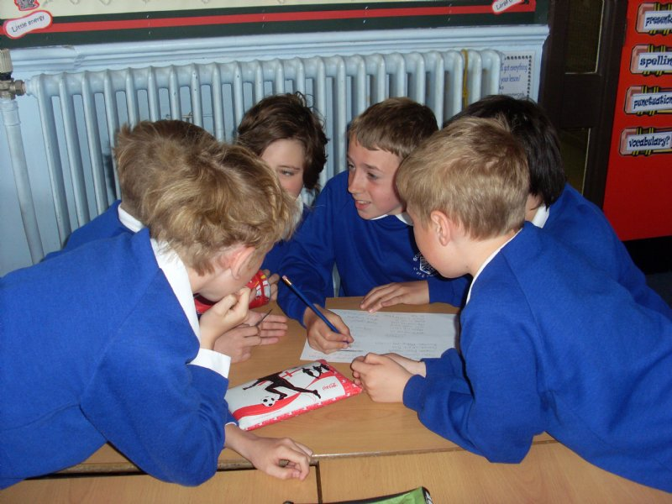
Take turns talking.
Listen to others.

SL.2.1A
I can build on others’ talk in conversations by linking their comments to the remarks of others.

I agree with what Susan said to John and
I also think……

SL.2.1B
I can ask for clarification and further explanation as needed about the topics and
texts under discussion.
I’m not sure I understand what you mean about that part of the story.

SL.2.1C
I can recount or describe key ideas or details from texts read aloud or information presented orally or through other media.
Let me tell you more about the story.

SL.2.2
I can ask and answer questions about what a speaker says in order to clarify comprehension, gather additional information, or deepen understanding of a topic or issue.

SL.2.3
I can tell a story or recount an experience with appropriate facts and details, speaking audibly (so all can hear) in coherent sentences.

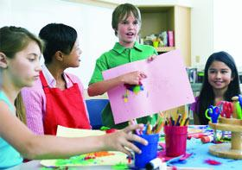

SL.2.4
I can use audio recordings, drawings or other visual displays to clarify ideas, thoughts, and feelings
about a story.

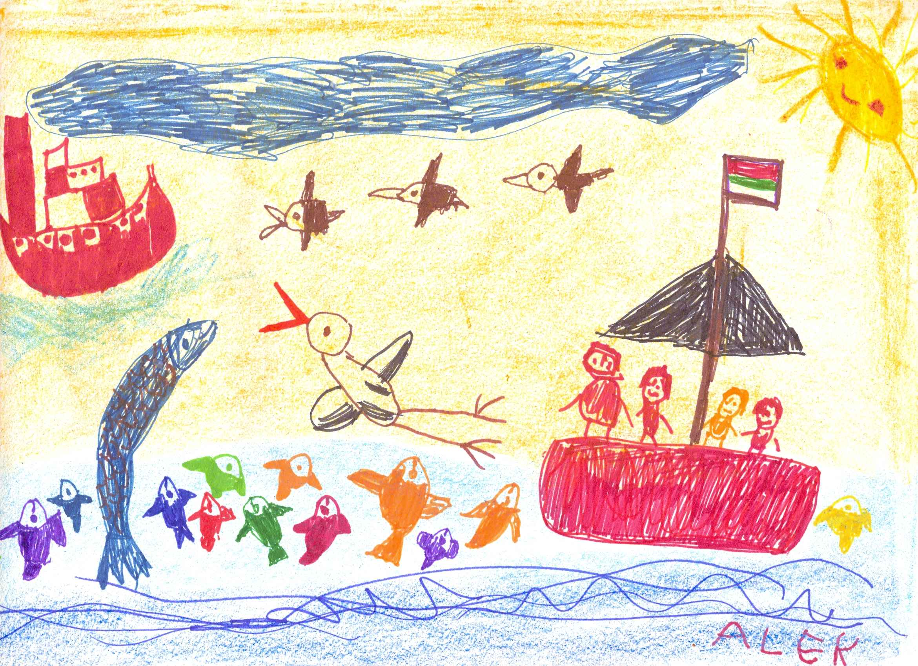

SL.2.5
I can produce complete sentences to provide requested detail or clarification.

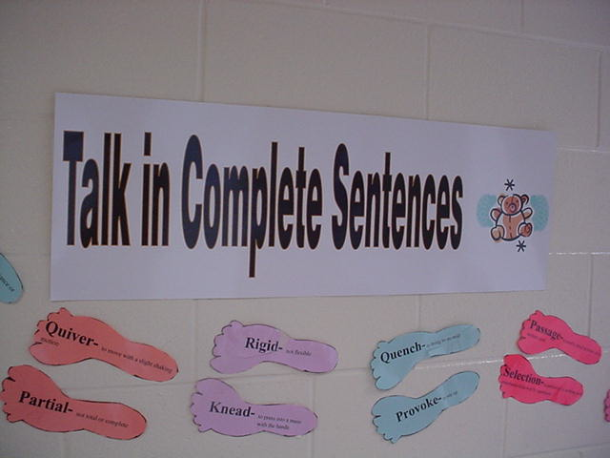

SL.2.6
I can use collective nouns.

A herd of cattle.

A school of fish.

A litter of puppies.
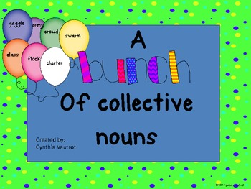

L.2.1A
I can form and use frequently occurring irregular plural nouns.
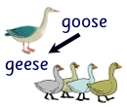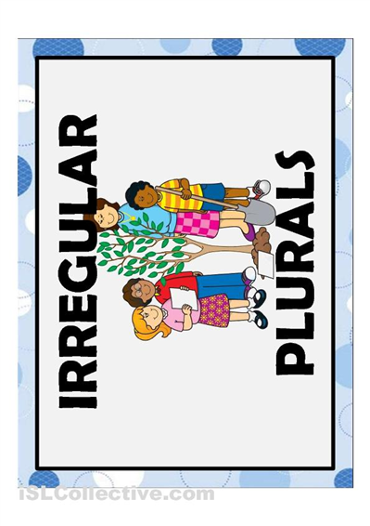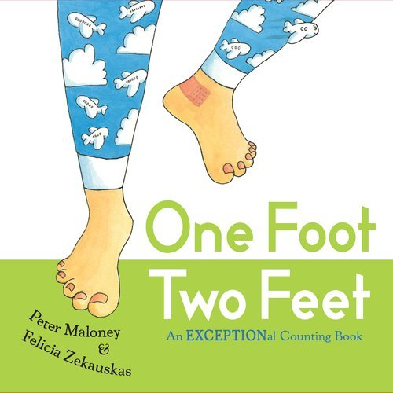

L.2.1B
I can use reflective pronouns.

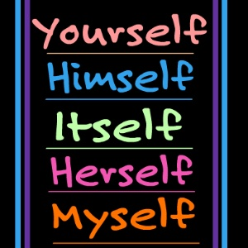

L.2.1C
I can form and use the past tense of frequently occurring irregular verbs.

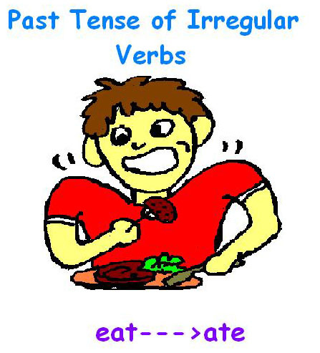

L.2.1D
I can use adjectives and adverbs, and choose which to use when.
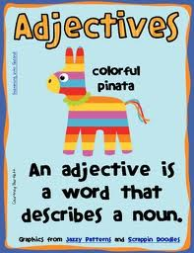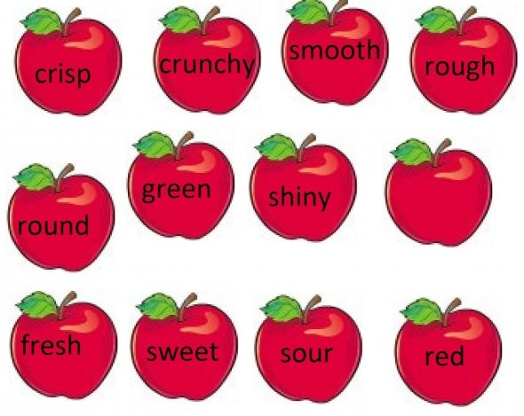
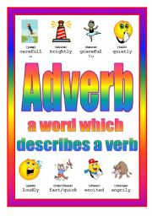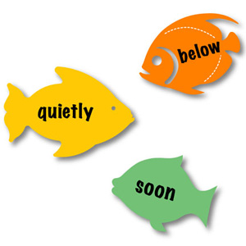
L.2.1E
I can produce, expand, and rearrange complete simple and compound sentences.
The little boy watched the movie.
The boy watched the movie.

The action movie was watched by the little boy.

L.2.1F
I can create documents with legible handwriting.

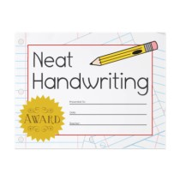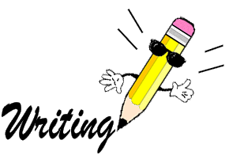

L.2.1G
I can capitalize holidays, product names, and geographic names.
Chick-fil-A
sandwich

Washington, Georgia
Christmas
Thanksgiving

L.2.2A

I can use commas in greetings and closings of letters.
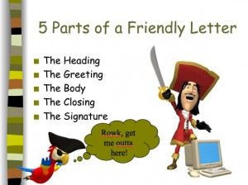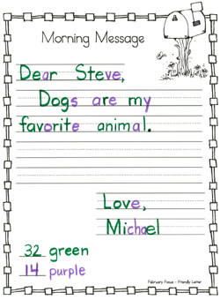
COMMA
COMMA

L.2.2B
I can use an apostrophe to form contractions and frequently occurring possessives.
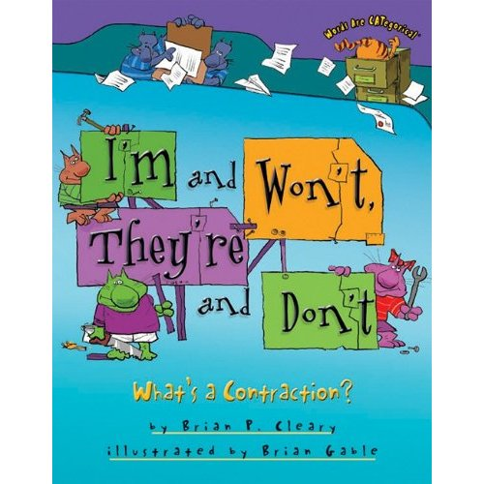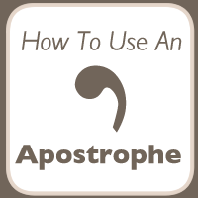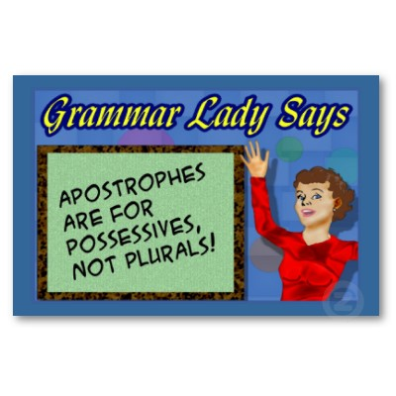

L.2.2C
I can generalize learned spelling patterns when writing words.

cage
boy

badge
boil

L.2.2D
I can consult reference materials to check and correct spellings.
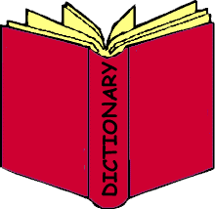
L.2.2E
I can compare formal and informal uses of language.

There are times to use informal language and times to use
formal language.
For instance, I know that I talk
differently than I write.

L.2.3A
I can use context in the sentence as a clue to the meaning of a word or phrase.

I can read the rest of the sentence to help me figure out the meaning of a word
I don’t know.

L.2.4A
I can determine the meaning of the new word formed when a known prefix is added to a known word.
Happy means “to feel pleased or glad”.
Un- means NOT so…….
Unhappy must mean NOT happy.

L.2.4B
I can use a known root word as a clue to the meaning of an unknown word with the same root.
ROOT WORD

add
addition

add
additional

add

L.2.4C
I can use knowledge of the meaning of individual words to predict the meaning of compound words.
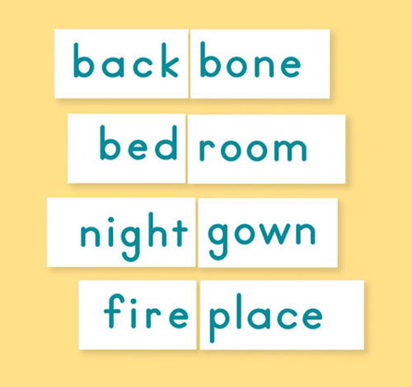

L.2.4D
I can use glossaries and beginning dictionaries, both print and digital, to determine or clarify the meaning of words and phrases.

L.2.4E
I can identify real-life connections between words and their use.
The chili peppers I ate at the restaurant were really hot and spicy.

L.2.5A
I can distinguish shades of meaning among closely related verbs and closely related adjectives.
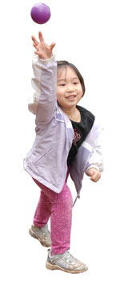

The girl is short and thin.
The girl is short and slender.

The girl is throwing the ball.
The girl is tossing the ball.
L.2.5B
I can use words from conversations, reading and responding to texts, including using adjectives and adverbs to describe.

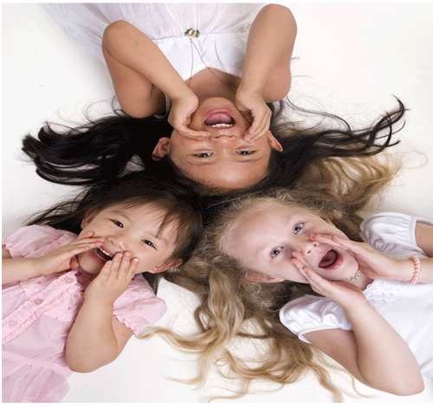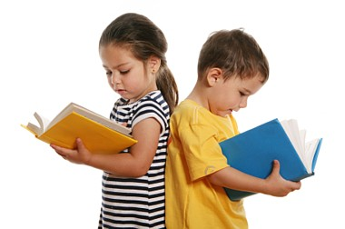
When other kids are happy, that makes me happy.

L.2.6

