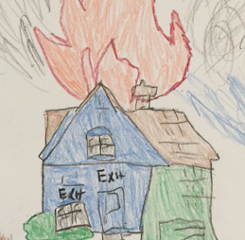
2018 Fire Safety Week Theme is:
“Look. Listen. Learn. Be aware.
Fire can happen anywhere!”

2018 Red Ribbon Week Theme is:
“Life is your journey, travel drug free.”

