**When I use multiplication, the total number of objects is the product. The numbers multiplied are the factors.**

**Multiplication involves a specific number of groups with the same number of objects in each group.**

**CCGPS3.OA.1**

**5 x 4 = 20**

**factors**

**5 groups of 4 = product**

I purchased 5 boxes of cookies. Each box had 4 cookies. How many cookies in all?

**Repeated addition 4 + 4 + 4 + 4 + 4**

**I know division gives me a quotient (the total number of objects).**

**Division answers “how many in each group?” *or* “how many groups can I make?”.**

**CCGPS3.OA.2**

|  |
| --- |
| **How many in each group?**  There are 12 cookies on the counter. If you are sharing the cookies equally among three bags, how many cookies will go in each bag?  **12 ÷ 3 = 4**  **quotient** |
| **How many groups can I make?**  There are 12 cookies on the counter. If you put 3 cookies in each bag, how many bags will you fill?      **12 – 3 – 3 – 3 – 3 = 0**  **Repeated subtraction** |

**I can use various strategies to solve multiplication and division word problems.**

**CCGPS3.OA.2**

**There are 12 cookies on the baking sheet. My mom put 6 cookies in each row. How many rows are there?**

|  |  |  |
| --- | --- | --- |
| **Using Arrays**  http://www.athens.edu/vinsobm/lesson_19_files/image005.jpg | **Using Equal Groups**  xxxxxx  xxxxxx | **Using a Number Line** |
| **Using Repeated Addition**  **6 + 6 = 12**  **2 x 6 = 12** | | |

**Max loves bananas. His grandmother has 24 bananas. If she gives Max 4 bananas each day, how many days will the bananas last?**

|  |  |
| --- | --- |
| **Using Drawings**  **I drew 24 bananas then used my highlighter to show groups of 4. I counted the groups.**  **24 ÷ 4 = 6**  **OOOOOOOO OOOOOOOO**  **OOOOOOOO** | **Using Repeated Subtraction**  **24-4 = 20**  **20-4 = 16**  **16-4 = 12**  **12-4 = 8**  **8-4 = 4**  **4-4 = 0**  **I subtracted 4 from 24 until I got 0. Then I counted how many times I subtracted.** |

**I can determine the unknown number that makes a multiplication or division equation true.**

**CCGPS3.OA.3**

|  |  |  |
| --- | --- | --- |
| **Unknown Product**  **3 x 5 = ___**  **8 x 2 =**  **There are 2 bags with 8 apples in each. How many apples in all?** | **Group Size Unknown**  **3 x ___ = 18**  **18 ÷ 3 = c**  **If 18 apples are arranged into 3 equal rows, how many apples will be in each row?** | **Number of Groups Unknown**  **____ x 4 = 40**  **40 ÷ 4 =**  **If 40 apples are arranged into equal rows of 4 apples, how many rows will there be?** |

**CCGPS3.OA.4**

**I can apply properties of operations as strategies to multiply and divide.**

**CCGPS3.OA.5**

**Commutative Property of Multiplication**

**6 x 4 = 24**

**4 x 6 = 24**

**Associative Property of Multiplication**

**7 x 5 x 2 =**

**Multiply 5 x 2 = 10 then multiply**

**10 x 7 = 70 so……………**

**7 x 5 x 2 = 70**

**Zero Property of Multiplication**

**0x7=0**

**7x0=0**

**Identity Property of Multiplication**

**1x7=7**

**7x1=7**

**Distributive Property**

**(breaking numbers apart)**

**7 x 6 = ____**

**7x5=35 7x3=21 5x6=30**

**7x1= 7 7x3=21 2x6=12**

**35+7=42 21+21=42 30+12=42**

**I could break apart 7x6 several ways…**

**I can determine if equations are true or false.**

|  |  |
| --- | --- |
| **TRUE**  **0 x 7 = 7 x 0**  **1 x 5 = 5 x 1**  **5 x 2 x 3 = 10 x 3**  **4 x 2 < 10 x 2** | **FALSE**  **8 ÷ 4 = 4 ÷ 8**  **2 x 2 x 2 = 2 x 0**  **0 x 6 > 0 x 10**  **5 x 5 = 20 ÷ 2** |

**CCGPS3.OA.5**

**I understand that division is an unknown factor problem.**

Unknown factor

**32 ÷ 8 = _____**

**Find the number that is multiplied by 8 that equals 32.**

**CCGPS3.OA.6**

**CCGPS3.OA.6 con’t**

**FACT FAMILY TRIANGLE**

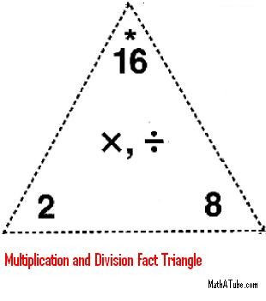

**8 x 2 = 16**

**2 x 8 = 16**

**16 ÷ 2 = 8**

**16 ÷ 8 = 2**

**I know that multiplication and division are inverse operations.**

**I know from memory all multiplication facts.**

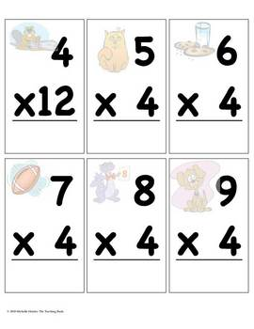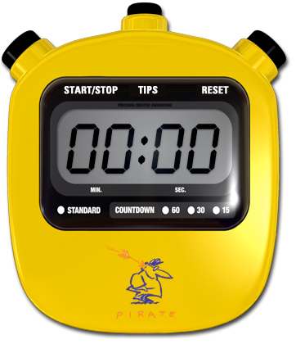

**CCGPS3.OA.7**

**I can solve two-step word problems using the four operations.**

**Mike runs 2 miles a day. His goal is to run 25 miles. After 5 days, how many miles does Mike have left to run in order to meet his goal? Write an equation and find the solution.**

**2 × 5 + *m* = 25**

**Goal**

**Number of days ran**

**Miles per day**

**Using a letter for the unknown:**

**how many miles are left?**

**CCGPS3.OA8**

**I can assess the reasonableness of answers using mental computation and estimation strategies including rounding.**



**I can identify arithmetic patterns in an addition or multiplication table.**

**and**

**I can explain them using properties of operations.**

**CCGPS3.OA.9**

**Arithmetic Patterns = patterns that change by the same rate. Example: 2,4,6,8,…. Increases by 2 each time.**

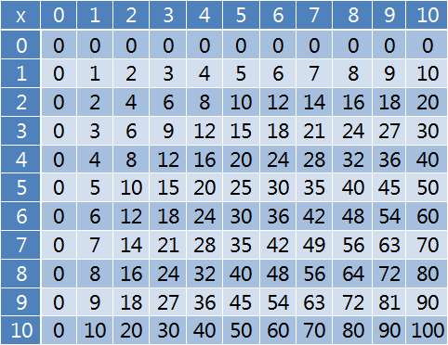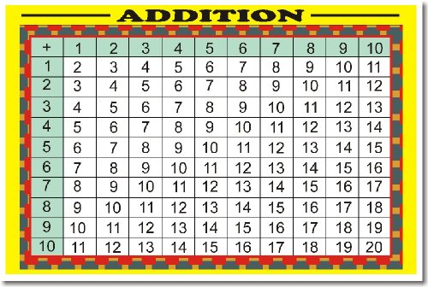

**On a multiplication chart, On an addition chart,**

**the products in each row the sums in each row**

**and column increase by the and each column**

**same amount. increase by the same**

**same amount.**

**CCGPS3.OA.9**

**I can use place value understanding to round whole numbers to the nearest 10 or 100.**

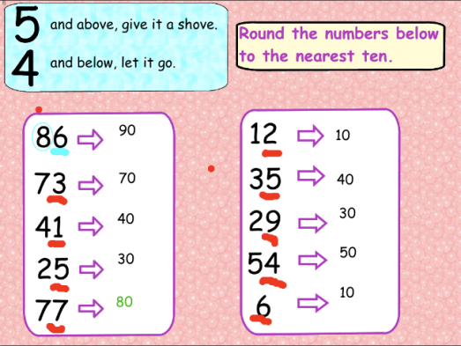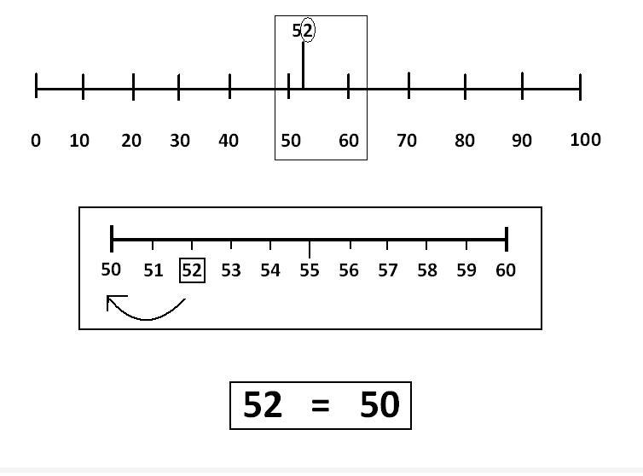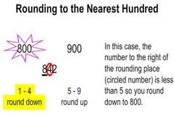

**CCGPS3.NBT.1**

**I can fluently add and subtract within 1000.**

**There are178 fourth graders and 225 fifth graders on the playground. What is the total number of students on the playground?**

**CCGPS3.NBT.2**

**CCGPS3.NBT.2 con’t**

|  |  |  |
| --- | --- | --- |
| **Using Place Value**  **100+200 = 300**  **70+20 = 90**  **8+5 = 13**  **300+90+13=403** | **Using the standard algorithm**  **1 1**  **178**  **+ 225**  **403** | **Using the relationship between addition and subtraction**  **Add 2 to 178 to equal 180.**  **Add 180+220 to get 400.**  **Add the 3 left over to get 403.** |

**I can multiply one digit whole numbers by multiples of 10.**

**4 x 10 = 40 4**

**x 10**

**40**

**CCGPS3.NBT.3**

**CCGPS3.NF.1**

**I know a fraction is the quantity formed when a whole is partitioned into equal parts.**

$\frac{3}{4}$**of the square is purple.**

**There are three $\frac{1}{4}$‘s colored.**

**CCGPS3.NF.1 con’t**

**I understand these concepts relating to fractions.**

|  |
| --- |
| **These are equal thirds. These are not equal thirds.** |
| **The number of equal parts tells how many make a whole.**  1/4  1/4 $\frac{4}{4}$ **= = 1 whole**  1/4  1/4 |
| **As the number of equal pieces in the whole increases, the size of the fractional pieces decreases.** |
| **The size of the fractional part is relative to the whole. $\frac{1}{2}$**  **of the students in the classroom is different**  **than $\frac{1}{2}$ of the students in the school.** |
| **The numerator is the count of equal parts.**  **The denominator is the number of equal parts.**  http://www.mathsisfun.com/images/fraction.gif |

**I understand and can represent a fraction as a number on the number line between whole numbers.**

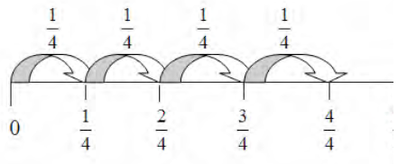

**CCGPS3.NF.2a,b**

**I understand two fractions are equivalent because they are the same size.**

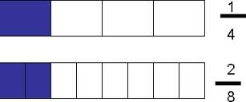

**CCGPS3.NF.3a**

**I can create equivalent fractions and explain why by using a visual model.**

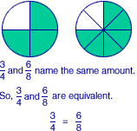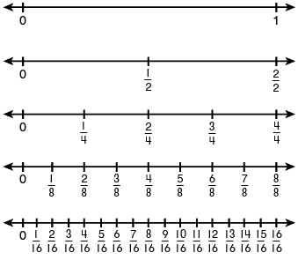

**CCGPS3.NF.3b**

**I can recognize fractions that are equivalent to whole numbers.**

$$\frac{3}{1}=3$$

$\frac{4}{4}$ = 1



**CCGPS3.NF.3c**

**I can compare two fractions with the same numerator or denominator.**

**I recognize that comparisons are valid when the two fractions refer to the same whole.**

**CCGPS3.NF.3d**

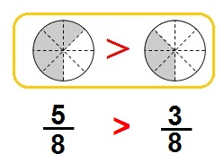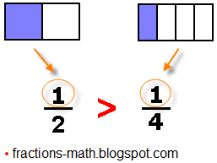

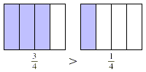 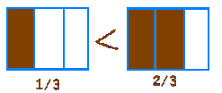

**= $\frac{4}{4}$ 5 = $\frac{5}{1}$ $\frac{8}{1}=8$**

**I can tell and write time to the nearest minute.**

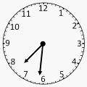[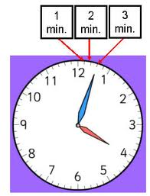](http://www.google.com/imgres?num=10&hl=en&safe=off&biw=1366&bih=571&tbm=isch&tbnid=Bzf_gqVsKDl04M:&imgrefurl=http://lawrencevillelocksmith.com/telling-time&page=3&docid=PTN2xZYyA8XfAM&itg=1&imgurl=http://www.studyzone.org/testprep/math4/e/timeto3.jpg&w=268&h=350&ei=CagMUKf6Hoay8ASq-ujICg&zoom=1&iact=hc&vpx=937&vpy=195&dur=5796&hovh=257&hovw=196&tx=100&ty=138&sig=102449167859536566375&page=3&tbnh=139&tbnw=106&start=59&ndsp=29&ved=1t:429,r:6,s:59,i:281)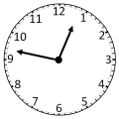

**CCGPS3.MD.1**

**I can solve word problems involving addition and subtraction of time intervals (elapsed time).**

**CCGPS3.MD.1**

**Tonya wakes up at 6:45 a.m. It takes her 5 minutes to shower, 15 minutes to get dressed, and 15 minutes to eat breakfast. What time will she be ready for school?**



**CCGPS3.MD.1**

**I can measure and estimate liquid volumes using liters (l).**

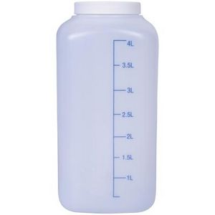 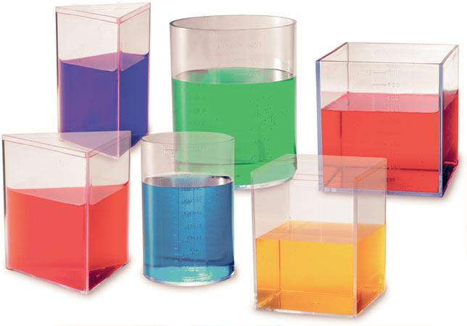

**CCGPS3.MD.2**

**I can measure and estimate masses of objects using grams (g) and kilograms (kg).**

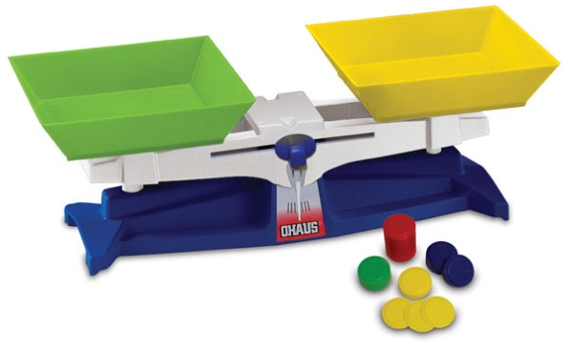

**CCGPS3.MD.2**

**I can add, subtract, multiply, and divide to solve one-step word problems involving masses or volumes.**

**÷ × + -**

**CCGPS3.MD.2**

**I can draw a scaled picture graph and a scaled bar graph.**

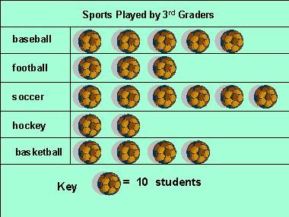

Data

Categories

Title

Key

Check the key! Sometimes there are Multiple Units.

**CCGPS3.MD.3**

**CCGPS3.MD.3 con’t**

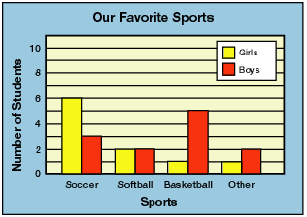

Key

Data

Scale Label

Scale

Title

Category Label

Categories

**I can use the information on picture and bar graphs to solve one and two-step problems.**

**CCGPS3.MD.3**



What interval was used for this scale?

How many girls like soccer?

How many more boys than girls like basketball?



Find the total number of 3rd graders surveyed.

How many 3rd graders played hockey?

How many students are represented by one ball?

**I can generate measurement data by length using a ruler marked with halves and fourths of an inch.**

**and**

**I can show the data on a line plot graph.**

**CCGPS3.MD.4**



How many total objects were measured?

How many objects measured more than 1 ½ inches?

How many objects measured 2 inches?

**I recognize area as an attribute of plane figures and understand area measurement.**

1 square unit

4

4

**CCGPS3.MD.5a,b**

**Area = 16 square units**

8

2

**Area = 16 square units**

**I can measure area by counting unit squares in metric, customary, or non-standard units.**

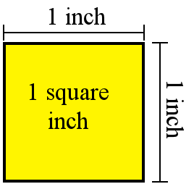 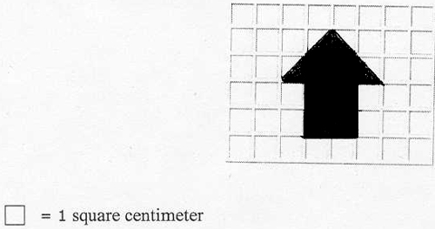 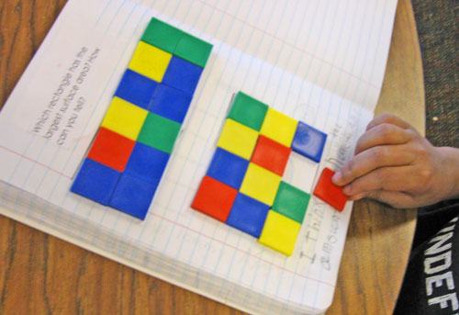

**CCGPS3.MD.6**

**I can relate area to the operations of multiplication and addition.**

**CCGPS3.MD.7a,b,c,d**

**To find the area……Count the squares or multiply 4 x 4 =16.**

|  |
| --- |
| **Drew wants to tile the bathroom floor using 1 foot tiles. How many square foot tiles will he need?**  **Use the distributive property to find the area.**    **5 x 6 = 30 and 2 x 6 = 12**  **30 + 12 = 42**  **6 feet**  **8 feet**  **8x6 = 48** |



|  |  |
| --- | --- |
| **LINEAR Measurement**  **Measuring length**  **-inches**  **-centimeters**  **-yards**  **-meters**  **-feet** | **AREA**  **Measurement**  **Measuring square units**  **-square centimeters**  **-square inches** |

**I can solve problems involving the perimeters of polygons.**

**Perimeter**

**The distance around a shape**

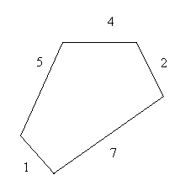

**Polygon**

**A flat shape with closed straight sides**

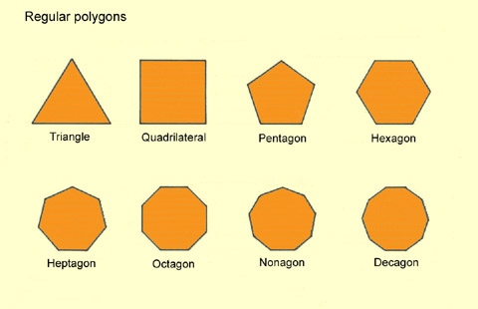

**CCGPS3.MD.8**

**I recognize shapes occur in different categories based on attributes.**

**CCGPS3.G.1**

|  |
| --- |
| **Quadrilateral**  **A closed, flat shape with four straight sides**  http://euler.slu.edu/escher/upload/thumb/6/68/Quadrilaterals.svg/300px-Quadrilaterals.svg.png |
| **Parallelogram**  **A quadrilateral that has two pairs of parallel sides**  http://upload.wikimedia.org/wikipedia/commons/f/f7/Parallelogram_(PSF).pnghttp://etc.usf.edu/clipart/41700/41730/FC_Para-gram_41730_md.gif |

**I can partition shapes into parts with equal areas and express each part as a unit fraction of the whole.**

**CCGPS3.G.2**

**This figure was partitioned into four equal parts. Each part is $\frac{1}{4}$ of the total area.**

**A circle divided into halves, thirds, fourths,**

**sixths and eighths.**

