**I can use addition and subtraction within 20 to solve word problems.**

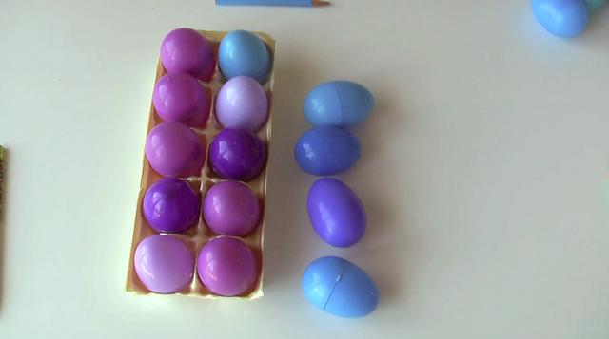 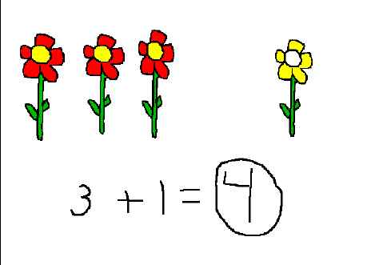 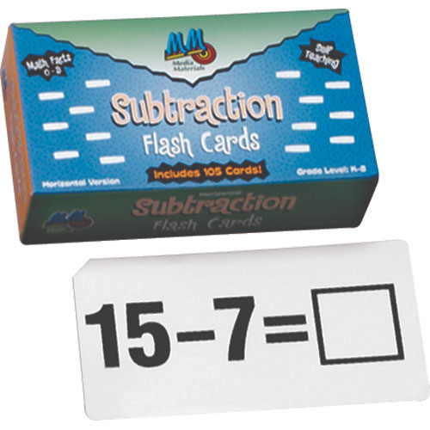

**Using objects Using drawings Using equations**

**CCGPS.1.0A1**

**Three Types of Addition and Subtraction Problems CCGPS.1.OA.1 con’t**

|  |  |  |
| --- | --- | --- |
| **Result Unknown**  **There are 9 students. Then 8 more show up. How many in all?**  **9 + 8 = _____** | **Change Unknown**  **There are 9 students. Some more show up. Now there are 14. How many students came?**  **9 + ___ = 14** | **Start Unknown**  **There are some students. Then 8 left. Now there are 5. How many at the beginning?**  **____ - 8 = 5** |

**I can solve addition word problems of three whole numbers with sums less than or equal to 20.**

|  |  |  |  |  |
| --- | --- | --- | --- | --- |
|  |  |  |  |  |
|  |  |  |  |  |

|  |  |  |  |  |
| --- | --- | --- | --- | --- |
|  |  |  |  |  |
|  |  |  |  |  |

**7 + 4 + 2 = 13**

**CCGPS.1.0A.2**

**I can apply**

**properties of operations**

**to add and subtract.**

|  |  |
| --- | --- |
| **Commutative Property of Addition**  https://lh6.googleusercontent.com/-RUKV1M8LDdA/TYVqhOwAgqI/AAAAAAAABS0/r1I0PJT-dNw/822.JPG | **Associative Property of Addition**  http://www.mathwarehouse.com/dictionary/A-words/images/picture-of-associative-property-of-addition.png |

**CCGPS.1.0A.3**

**I can understand subtraction as an unknown addend problem.**

|  |
| --- |
| **4 - 1 = ____ is the same as ___ + 1 = 4** |

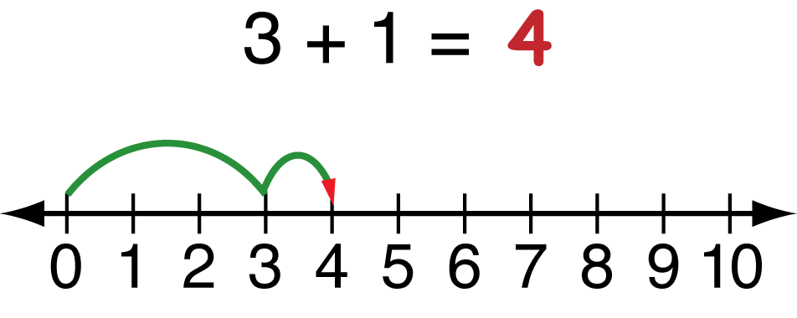

**CCGPS.1.0A.4**

**I can use counting all, counting on and counting back to add and subtract.**

|  |  |  |
| --- | --- | --- |
| **Counting All**  1,2,3,4,5,6,7,8,9,10, 11  http://www.sas.upenn.edu/~kimg/images/stickfigure.gif  **4 + 7 = _____** | **Counting On**  5,6,7,8,9,10,11  **http://www.sas.upenn.edu/~kimg/images/stickfigure.gif**  **4 + 7 = _____** | **Counting Back**  10, 9, 8, 7  **http://www.sas.upenn.edu/~kimg/images/stickfigure.gif**  **11 – 4 = ____** |

**CCGPS.1.0A.5**

**I can add and subtract within 20.**

|  |  |  |  |
| --- | --- | --- | --- |
| **Making Ten**  8 + 7 = ____  8+2=10 so  10+5 more =15 | **Decomposing to 10**  **14 – 6 = _____**  **14-4=10 so**  **10 – 2 more**  **= 8** | **Relationships between Adding and Subtracting**  15 – 7 = _____  7 + 8 = 15 so 15 – 7 = 8 | **Creating Known Sums**  **7 + 8 = ___**  **7+7=14 so**  **14+ 1more =**  **15** |

**CCGPS.1.0A.6**

**I can fluently add and subtract within 10.**

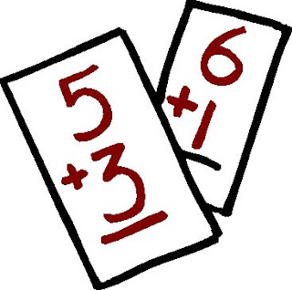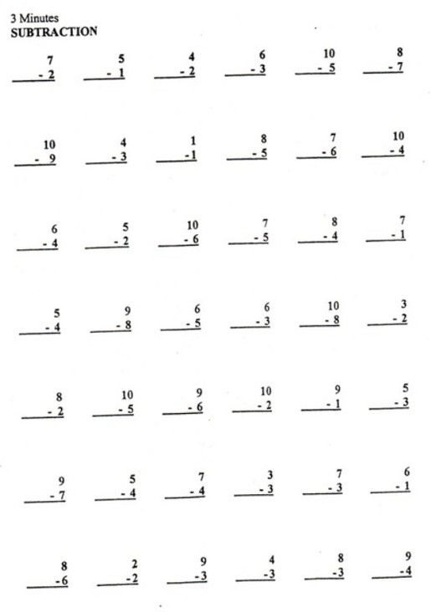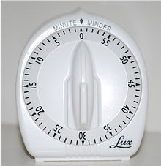

**CCGPS.1.0A.6**

**I understand the meaning of = (equal to).**

|  |  |
| --- | --- |
| **TRUE**  6 = 6  7= 8-1  5+2 = 2+5  = 2+0 | **FALSE**  **8 = 3**  **9-0 = 7**  **4+1 = 6+2**  **= 3** |

**CCGPS.1.0A.7**

**I can solve the unknown number in an equation.**

**I know 5 plus 3 is 8. So 8 minus 3 is 5.**

**5 = ____ - 3**

**CCGPS.1.0A.8**

**I can count to 120 from any given point.**

…98, 99, 100, 101, 102… 101101….1102, 103…

..116, 117, 118, 119, 120

….66, 67, 68, 69, 70…. 71, 72…..

..43, 44, 45, 46, 47, 48….

**CCGPS.1.NBT.1**

**I can represent any number from 0 – 120.**

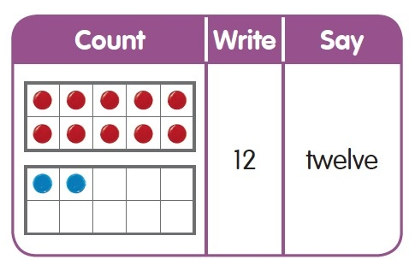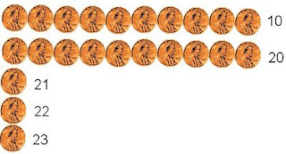

**111 =** 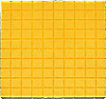http://www2.sd5.k12.mt.us/elrod/multiage/images/Base10_ten.jpghttp://www2.sd5.k12.mt.us/elrod/multiage/images/Base10_one.jpg **54 =  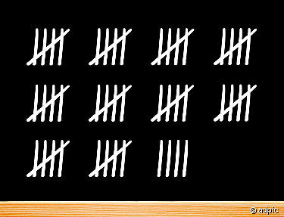 CCGPS.1.NBT.1**

**I understand that**

**10 (ten) is the same**

**as 10 ones.**

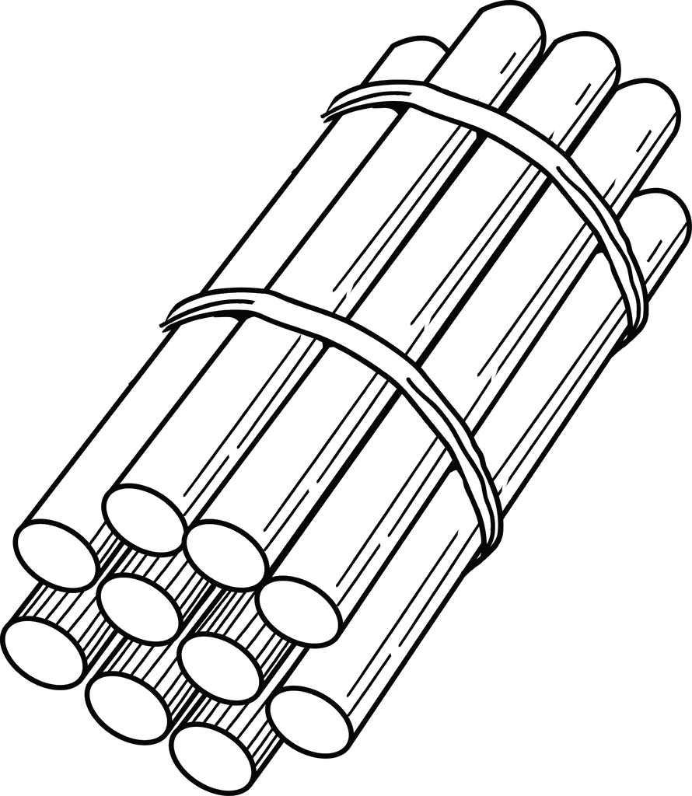**= ten**

**CCGPS.1.NBT.2a**

**I know the numbers**

**11-19 are composed of a**

**ten and ones.**

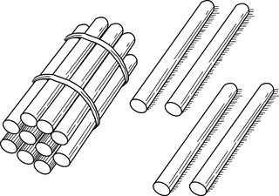 **= 14**

**1 ten and 4 ones**

**CCGPS.1.NBT.2b**

**I know numbers**

**10, 20, 30, 40, 50, 60, 70, 80, 90**

**equal tens and 0 ones.**

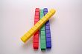 **= 40 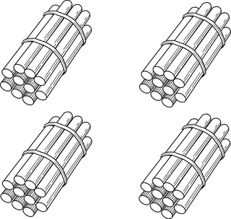 = 40**

**CCGPS.1.NBT.2c**

**I can compare**

**two-digit numbers using < and >.**

|  |  |
| --- | --- |
| **LESS THAN**  **42 < 45**  **4 tens 2 ones < 4 tens 5 ones** | **GREATER THAN**  **56 > 31**  **5 tens 6 ones > 3 tens 1 one** |

**CCGPS.1.NBT.3**

**I can use place value understanding and properties of operations to add and subtract within 100.**

**CCGPS.1.NBT.4**

**CCGPS.1.NBT.4**

**There are 37 children on the playground. 23 more children join them. How many now?**

|  |
| --- |
| **Using a hundreds chart: Start at 37. Move over 3 ones to 40.**  **Move down 2 tens and land on 60.**  http://4.bp.blogspot.com/_jdKn-n_HSVc/S_bxCrfJ8KI/AAAAAAAADN8/uG247Xs7zkI/s1600/chart.hundreds.jpg |
| **Using place value blocks: Make a pile of 37. Make a pile of 23.**  **Join the tens and get 50.**  **Join the ones and get 60.**  **http://www2.sd5.k12.mt.us/elrod/multiage/images/Base10_ten.jpghttp://www2.sd5.k12.mt.us/elrod/multiage/images/Base10_ten.jpghttp://www2.sd5.k12.mt.us/elrod/multiage/images/Base10_ten.jpghttp://www2.sd5.k12.mt.us/elrod/multiage/images/Base10_one.jpghttp://www2.sd5.k12.mt.us/elrod/multiage/images/Base10_one.jpghttp://www2.sd5.k12.mt.us/elrod/multiage/images/Base10_one.jpghttp://www2.sd5.k12.mt.us/elrod/multiage/images/Base10_one.jpghttp://www2.sd5.k12.mt.us/elrod/multiage/images/Base10_one.jpghttp://www2.sd5.k12.mt.us/elrod/multiage/images/Base10_one.jpghttp://www2.sd5.k12.mt.us/elrod/multiage/images/Base10_one.jpg http://www2.sd5.k12.mt.us/elrod/multiage/images/Base10_ten.jpghttp://www2.sd5.k12.mt.us/elrod/multiage/images/Base10_ten.jpghttp://www2.sd5.k12.mt.us/elrod/multiage/images/Base10_one.jpghttp://www2.sd5.k12.mt.us/elrod/multiage/images/Base10_one.jpghttp://www2.sd5.k12.mt.us/elrod/multiage/images/Base10_one.jpg** |
| **Using place value blocks: Break apart 37 and 23 into 3 tens and 2 tens.**  **Break apart 37 and 23 into 7 ones and 3 ones.**  **Add the tens and get 50.**  **Add the ones and get 10 more to equal 60.**  **http://www2.sd5.k12.mt.us/elrod/multiage/images/Base10_ten.jpghttp://www2.sd5.k12.mt.us/elrod/multiage/images/Base10_ten.jpghttp://www2.sd5.k12.mt.us/elrod/multiage/images/Base10_ten.jpg http://www2.sd5.k12.mt.us/elrod/multiage/images/Base10_ten.jpghttp://www2.sd5.k12.mt.us/elrod/multiage/images/Base10_ten.jpg http://www2.sd5.k12.mt.us/elrod/multiage/images/Base10_one.jpghttp://www2.sd5.k12.mt.us/elrod/multiage/images/Base10_one.jpghttp://www2.sd5.k12.mt.us/elrod/multiage/images/Base10_one.jpghttp://www2.sd5.k12.mt.us/elrod/multiage/images/Base10_one.jpghttp://www2.sd5.k12.mt.us/elrod/multiage/images/Base10_one.jpghttp://www2.sd5.k12.mt.us/elrod/multiage/images/Base10_one.jpghttp://www2.sd5.k12.mt.us/elrod/multiage/images/Base10_one.jpg http://www2.sd5.k12.mt.us/elrod/multiage/images/Base10_one.jpghttp://www2.sd5.k12.mt.us/elrod/multiage/images/Base10_one.jpghttp://www2.sd5.k12.mt.us/elrod/multiage/images/Base10_one.jpg** |
| **Using mental math: Start at 37 and count 3 more to get 40.**  **Add 20 which is 2 tens. That makes 60.**  http://www.simtalk.com/news-2-you/monarch/graphics/Header-review.gif |
| **Using a number line: Start at 37.**  **Break up 23 into tens and ones (20 and 3).**  **Add 3 ones to get to 40.**  **Jump 10 to 50 and then 10 more 60.**  http://www.teaching.com.au/IBSStaticResources/Bo_Resources/MTA/IMAGE/LF224.JPG |

**CCGPS.1.NBT.4**

**I can find 10 more or 10 less than a two-digit number without counting.**

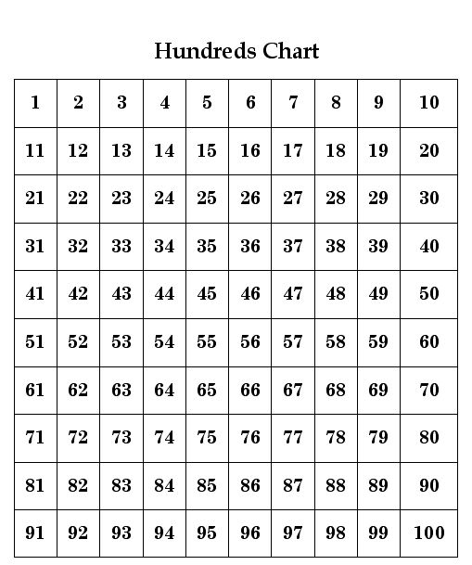

**There are 74 birds. 10 flew away. How many are left?**

**CCGPS.1.NBT.4**

**I can subtract multiples of 10 using knowledge of place value, properties of operations, and relationships between addition and subtraction.**

**CCGPS.1.NBT.5**

**CCGPS.1.NBT.5**

There are 60 students in the gym. 30 students leave. How many students are still in the gym?

|  |
| --- |
| **Using a hundreds chart:** Start at 60. Move up 3 rows to 30.  **http://4.bp.blogspot.com/_jdKn-n_HSVc/S_bxCrfJ8KI/AAAAAAAADN8/uG247Xs7zkI/s1600/chart.hundreds.jpg** |
| **Using mental math: 60 – 30 = 30 http://www.simtalk.com/news-2-you/monarch/graphics/Header-review.gif** |
| **Using place value blocks: Build 6 towers of ten. Remove 3 towers.**  **3 towers of 10 are left.**  http://www2.sd5.k12.mt.us/elrod/multiage/images/Base10_ten.jpghttp://www2.sd5.k12.mt.us/elrod/multiage/images/Base10_ten.jpghttp://www2.sd5.k12.mt.us/elrod/multiage/images/Base10_ten.jpghttp://www2.sd5.k12.mt.us/elrod/multiage/images/Base10_ten.jpghttp://www2.sd5.k12.mt.us/elrod/multiage/images/Base10_ten.jpghttp://www2.sd5.k12.mt.us/elrod/multiage/images/Base10_ten.jpg |
| **Using a number line: Start at 60. Move back 3 jumps of 10 each.**  **Land on 30.**  http://t0.gstatic.com/images?q=tbn:ANd9GcQ555iQbUVirpnqs1G5gDHCqltz4JYHW9poNJDVTGiNY15Q3tgBWzDs3jBpkQ |

**CCGPS.1.NBT.5**

**I can compare the lengths of objects using a nonstandard measurement.**

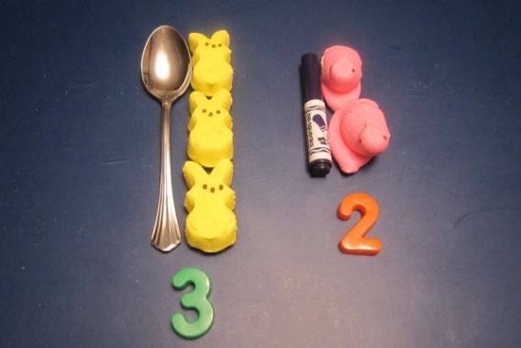 **The spoon is taller than the marker.**

**CCGPS.1.MD.1**

**I know that the length of an object is the number of the same size units without gaps.**

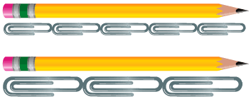

**CCGPS.1.MD.2**

**I can tell time to the hour and half-hour.**

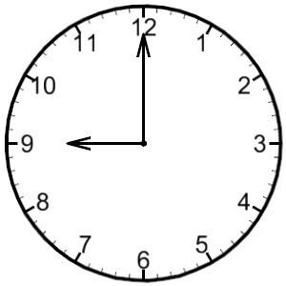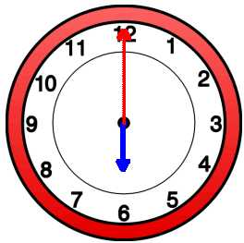 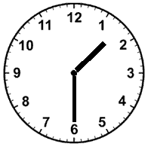

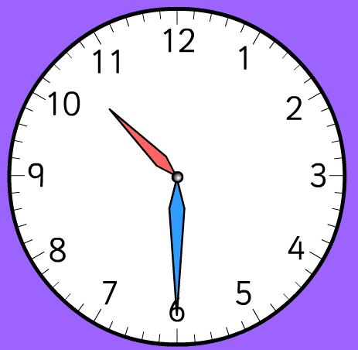[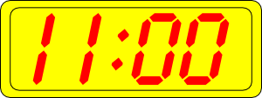](javascript:edit(24454)) 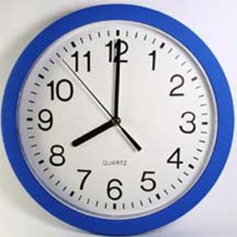

**CCGPS.1.MD.3**

**I can organize, represent, and interpret data with three categories.**

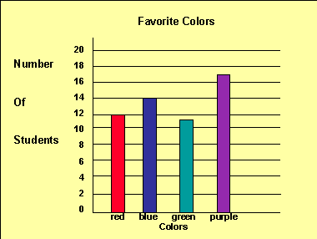

**Ask and answer questions about the total number of data points.**

**Ask and answer questions about how many more or less in one category than in another.**

**Ask and answer questions about how many in each category.**

**CCGPS.1.MD.4**

**I can describe objects in the environment using names of shapes and describe them using positional words.**

**C:\Documents and Settings\Teacher\Local Settings\Temporary Internet Files\Content.IE5\SPYJ09YV\MC900048285[1].wmf C:\Documents and Settings\Teacher\Local Settings\Temporary Internet Files\Content.IE5\76SU0BUW\MC900048284[1].wmf**

|  |  |  |  |  |  |
| --- | --- | --- | --- | --- | --- |
| **Above** | **Below** | **Beside** | **In front of** | **Behind** | **Next to** |

**Review of CCGPS.K.G.1**

**I know the difference between defining attributes and non-defining attributes of shapes.**

|  |  |
| --- | --- |
| **Defining attributes:**  A triangle has 3 sides.  A triangle has 3 angles. | **Non-defining attributes:**  A triangle doesn’t have to be a  certain color.  A triangle isn’t always in the  same position. |

**CCGPS.1.G.1**

**I can create a new shape by combining flat and solid shapes.**

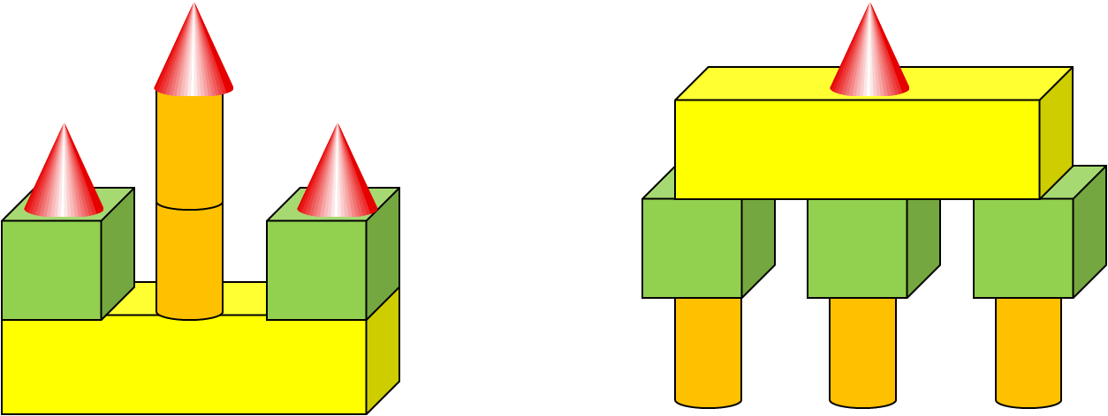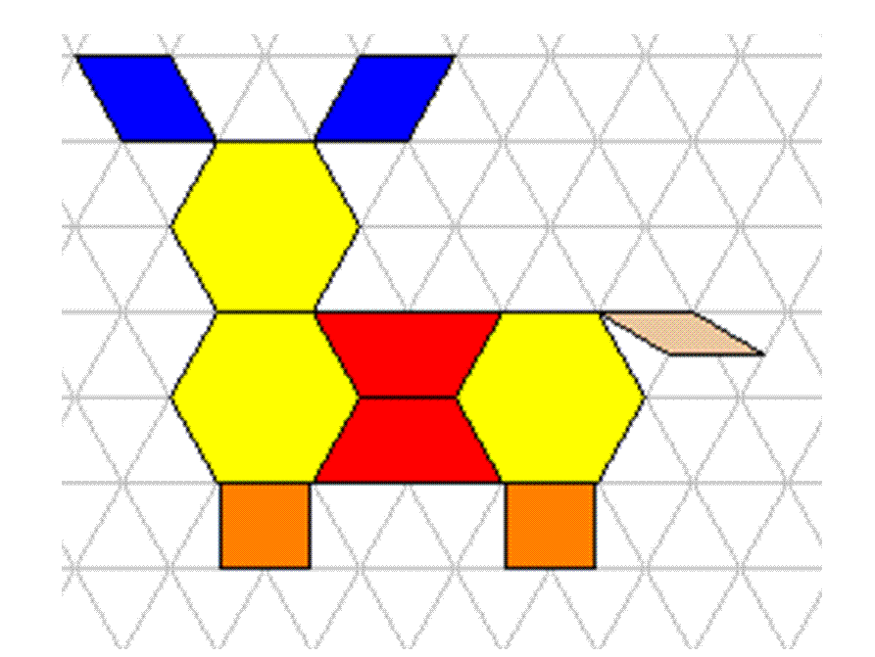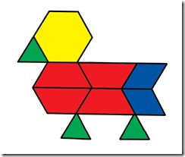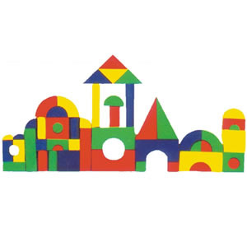

**CCGPS.1.G.2**

**I can divide circles and rectangles into halves,**

**fo** **urths, and quarters.**

|  |  |
| --- | --- |
| **Halves**  http://www.mathgoodies.com/lessons/fractions/circles/circle_halves_white.gif **http://www.mathgoodies.com/lessons/fractions/circles/circle_halves_white.gif** | **Fourths or Quarters**http://www.mathgoodies.com/lessons/fractions/circles/circle_fourths_white.gif |

**CCGPS.1.G.3**